Seismic Waveform Tool (SWFT) Tutorial

Eric Matzel, Rengin Gok, Justin Barno
Lawrence Livermore National Laboratory

Doyeoun Kim
Cornell University

Prepared by LLNL under Contract DE-AC52-07NA27344.

LLNL-SM-754520

Table of Contents
Introduction 5
Getting Started 5
1. SWFT Seismic Data Processor 7
1.1. Loading Data Files 7
1.2. Data Correlation 8
1.3. Plotting 11
1.4. Utilities 12
1.4.1. Metadata and Headers 12
1.4.2. Trace Segmentation 14
1.4.3. Merge seismograms into longer segments 15
1.4.4. Display/Write Headers 16
1.4.5. Sort data 17
2. Regional Body-Wave Amplitude Processor 20
3. Phase picker 22
3.1. Seismogram Phase Picker (see Tools>Phase Picker) 22
4. Coda Tool-Moment Magnitude Calculation Using Coda Waves 26
4.1. Output Files 33
5. SWFT Command Manual 34
Application Support Commands 34
5.1. dir 34
5.2. cd 34
5.3. ls 34
5.4. find 34
5.5. edit 35
5.6. help 35
5.7. save 36
5.8. writeascii 36
5.9. clear 36
5.10. color 37
5.11. select 37
Plotting Support Commands 38
5.12. autoplot 38
5.13. plot 38
5.14. picks 38
5.15. align 38
5.16. profile 39
Header Information Commands 41
5.17. lh 41
5.18. ch 41
5.19. b 41
5.20. e 42
5.21. o 42
5.22. date 42
5.23. gv 42
5.24. dt 43
5.25. clearpicks 43
5.26. reckon 44
5.27. distaz 44
5.28. refdistaz 45
5.29. track 45
Statistical Information Commands 46
5.30. min 46
5.31. max 46
5.32. extremum 46
5.33. maxtime 47
5.34. mean 47
5.35. median 47
5.36. variance 47
5.37. rms 47
5.38. rmsfit 48
5.39. p2p 48
5.40. skewness 49
5.41. skewness’ 49
5.42. kurtosis 50
5.43. statistics 50
5.44. statistics’ 50
5.45. sum 51
5.46. valueatindex 51
Waveform Modification Commands 52
5.47. abs 52
5.48. add 52
5.49. differentiate 52
5.50. integrate 53
5.51. dividetrace 53
5.52. envelope 54
5.53. fft 54
5.54. hilbert 55
5.55. interpolate 56
5.56. log 56
5.57. log10 57
5.58. multiply 57
5.59. raw 58
5.60. normalize 59
5.61. scale 59
5.62. power 59
5.63. spower 60
5.64. mute 60
5.65. rmean 61
5.66. rmedian 61
5.67. rtrend 62
5.68. reverse 62
5.69. signum 62
5.70. sqr 63
5.71. sqrt 64
5.72. stack 64
5.73. stretch 65
Filtering and Basic Processing Commands 66
5.74. taper 66
5.75. bp 66
5.76. lp 67
5.77. filter 67
5.78. acor 68
5.79. xcor 68
5.80. correlate 69
5.81. cut 70
5.82. despike 70
5.83. smooth 71
5.84. whiten 72
5.85. transfer 72
References 75

Introduction

The Seismic waveform tool (SWFT) is a computer code that is designed to do research level signal analysis on seismic waveforms, including visualization, filtering and measurement. The code allows manipulation of single or multiple traces in either interactive or batch processing modes. Along with a generalized seismic data processor, it includes tools to make standardized amplitude and coda measurements.

Getting Started

The SWFT code is written in Java and will work on any system with Java version 1.7.0 or higher. SWFT has been tested at LLNL on Windows, OS-X, and SUN systems. The SWFT .jar file may be executed by:

java –jar SWFT.x.x.jar

where “x.x” is a generic version number. If memory allocations for your platform are insufficient, you may need to execute by adding flags:

java –jar –Xms1500m –Xmx1500m SWFT.x.x.jar

This will open up a GUI interface from which you can read, plot and filter SAC data files.

The SWFT GUI initially contains three windows: One for plotting waveforms, a data table and a console for typing commands.

Files are typically opened from the menu bar:
File > Open > SAC
This opens a file chooser window from which you can select multiple files.

The data table will be automatically filled. The waveforms will not be plotted on first read but will appear once any subsequent commands are entered. (This is to prevent the program from hanging if a very large number of files is opened.)

Commands can be typed into the bottom of the console window. "Help" will give a list of commands that can be entered for trace processing.

These 3 windows are intended for interactive processing and visualization of data. SWFT also has several additional tools that are intended for batch processing of data. These can be found under the Tools dropdown list. These are listed below and described in the following sections.

SWFT Tools

SWFT Seismic Data Processor

Loading Data Files

DESCRIPTION
• SWFT supports several methods for loading seismic data. The simplest is to load individual sac traces via the menu. To rapidly fetch files from different directories, one can also create an ascii list of file locations. To facilitate batch processing of many large data sets, one can create a collection of file-lists, and read a master file list that points to each of them.

File > Open > SAC
File > Open > File List
File > Open > Multiple File Lists

Each of these options will open a file selection GUI. Note that any non-SAC formatted files in these lists will be ignored.

When data are organized in discreet subdirectories, users can create individual file lists using a recursive search procedure.

File > Open > Create Recursive File List : will create a list of all files below the chosen directory.
File > Open > Create Recursive File List Processed subset: will look for files in subdirectories named “Processed”, which are typically created during the seismic data processing stage.
File > Open > Create Recursive File List 1.XCOR subset: will look for files in cross-correlation subdirectories named “1.XCOR”

EXAMPLE
• Load data using multiple file lists

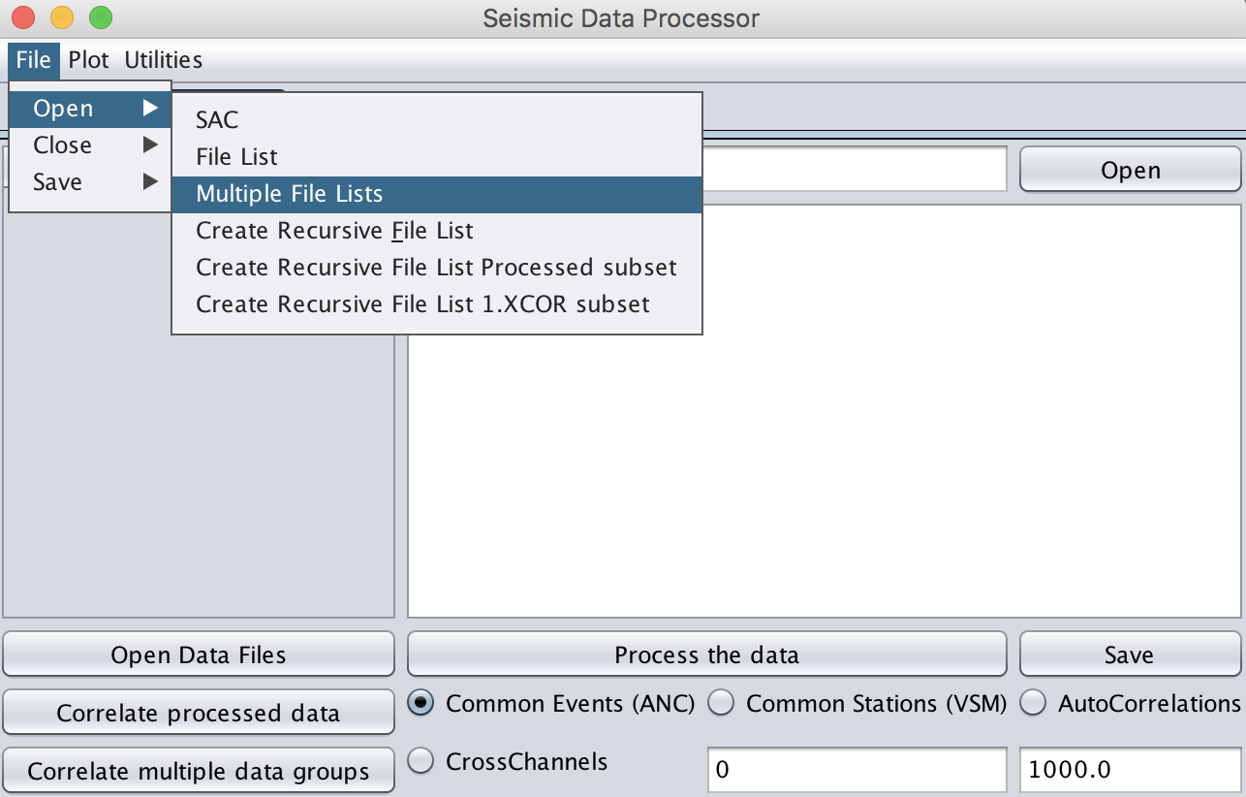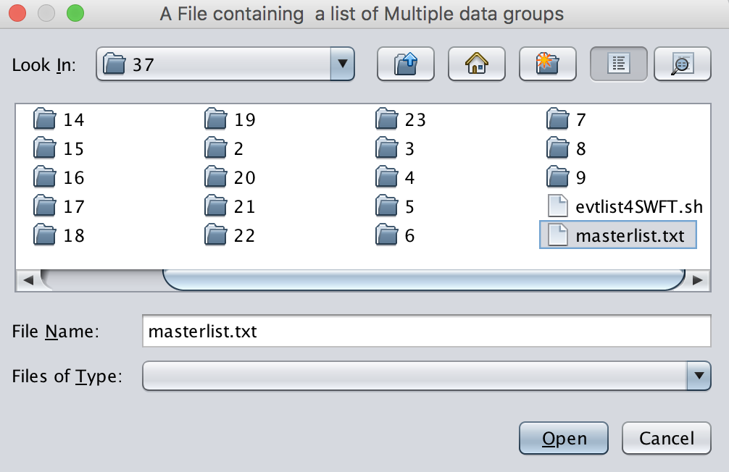
Figure 1.1-1. Load Multiple file lists (left) and the user will be prompted to select a text file (right).

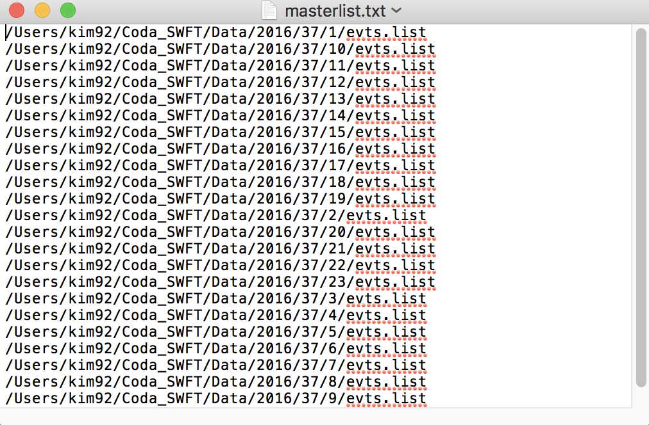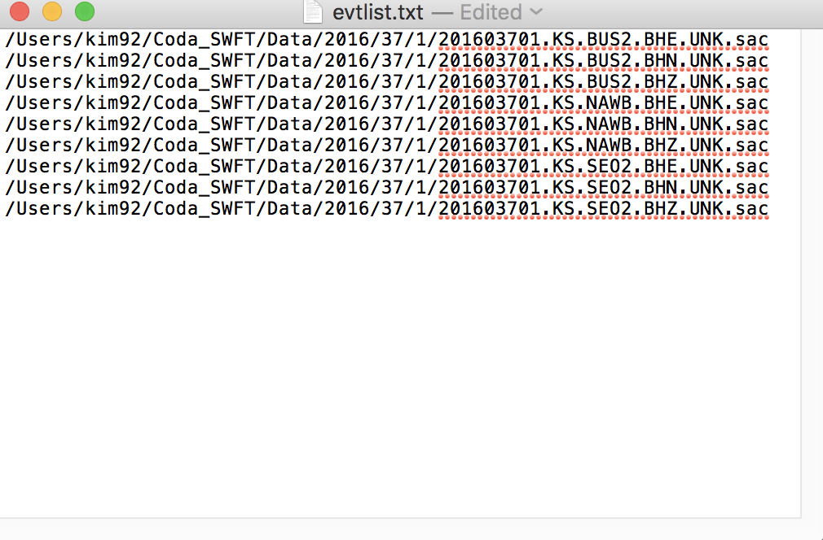
Figure 1.1-2. Sample of a list of data groups (left) and a file list (right).
Note “filelist_hour0.txt” can be found at the first row of “masterlist.txt” and has the path information on each SAC files.

Data Correlation

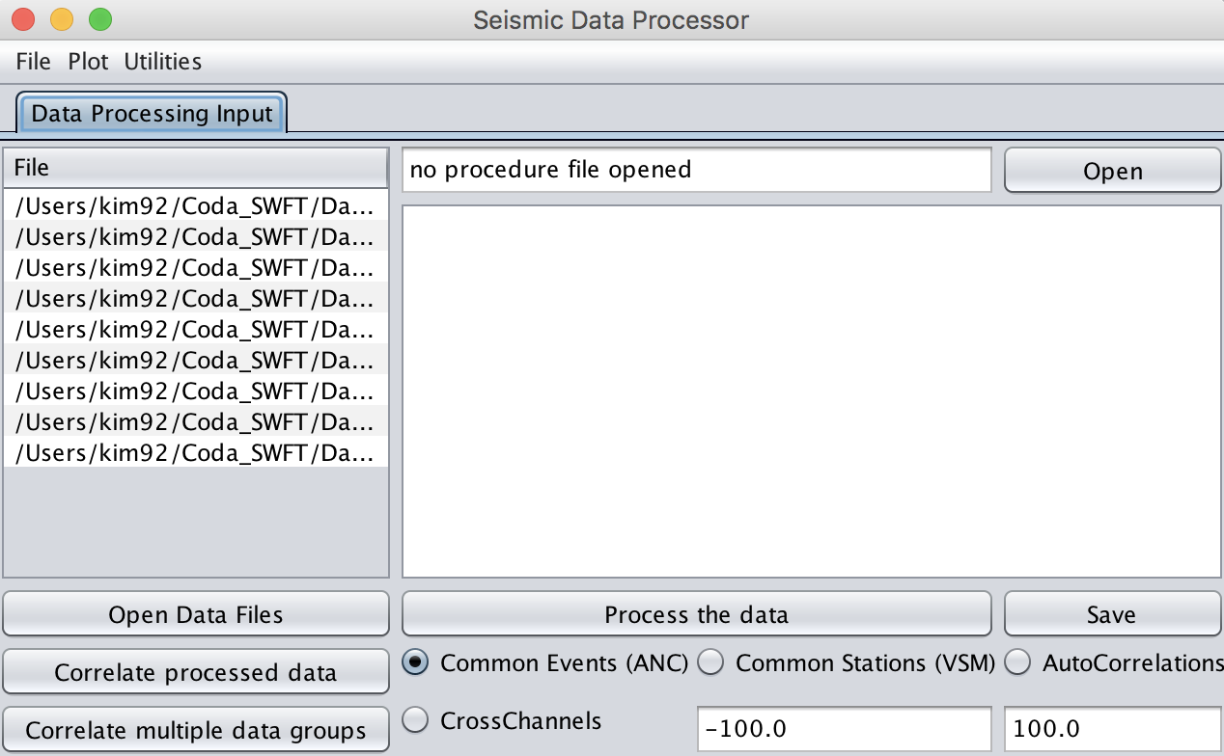
Figure 1.2-1. Load data and left-click either “Correlate processed data” or “Correlate multiple data groups” depending on the input data structure

DESCRIPTION
• This utility allows the user to cross-correlate seismic data.
• SWFT supports three different modules:
- Common Events (ANC): Ambient-noise style cross-correlation. Only seismograms with identical evids are correlated.
- Common Station (VSM): Virtual seismometer style cross-correlation. Only seismograms with identical stations are correlated.
- Autocorrelation: each trace is correlated with itself.

RELATED UTILITY
• Separately Stack Multiple Data Groups
• Jointly Stack Multiple Data Groups
• Stack

EXAMPLE
• How to estimate the Green functions with ambient noise correlation.
• Note each data below were already cut into equal length timeseries SAC files.
• Example data processed below were hour-long SAC files from three 3-component seismic stations (6 hours total with KS.BUS2.BH*sac, KS.NAWB.BH*sac, and KS.SEO2.BH*sac).
Step1. Preprocessing

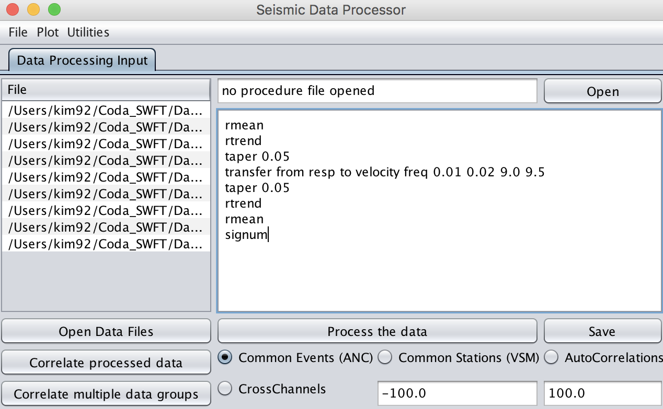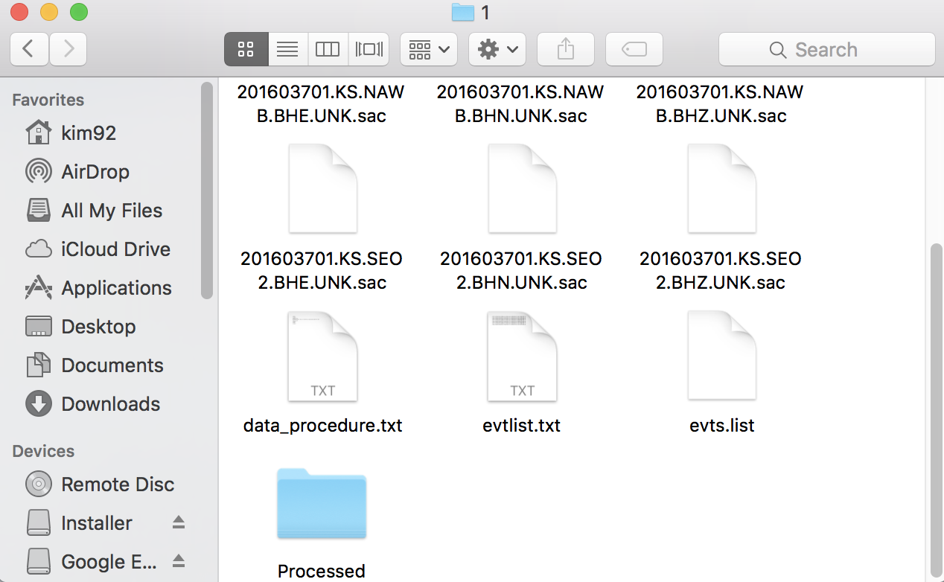
Figure 1.2-2. An example of preprocessing data (left). SWFT supports a batch process in Seismic Data Processor. The user can type desired SWFT commands line-by-line from the top of the red box as shown in the figure. Note: “signum” command is used to normalize every trace to ±1. Hit “Process the data” to continue. The resulting traces will be saved under the automatically created folder named “Processed” under the data directory (right).

IMPORTANT: Batch process in SWFT using the command box does not support multiple data groups.

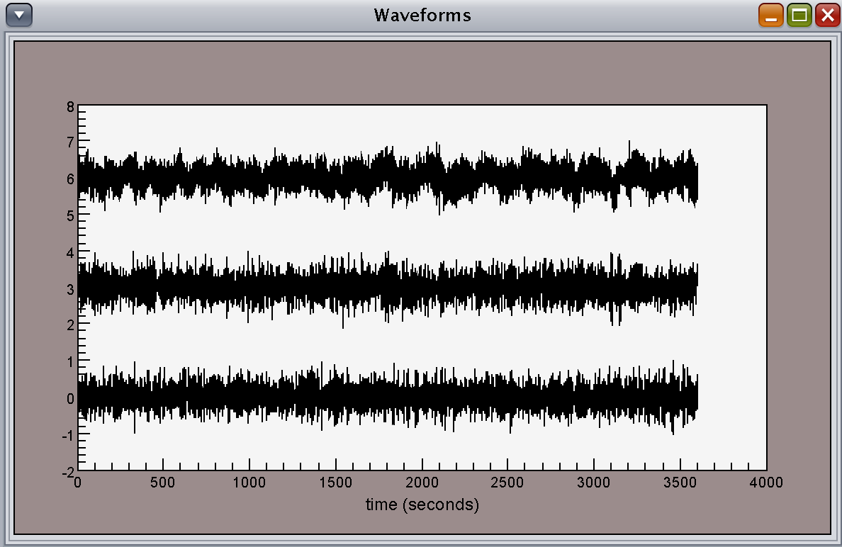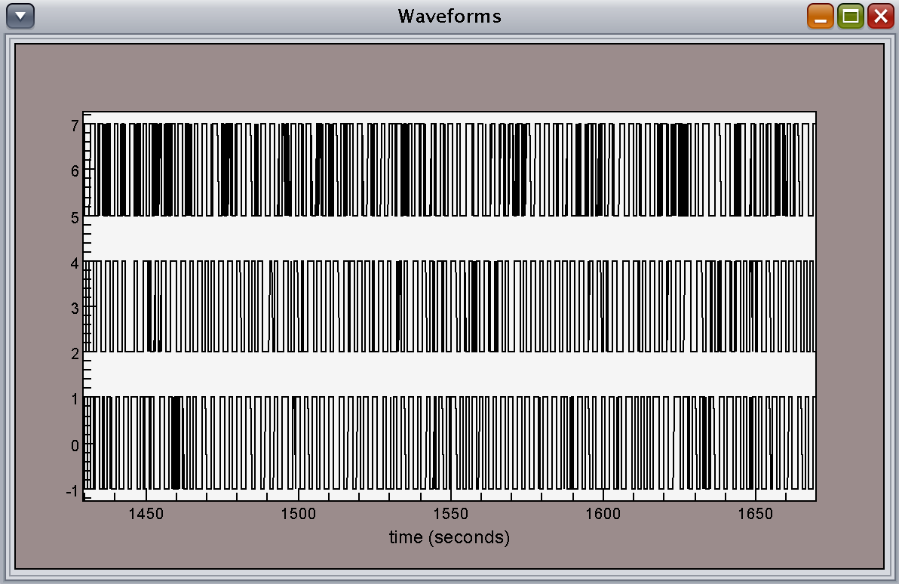
Figure 1.2-3. An example of 3-component hour-long raw data (left: KS.*.BHE*sac) and after preprocessing (right).

Step2. Correlating with respect to common events

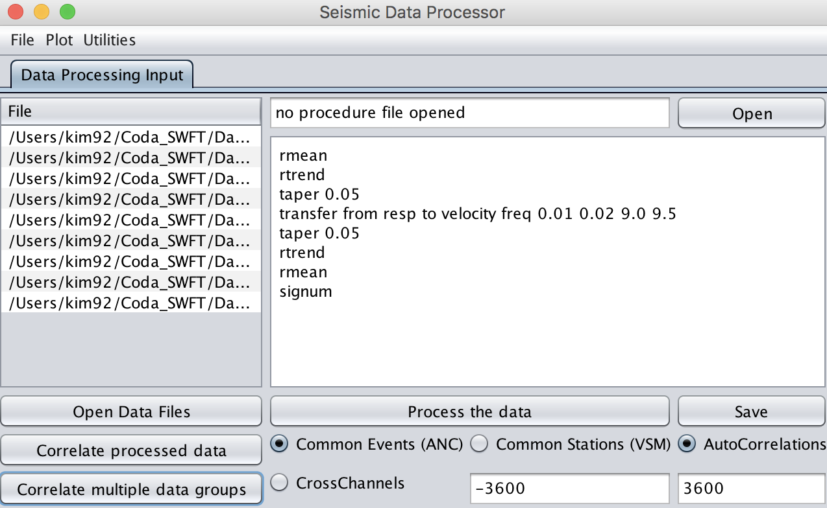
3
2
1
Figure 1.2-4. Correlate data.

1.Select the desired correlation method. In this example, common events and autocorrelation are selected for ambient noise correlation
2. Select a time window for correlation. The values in the left and right boxes represent positive and negative time-lag in seconds, respectively. In this example, full correlation was made using hour-long traces.
3. Select either “Correlate processed data” or “Correlate multiple data groups” depending on the required data structure.

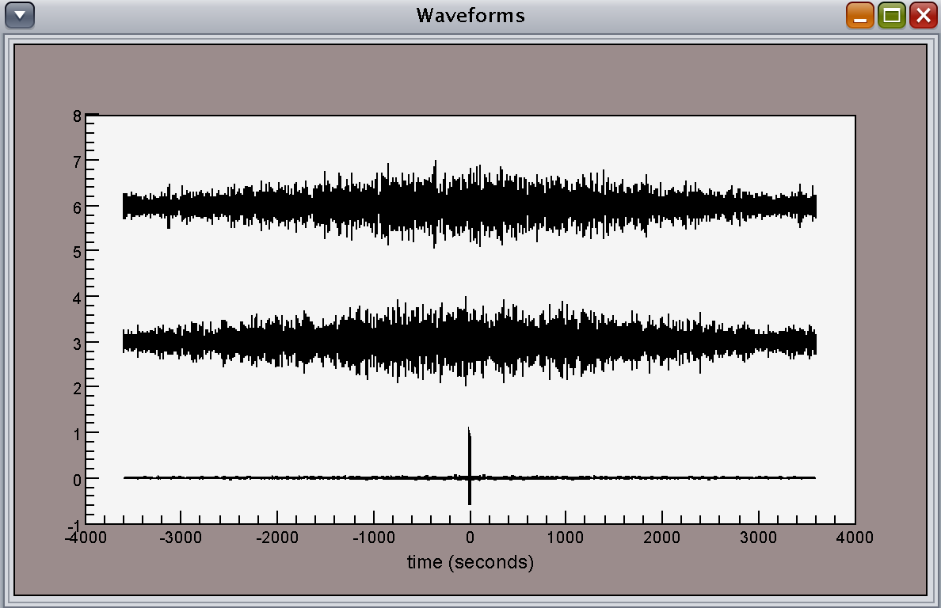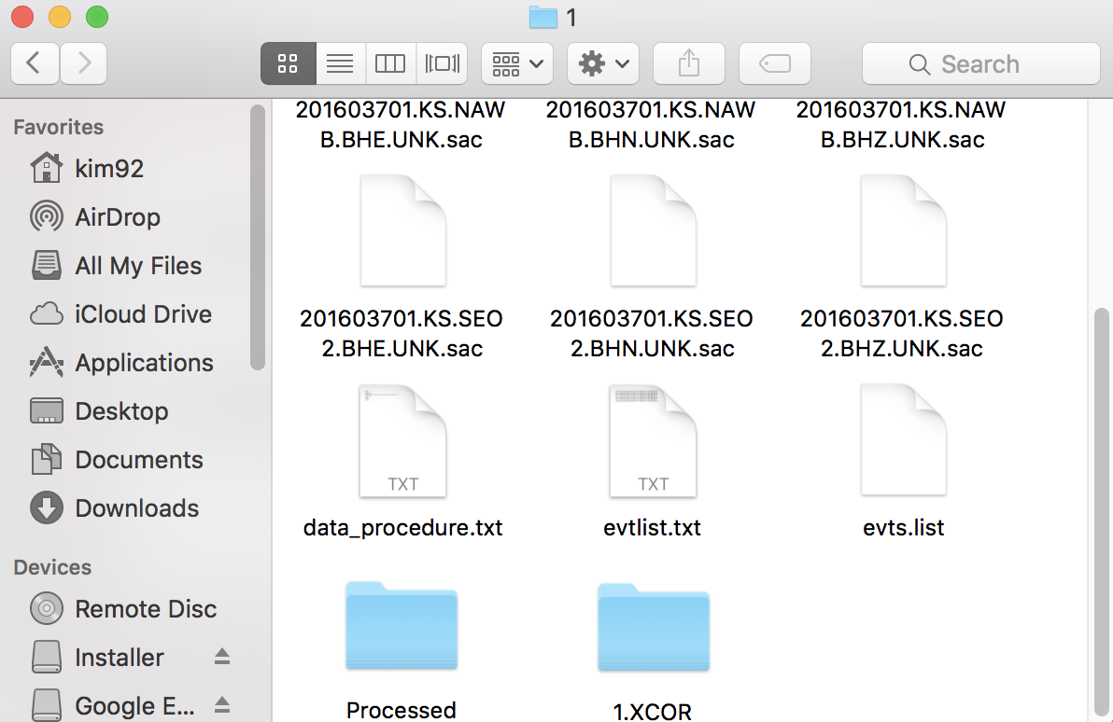
Figure 1.2-5. The correlated traces in lag time (left). The bottom trace is an auto-correlated trace. These resulting traces can be found under an automatically created folder name “1.XCOR” (right).

Step3. Stack the correlated traces

Depending on the input data structure the user can select different ways to create stacked seismograms.

In the Utility drop-down menu bar:
1) Stack – individually loaded SAC files
2) Separately Stack Multiple Data Groups – SAC files loaded with a file list
3) Jointly Stack Multiple Data Groups – SAC files loaded with multiple file lists

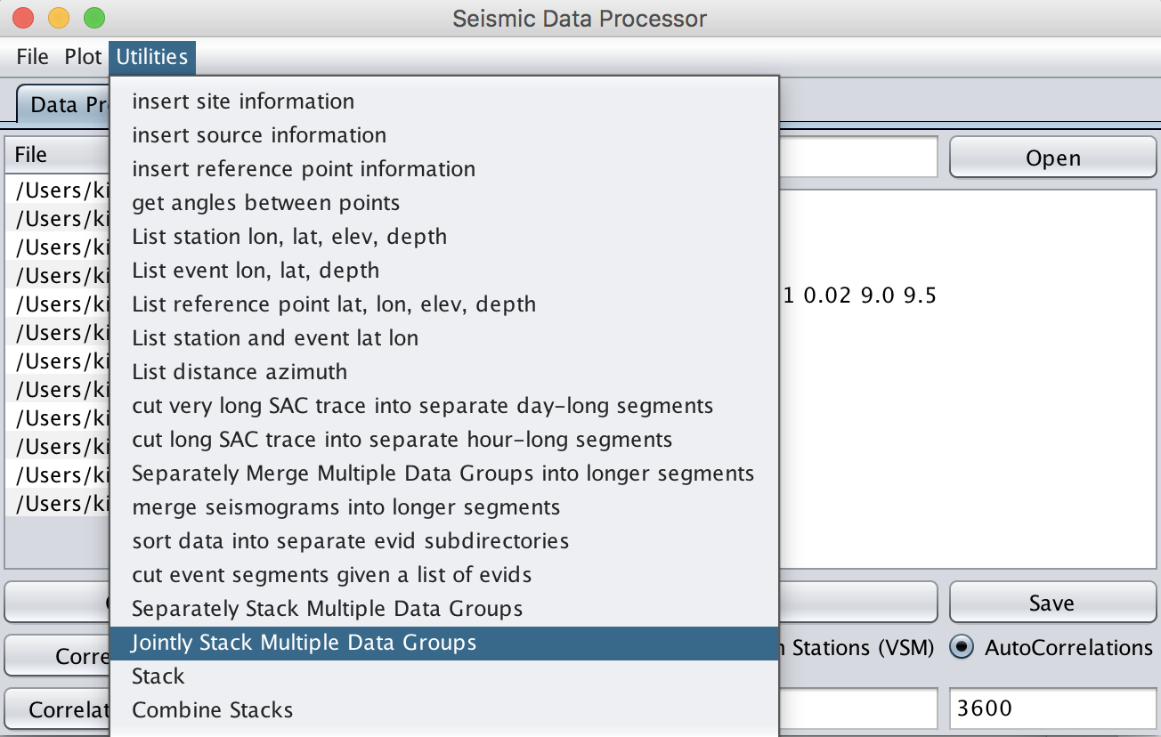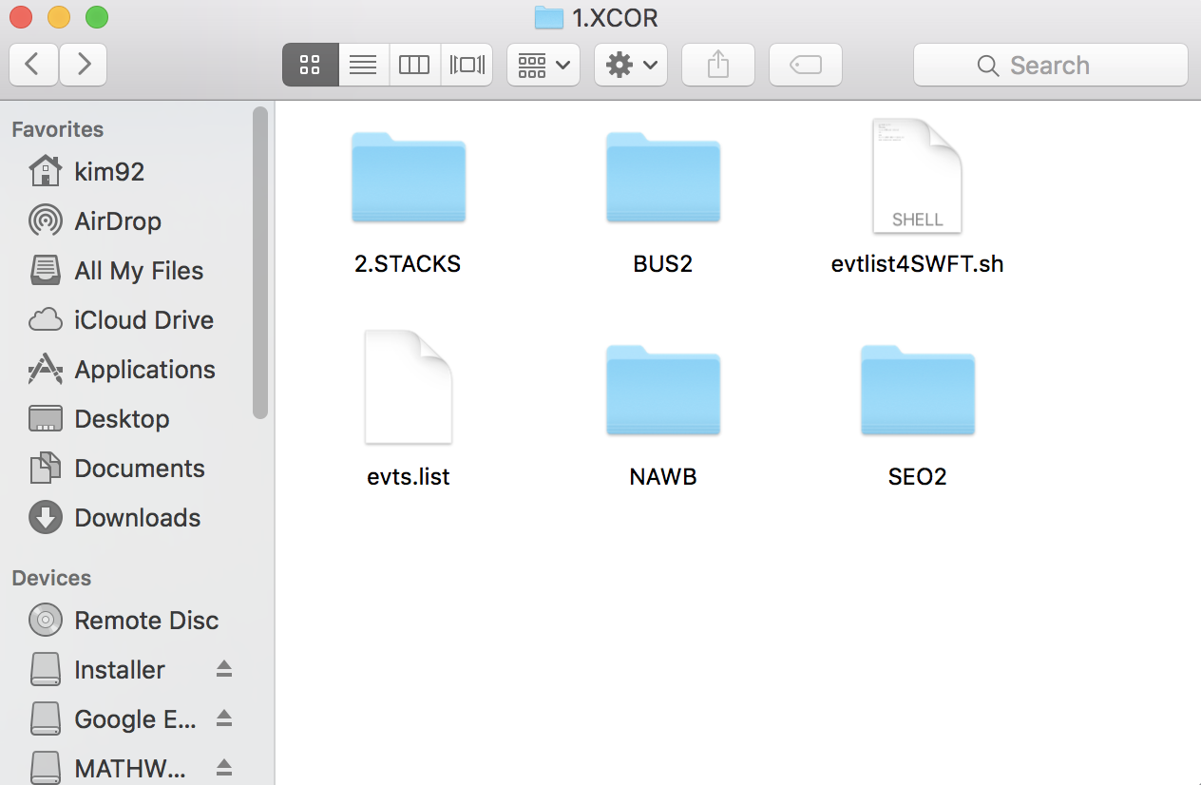
Figure 1.2-6. Stacking the correlated traces (left). The resulting stacked traces can be found under an automatically created folder name “2.STACK”(right). Note “2.STACK” directory has made under “1.XCOR” where the previous input files (first file) are placed.

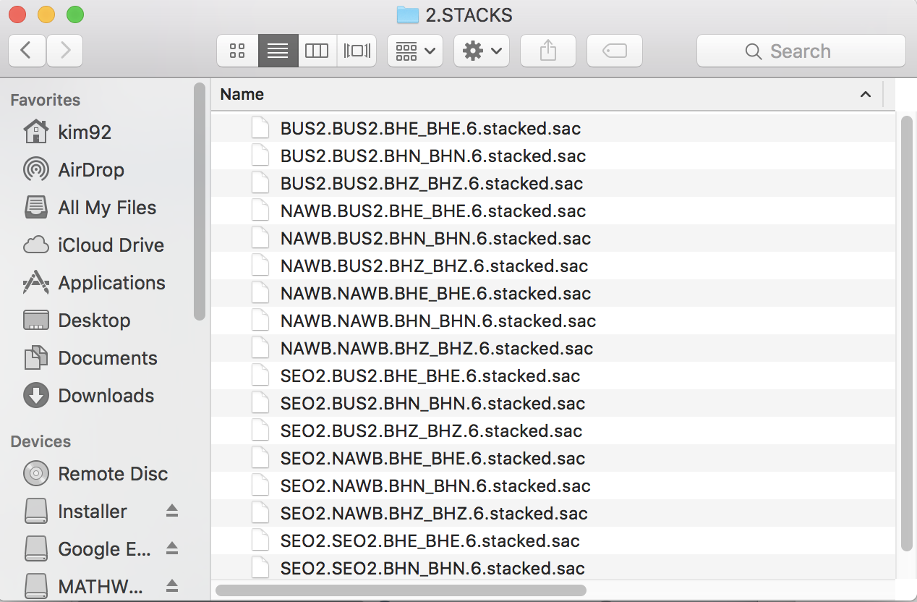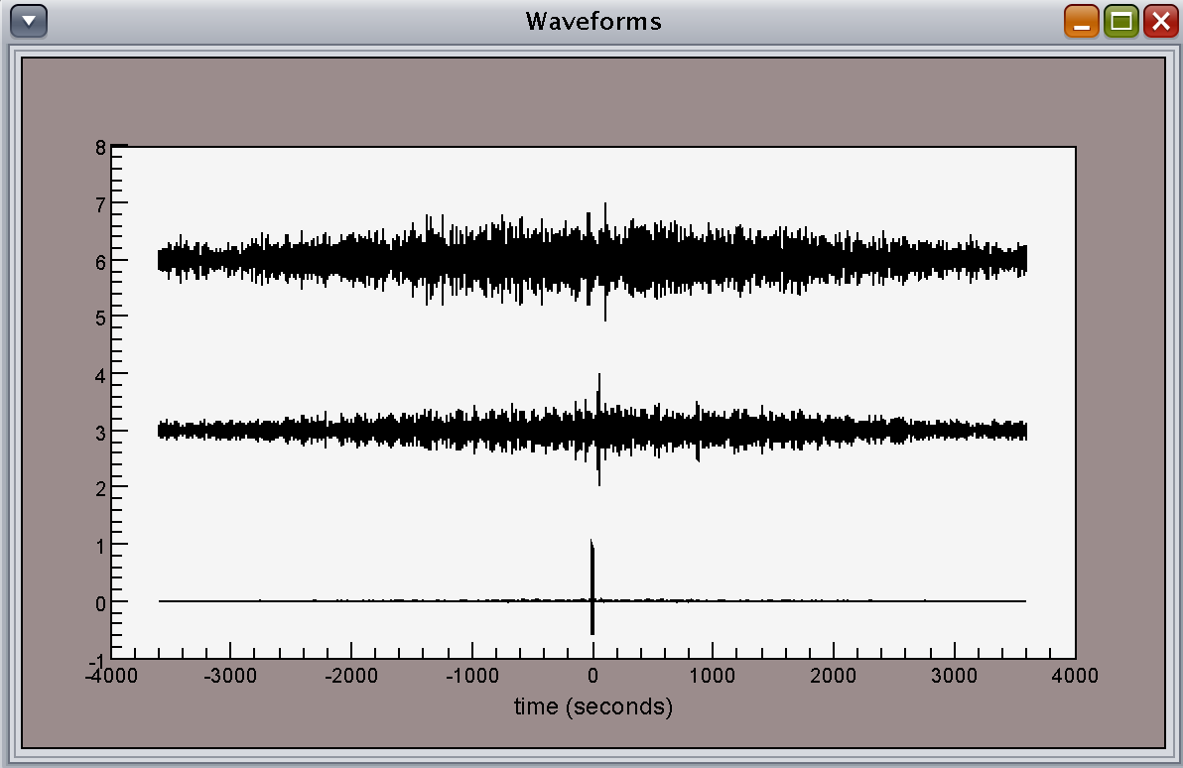
Figure 1.2-7. Final stacked SAC files (left) and 6-hour stacks of correlated recording in Figure 1.2-5.
Note a naming structure of the output (e.g., stacked SAC file): [Station].[Station].[Channel].[Channel].[num of stacks].stacked.sac

Plotting

The Plot tool under Seismic Data Processor allows the user to plot a geometric representation of sources and receivers. “Plot Stations” and “Plot Events” will display the locations of the stations and events from the header SAC variables in the loaded data. Note a yellow star and a black triangle indicate a station and a recorded event, respectively.

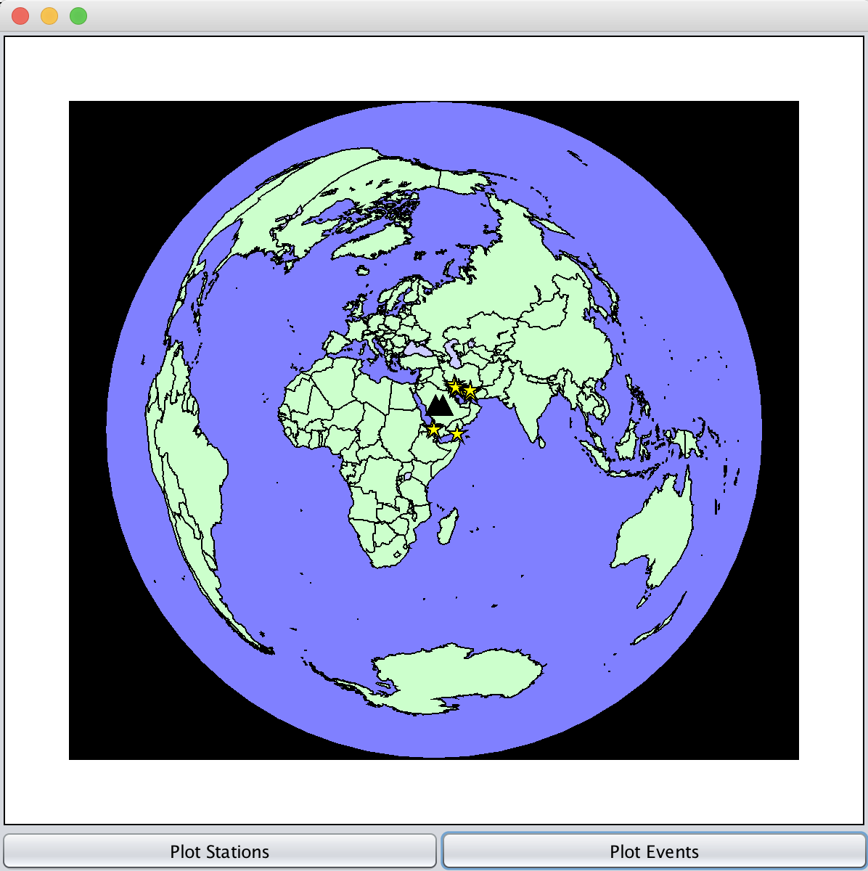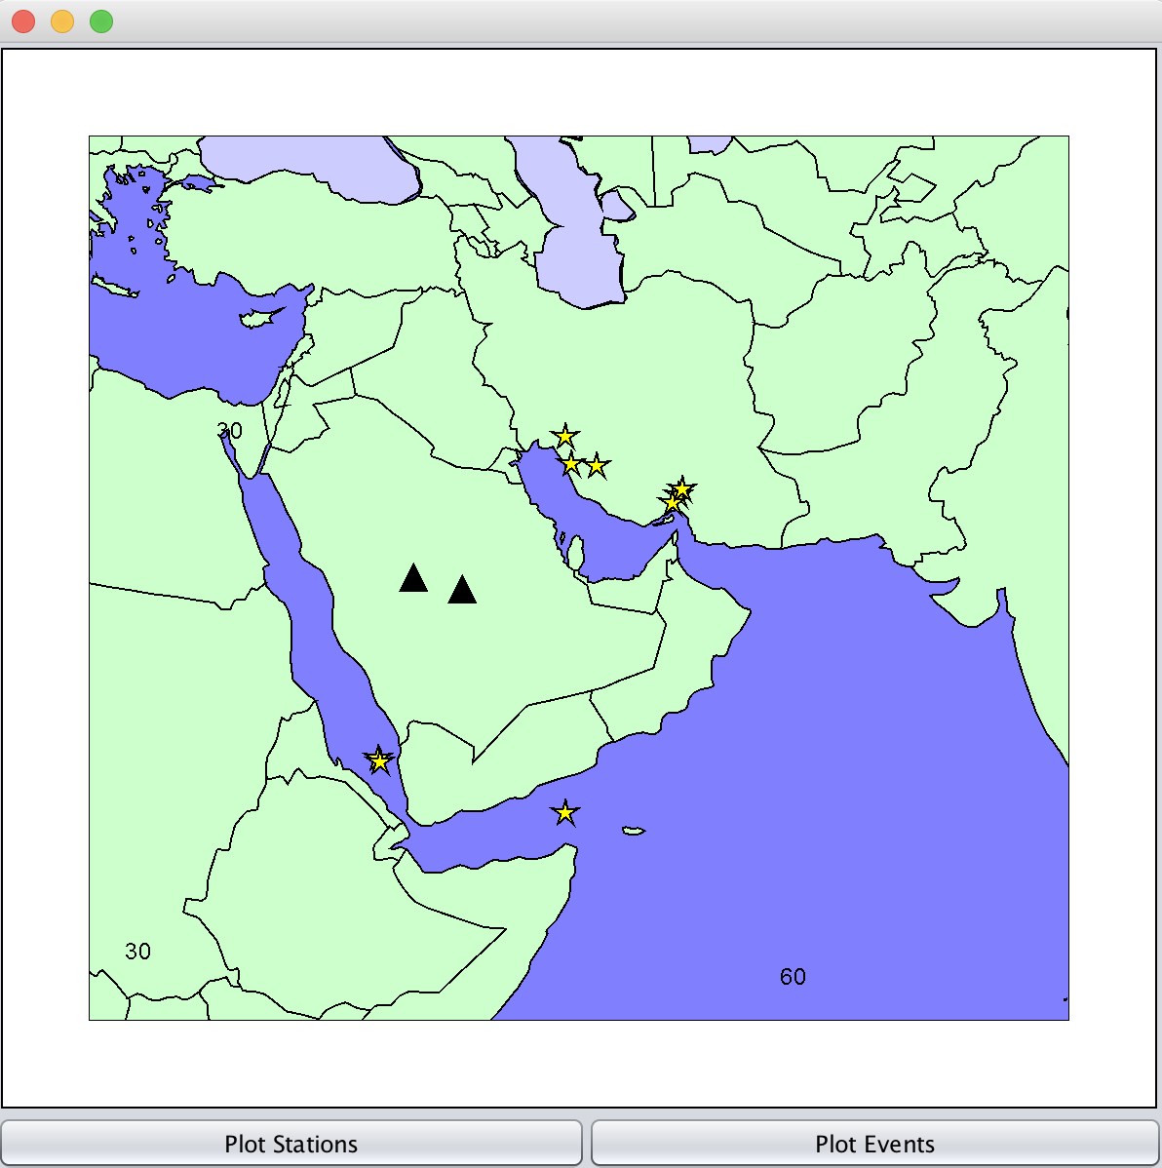

Figure 1.3-1. Plotting stations and events to the map (left) and viewing them in zoomed-in mode (right)

Selecting “Map” from the plot displays a world map interface in a new window.
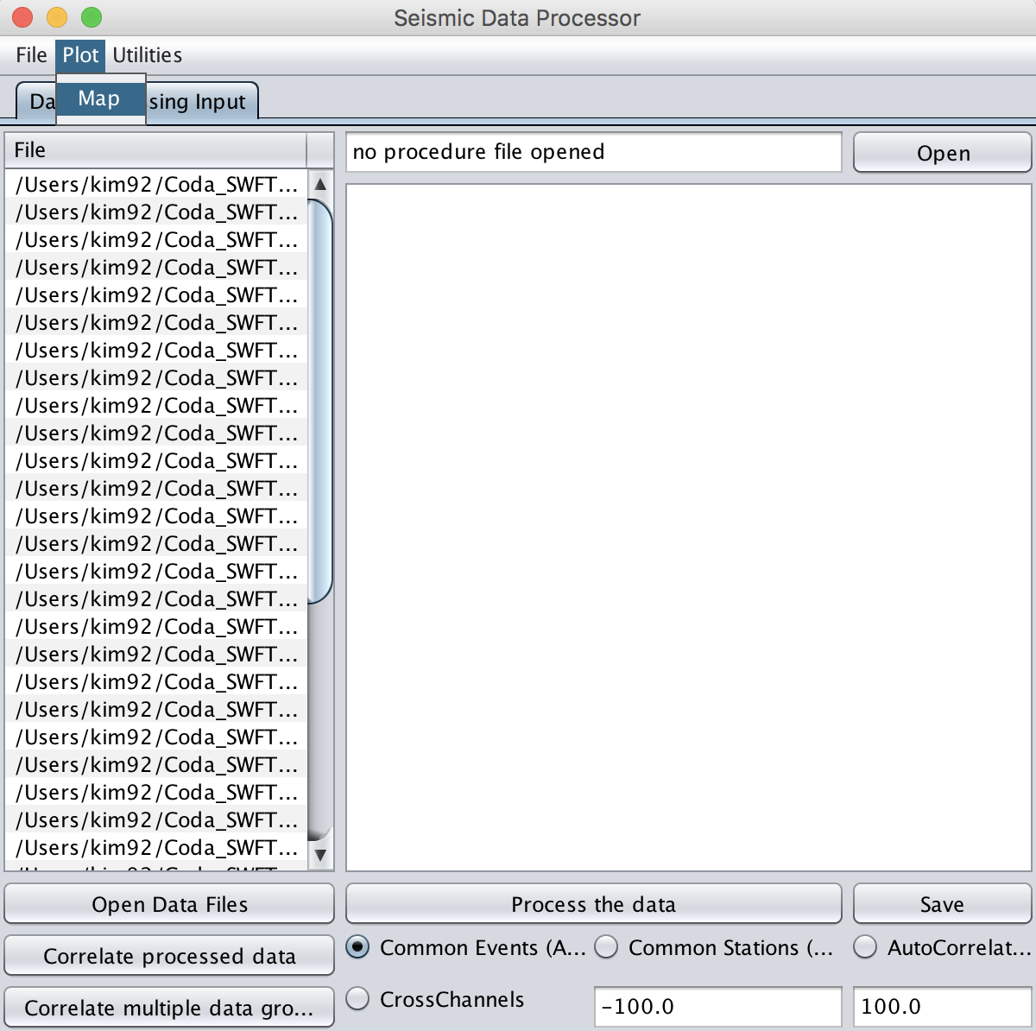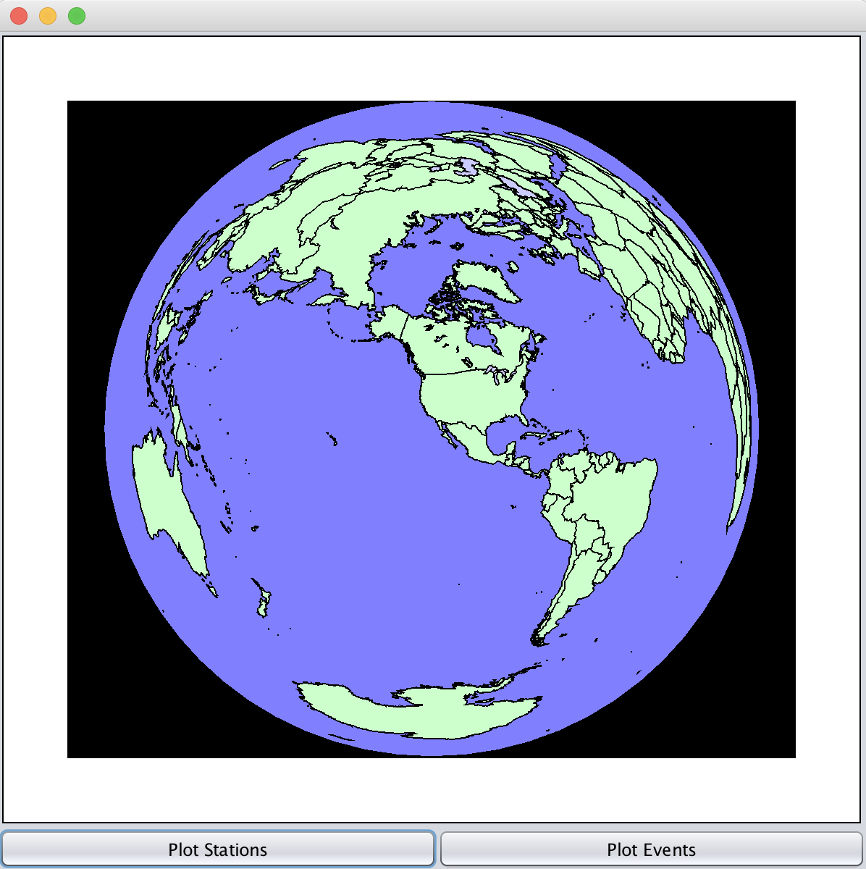

Figure 1.3-2. Using plot tools under Seismic Data Processor (left) and its display (right)

The map allows zooming-in (left-click), zooming-out (right-click) or tilting (shift + left-click).

Utilities

Metadata and Headers

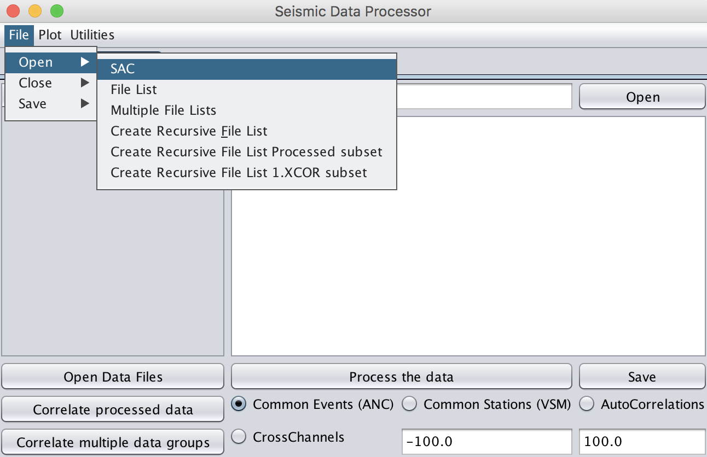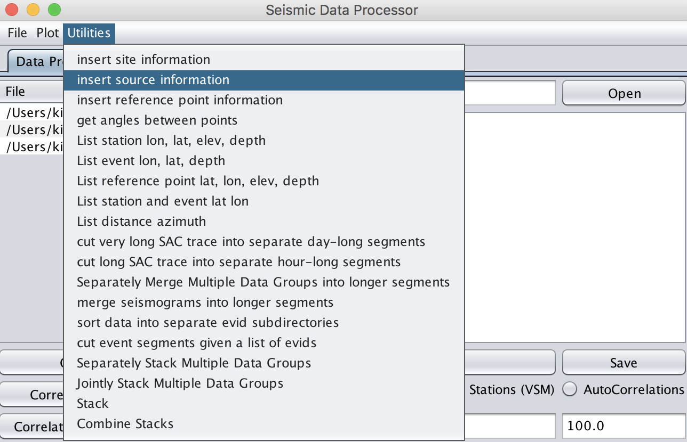
Figure 1.4.1-1. Load data (left) then select insert source information in the drop-down menu (right)

DESCRIPTION
• This utility allows the user to insert the source header information on latitude, longitude, elevation, and depth with a text file.
• Input text file formats are the following:
- Insert site information: station, latitude, longitude, depth, elevation
- Insert source information: evid, latitude, longitude, depth, elevation

RELATED UTILITY
• Insert site information
• Insert reference point information

EXAMPLE
• How to insert the source header information with a text file
lh
:
evdp: 0.0
evel: 0.0
evla: 0.0
evlo: 0.0
nevid: 1603710
:
edit sample_srinsert.txt

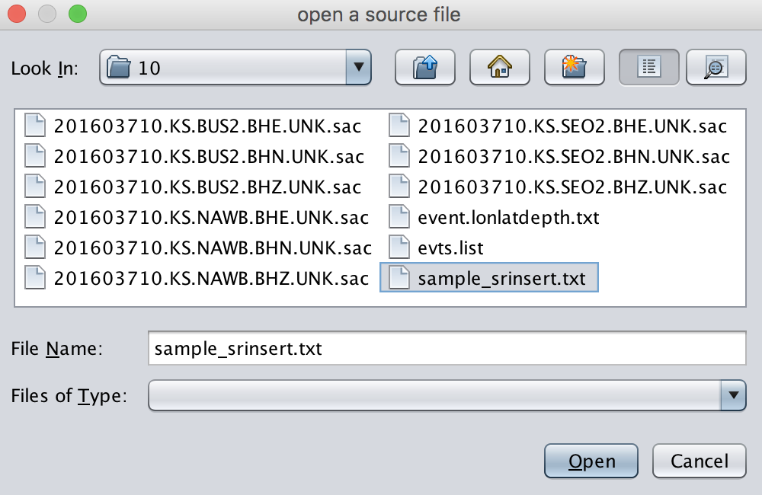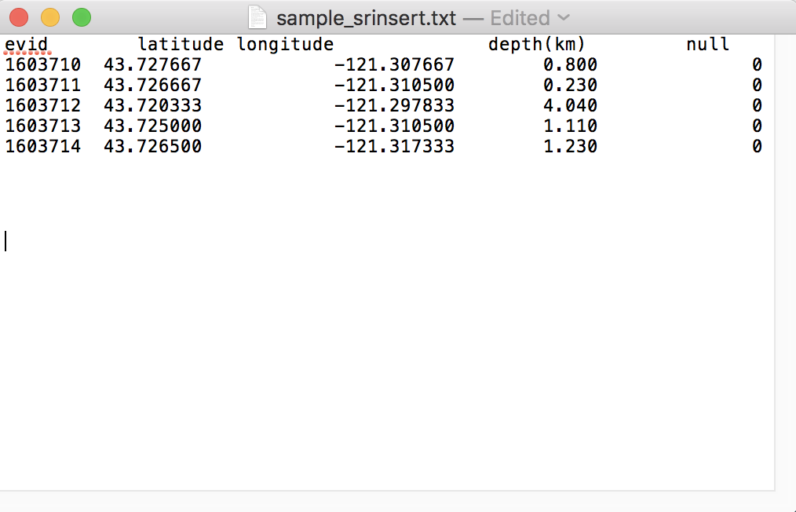
Figure 1.4.1-2. The user will be prompted to open a text file (left) and an example text file of the source header information is shown (right). Note the “null” column (i.e., elevation) is typically undefined in case of inserting source information.

lh
:
evdp: 0.8
evel: 0.0
evla: 43.727667
evlo: -121.307667
nevid: 1603710
:
Console> lh ↵
Console> edit event.lonlatdepth.txt ↵
Console> lh ↵

Trace Segmentation
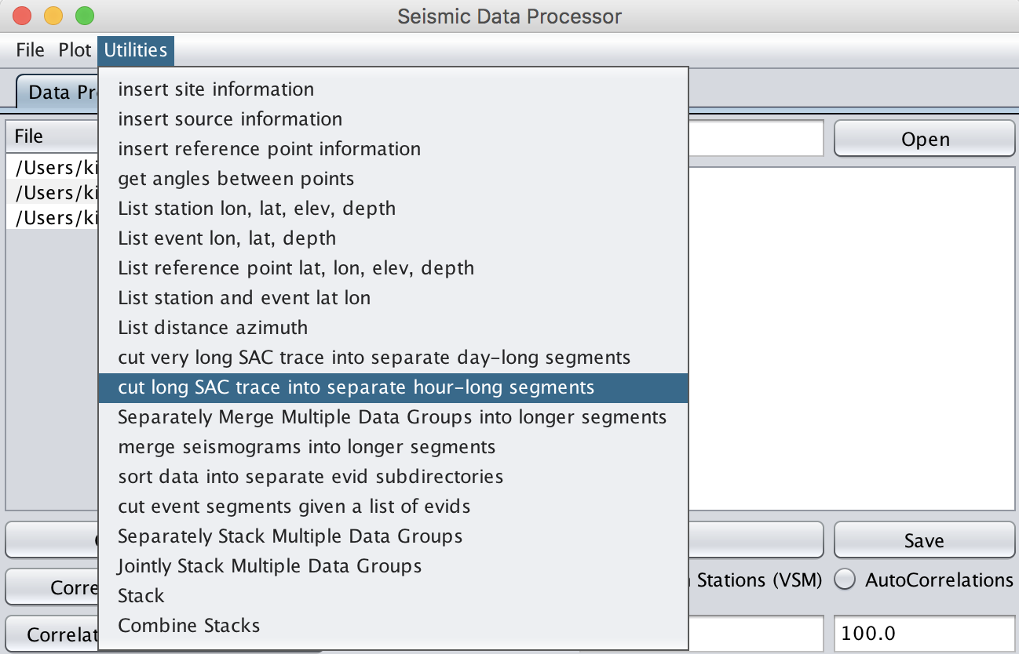
Figure 1.4.2-1. Load data (left) then select cut traces to hour-long segments in the drop-down menu (right)

DESCRIPTION
• This utility allows the user to cut long SAC traces (e.g., a day-long trace) into separate hour-long files.
• The resulting hour-long files are saved under a series of automatically created directories under the current parent directory.

RELATED UTILITY
• cut very long SAC trace into separate day-long segments

EXAMPLE
• How to cut day-long seismograms into hourly segmented traces
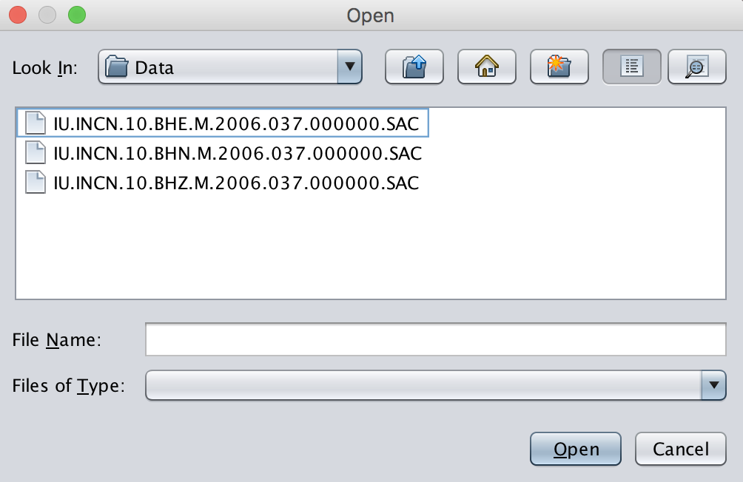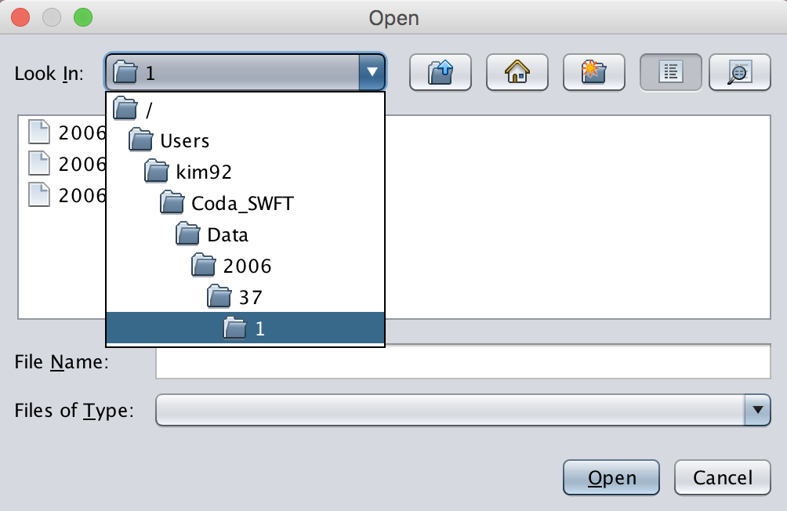
Figure 1.4.2-2. Directory structures of before (left) and after (right) of cutting a series of day-long SAC trace into separate hour-long segments.
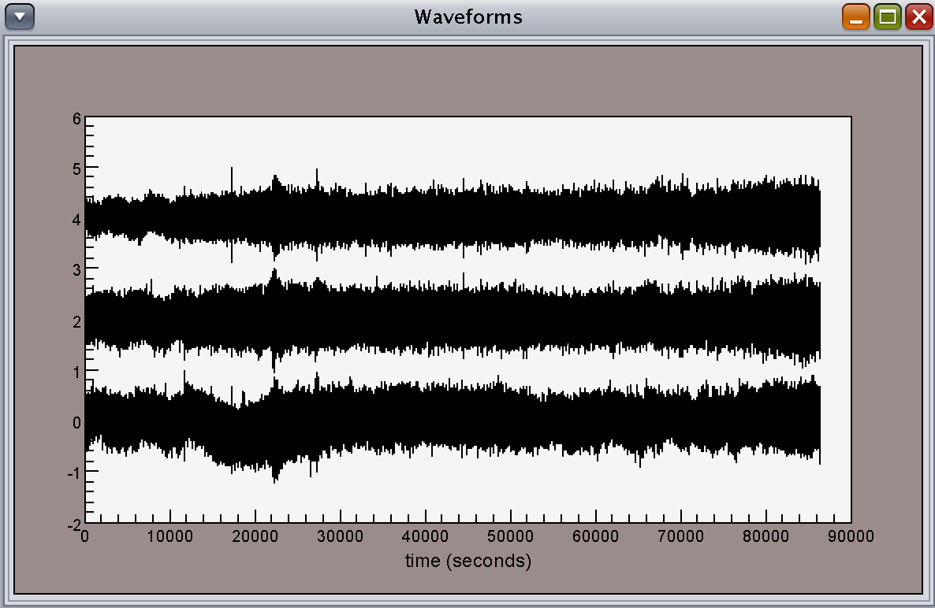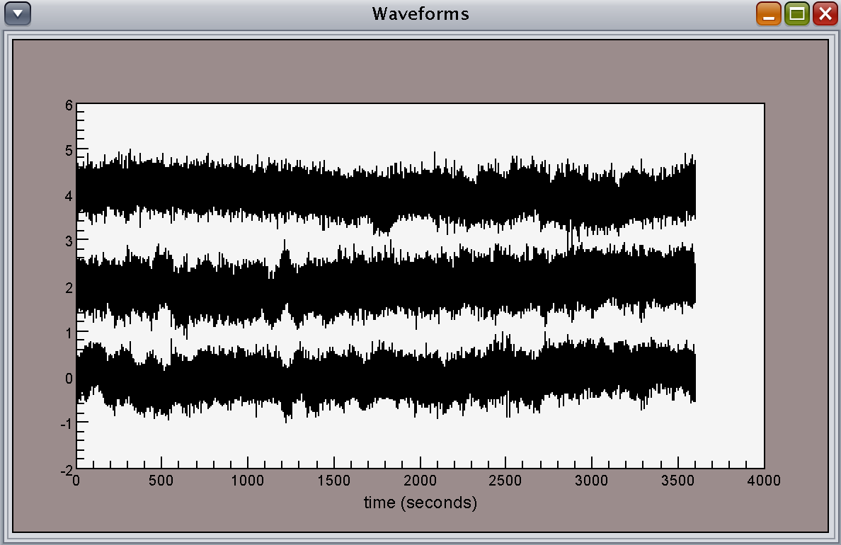
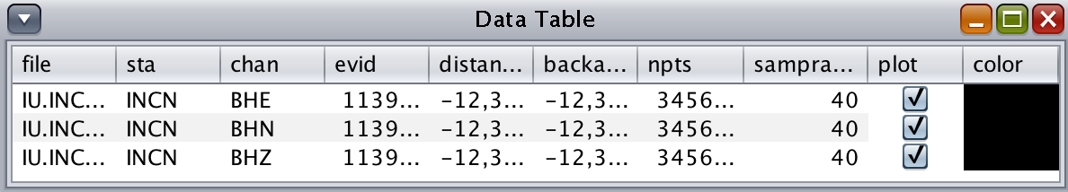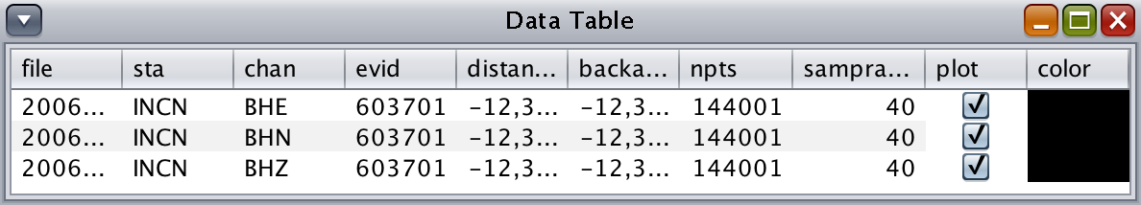
Figure 1.4.2-3. Before (left) and after (right) of cutting a series of day-long SAC trace into separate hour-long segments. Note after using this utility in SWFT Seismic Data Processor, the segmented files will be saved under the automatically generated directories (e.g., year> day> hour).

Merge seismograms into longer segments
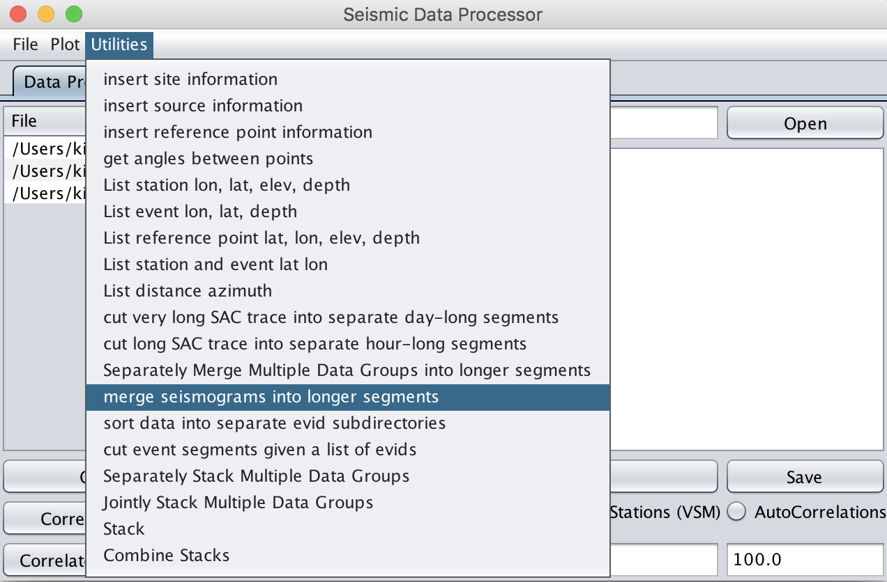
Figure 1.4.3-1. Load data (left) then select merge seismograms in the drop-down menu (right).

DESCRIPTION
• This utility allows the user to merge short SAC traces (e.g., an hour-long trace) into a longer segment
• The resulting hour-long files are saved under an automatically created directory named “MERGED_SEISMOGRAMS” inside the current working directory

RELATED UTILITY
• separately merge multiple data groups into longer segments

EXAMPLE
• How to merge hour-long seismograms into a daily trace
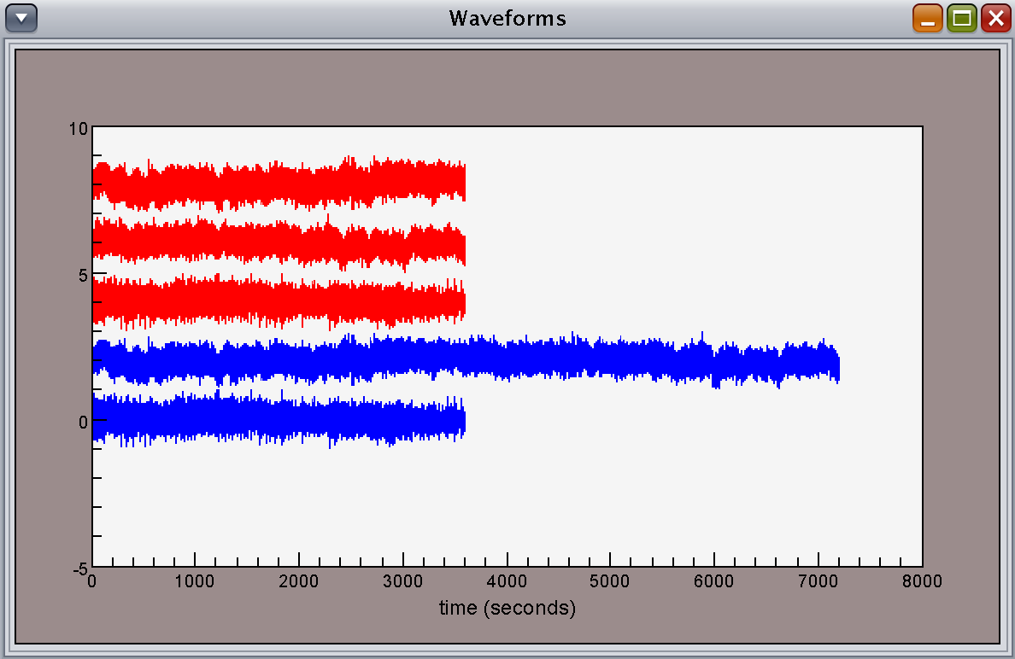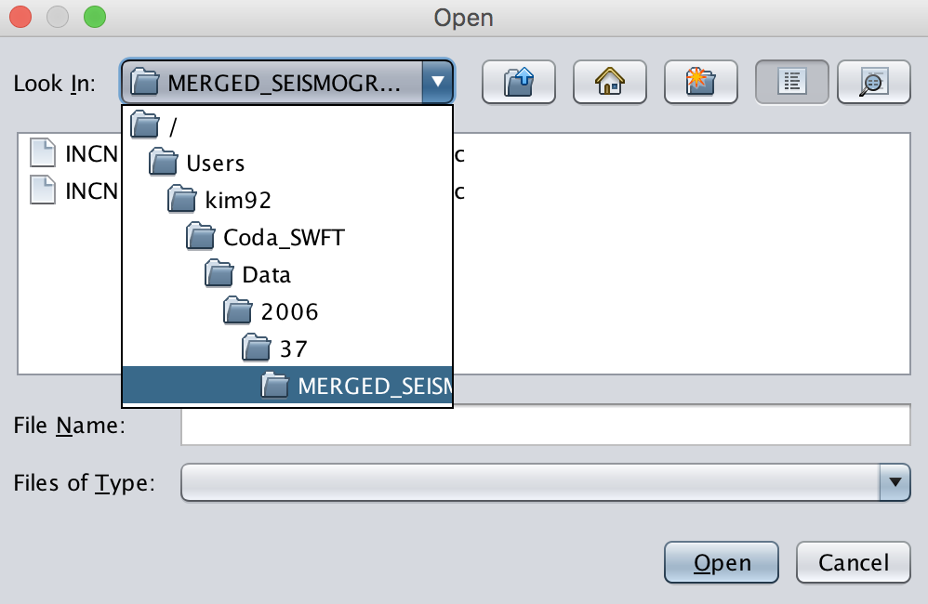
1+2
2+3
2
1
3
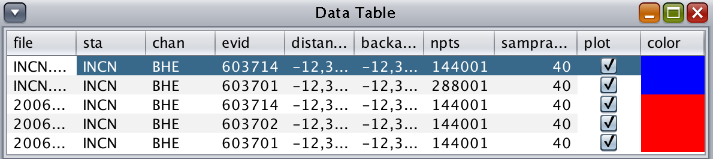
Figure 1.4.3-2. Before (red) and after (blue) of merging short SAC traces into longer segments (left). Note this utility will only effective when the begin and end time of the short SAC traces correspond to one another (e.g., 1+2 vs. 2+3, blue traces). The merged trace will be saved under an automatically created folder named “MERGED_SEISMOGRAM”.

Display/Write Headers
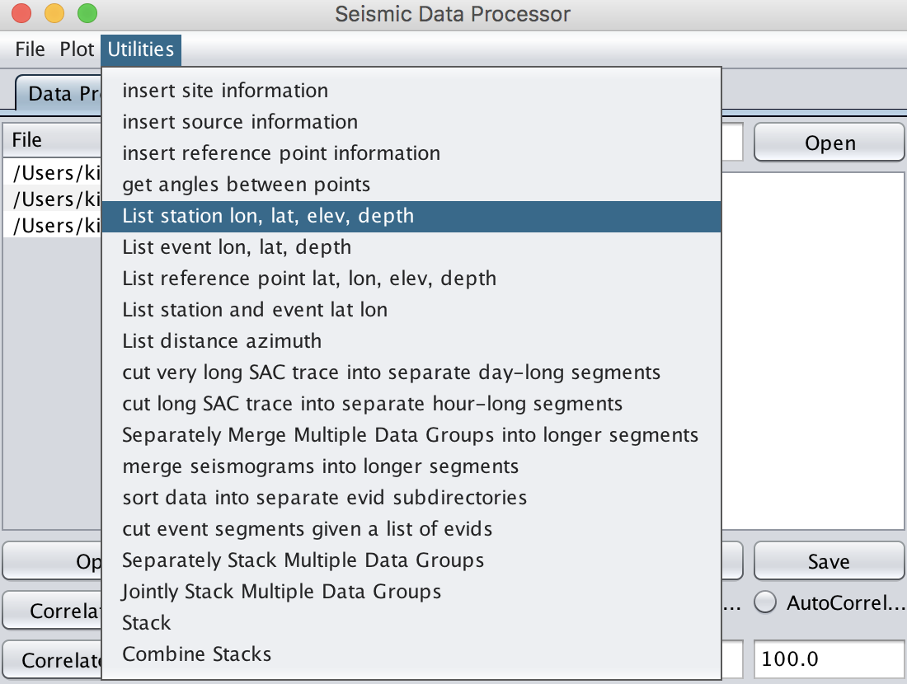
Figure 1.4.4-1. Load data (left) then select list station lat, lon, elev, depth in the drop-down menu (right)

DESCRIPTION
• This utility allows the user to write the station header information on latitude, longitude, elevation, and depth into a separate text file.

RELATED UTILITY
• List event lat, lon, and depth
• List reference point lat, lon, elev, and depth
• List station and event lat, and lon
• List distance and azimuth

EXAMPLE
• How to write the stations header information into a separate text file

lh
:
200603701.IU.INCN.BHE.UNK.sac
200603701.IU.INCN.BHN.UNK.sac
200603701.IU.INCN.BHZ.UNK.sac
station.lonlatdepth.txt
:
edit station.lonlatdepth.txt

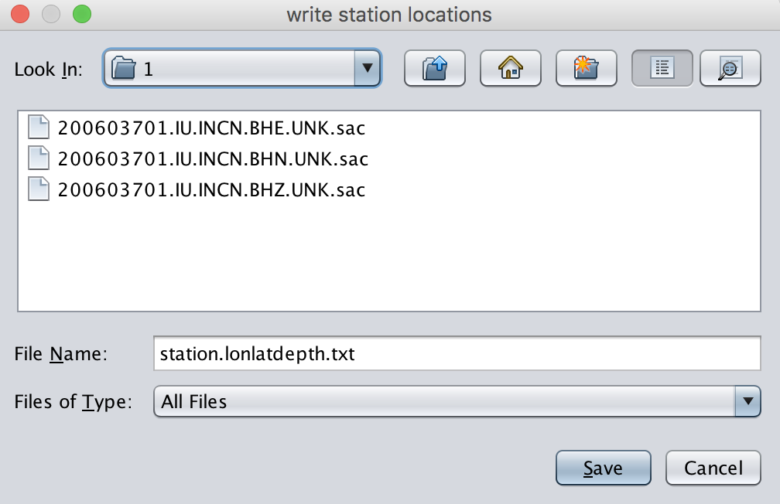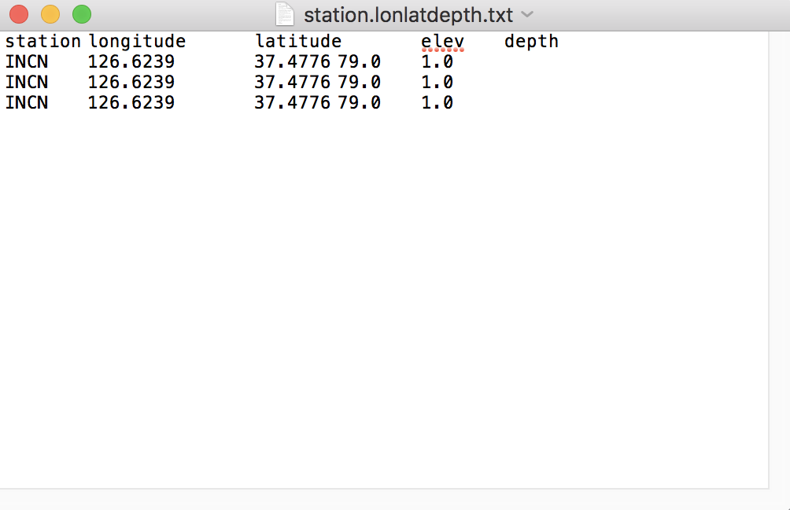
Figure 1.4.4-2. The user will be prompted to write the list into a file (left) and once the file has saved, use “edit” command to check if correct information is written.
Console> lh ↵
Console> edit station.lonlatdepth.txt ↵

Sort data
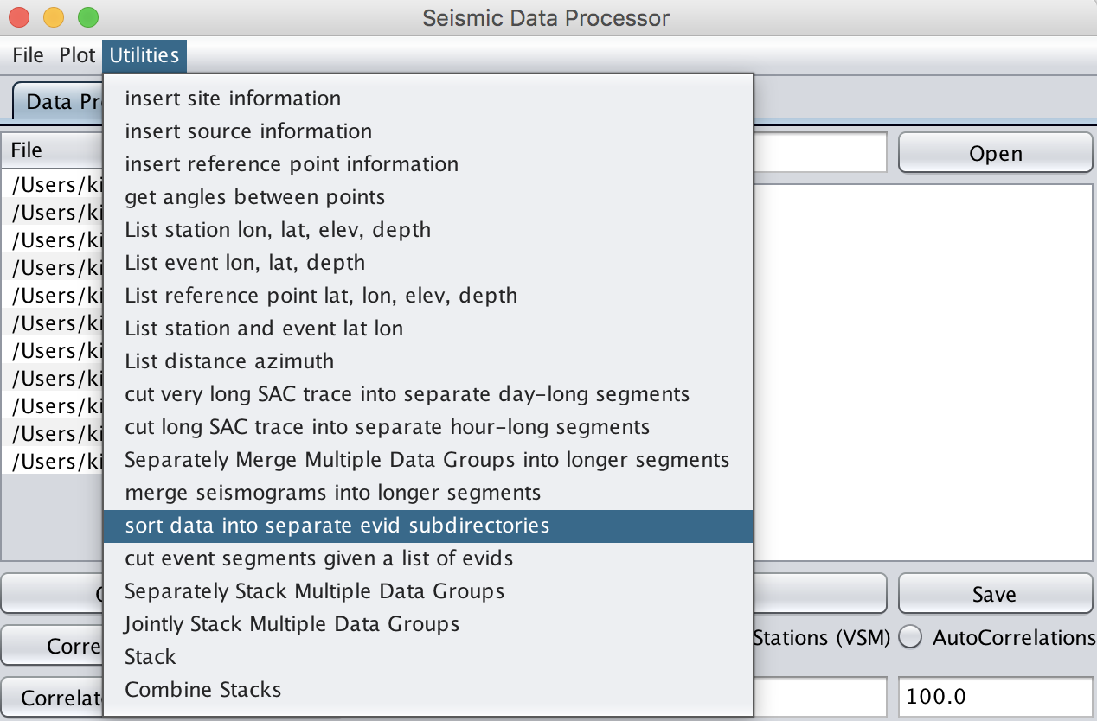
Figure 1.4.5-1. Load data (left) then select sort data into separate evid subdirectories in the drop-down menu (right).

DESCRIPTION
• This utility allows the user to organize all of SAC files based on their “evid” and separate them into the corresponding automatically created subdirectories.

EXAMPLE
• How to sort multiple SAC files with different “evids”

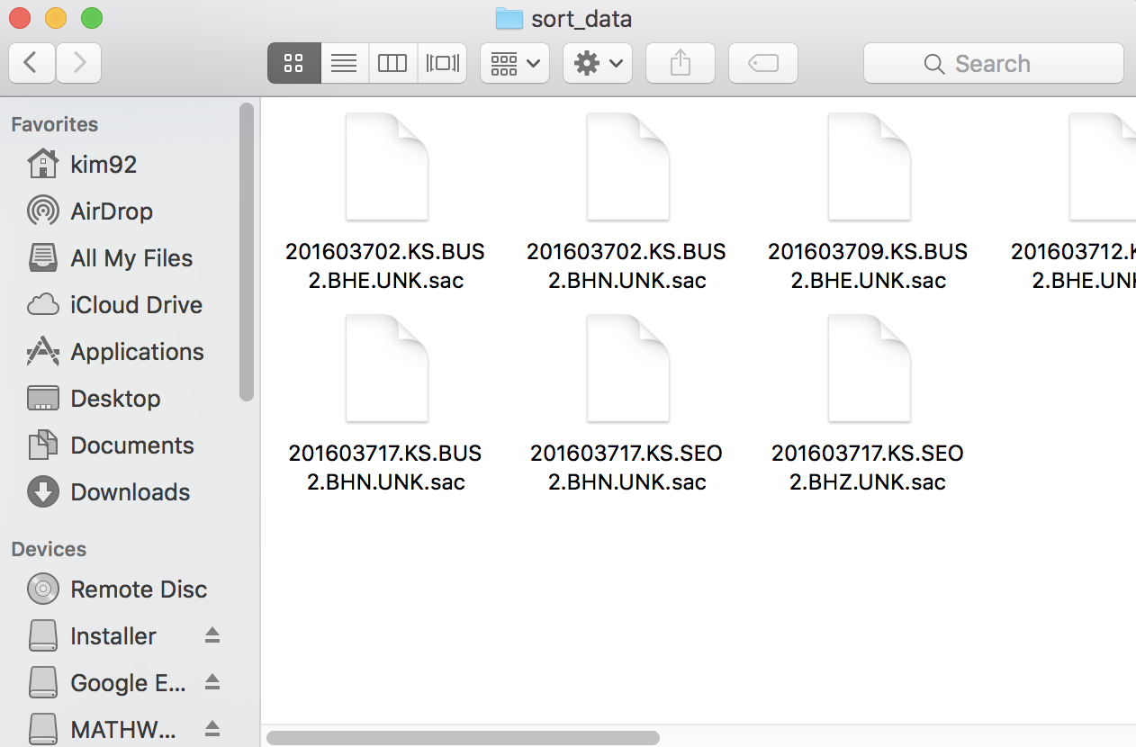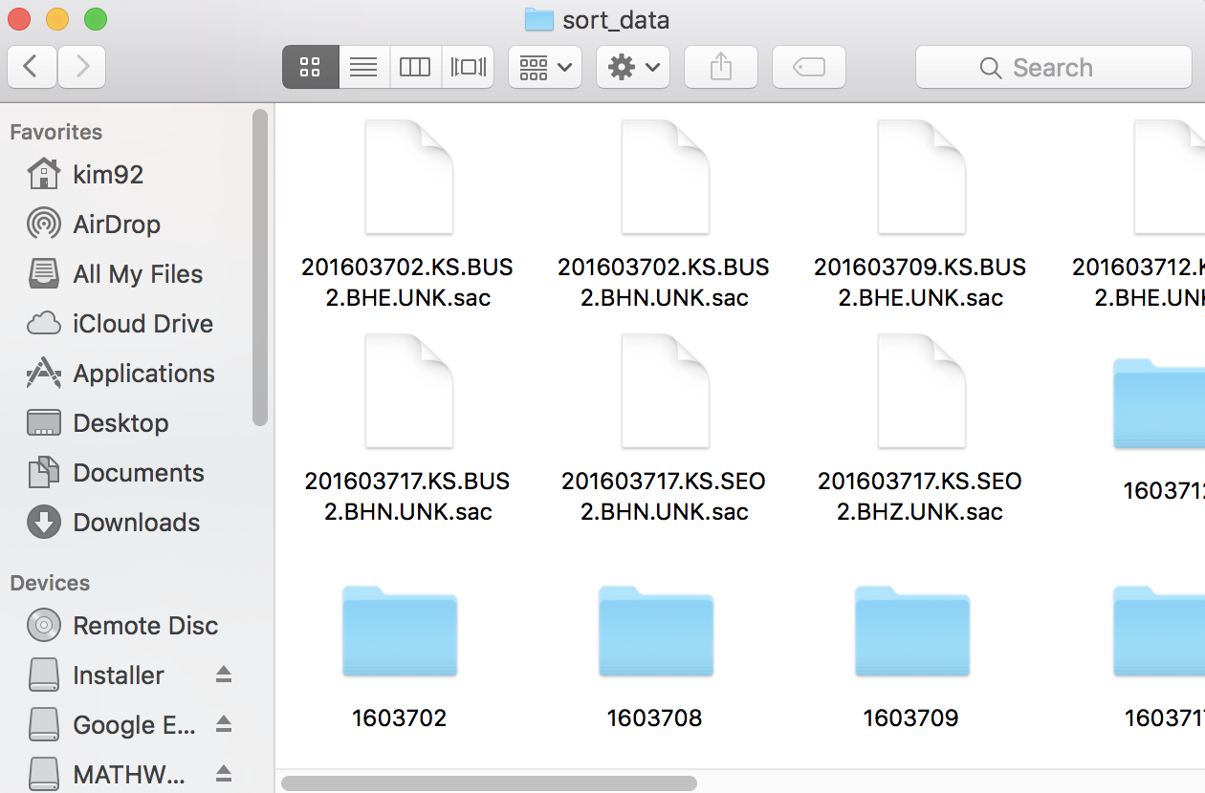
Figure 2-20. Before (left) and after (right) sorting data. Note newly created directories named after the “evids”.

1.4.6 Segment Event List

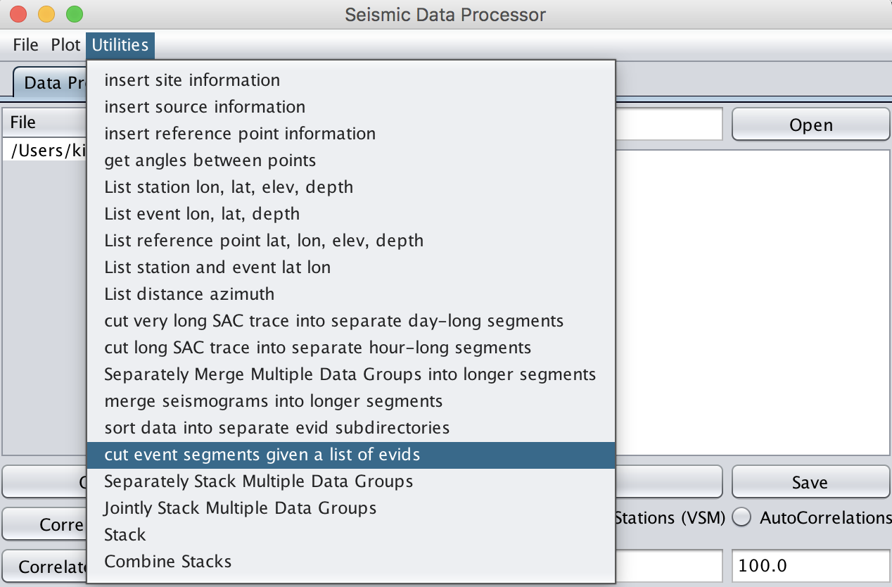
Figure 1.4.6-1. Load data (left) then select cut event segments given a list of evids in the drop-down menu (right).

DESCRIPTION
• This utility allows the user to cut data into segments given a text file that has list of “evids” and other header information (e.g., origin time, lat, lon, etc.)

EXAMPLE
• How to cut an hour-long SAC files into five event segment files given a list of “evids”
Note this example is provided with a list of hypothetical events
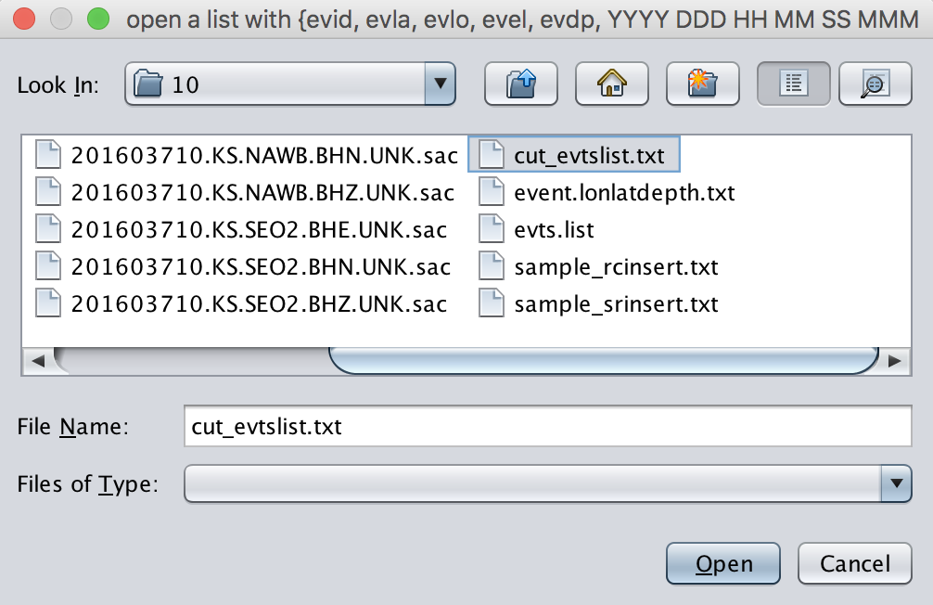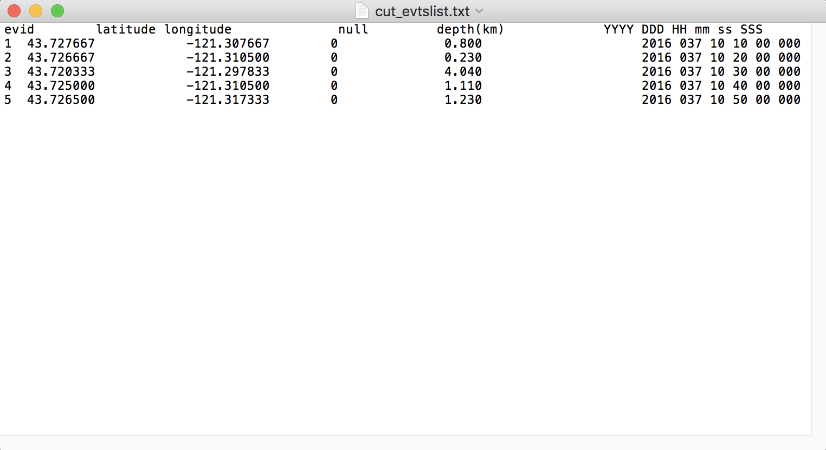
Figure 1.4.6-2. The user will be prompted to open a text file (left) and an example text file of “evid” list is shown (right).

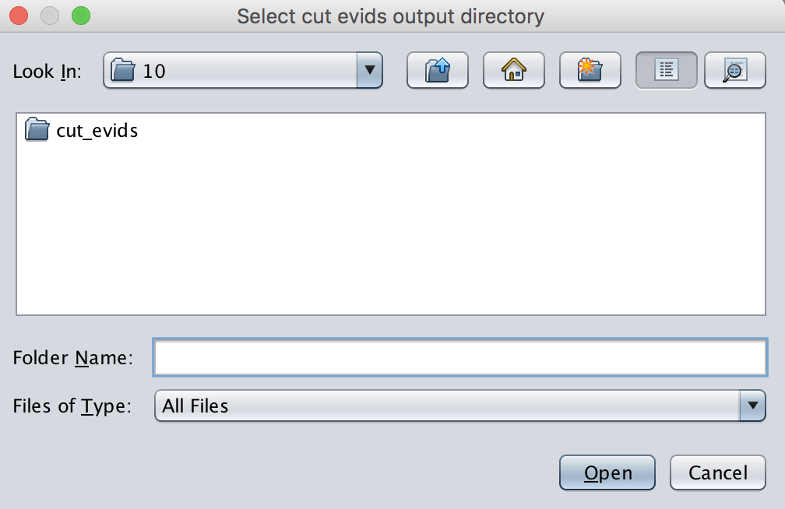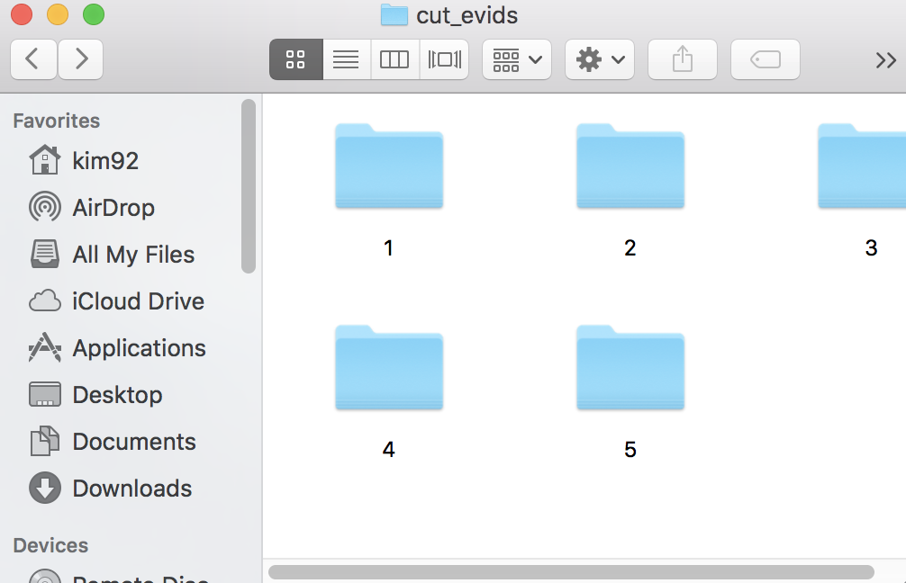
Figure 1.4.6-3. After inputting the “evid” list the user will be prompted to select or create a directory to place the segmented data (left). Note the automatically created five directories given a list of five events (i.e., evid=1~5) (right).

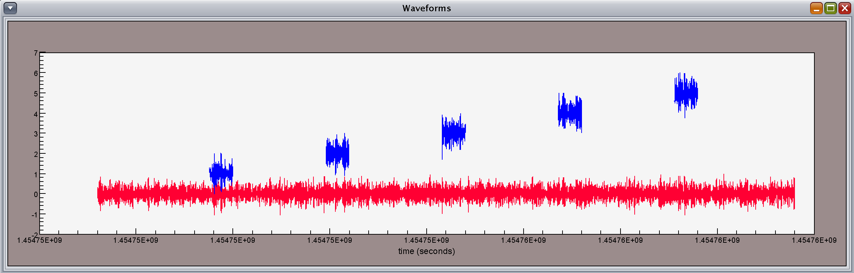
Figure 1.4.6-4. The raw hour-long SAC data (red) and the five segmented events of the given orgintime (blue).
Console> profile 1 ↵
Console> align b ↵

Regional Body-Wave Amplitude Processor

SWFT supports amplitude measurements of regional phases (e.g., Pn, Pg, Sn, Lg, and Noise) for given frequency windows. The obtained amplitude measurements can later be used for e.g., Magnitude and Distance Amplitude Correction (MDAC). The following example provides step-by-step instructions.

Step 1. Input data and relevant parameters (e.g., velocity model and frequency bands).

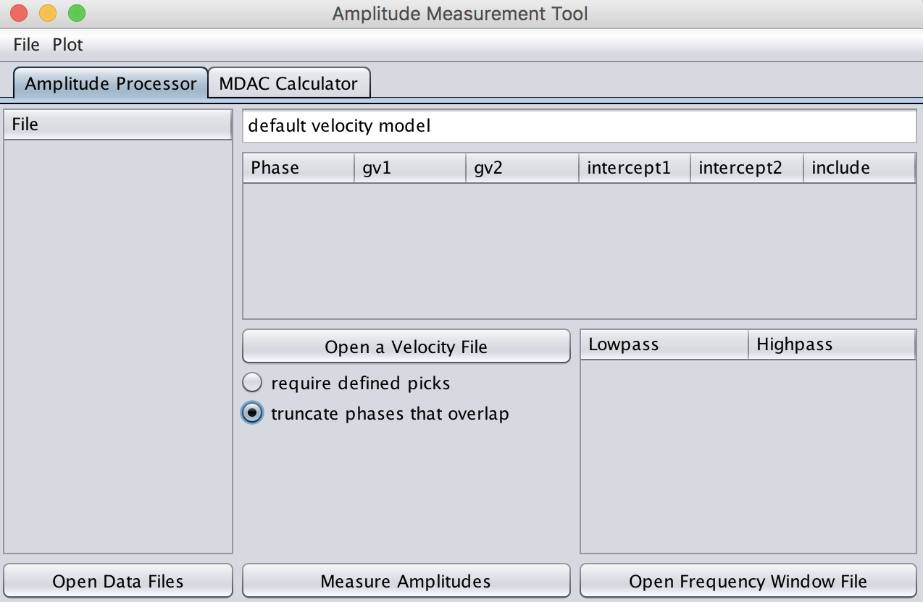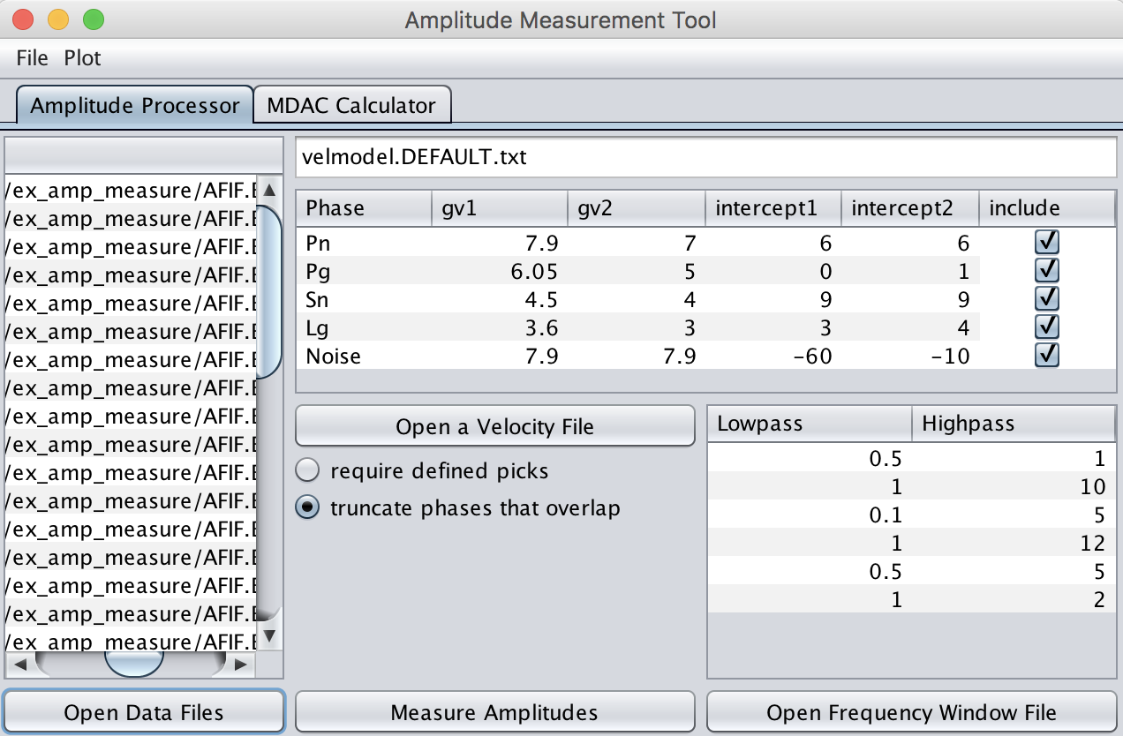
Figure 2-1. Load data, velocity file, and frequency window file in Amplitude Measurement Tool to measure amplitudes for given phases in each frequency band (click on Open Data Files, Open a Velocity File, and Open Frequency Window File in red boxes to load each data file) (left).

Note the five phases and the six different frequency ranges are given for this specific exercise as shown in Figure 2-2. When the input files are correctly loaded, those parameters will be populated to the corresponding sub-window under its field IDs (e.g., velocity file – Phase, Group Velocity 1, Group Velocity 2, Intercept 1, Intercept 2, and Include; frequency window file – Lowpass and Highpass frequency) (right, Figure 2-1).

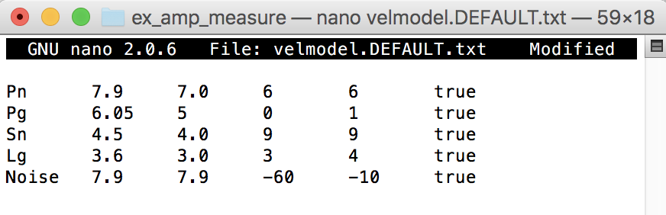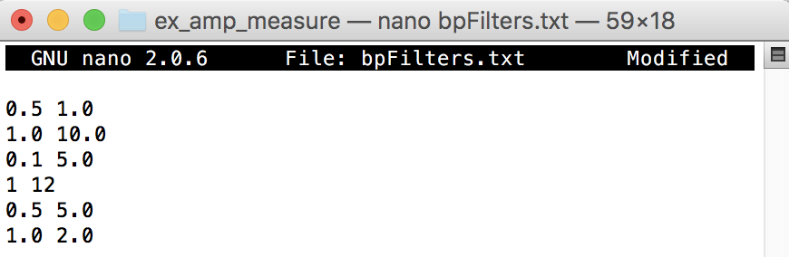
Figure 2-2. Examples of the velocity (e.g., velmodel.DEFAULT.txt) and frequency window files (e.g., bpFilters.txt).

Step 2. Measure Amplitudes of the input data

IMPORTANT: Check or uncheck “Required Defined Picks” (red box, Figure 5-3).
1) Checked – amplitudes will be measured based on the time windows of each phase defined by the given velocity file (picks shown in gray, right, Figure 2-3)
2) Unchecked – amplitudes will be measured based on the time windows of each phase defined by the user picks (picks shown in red, right, Figure 2-4)

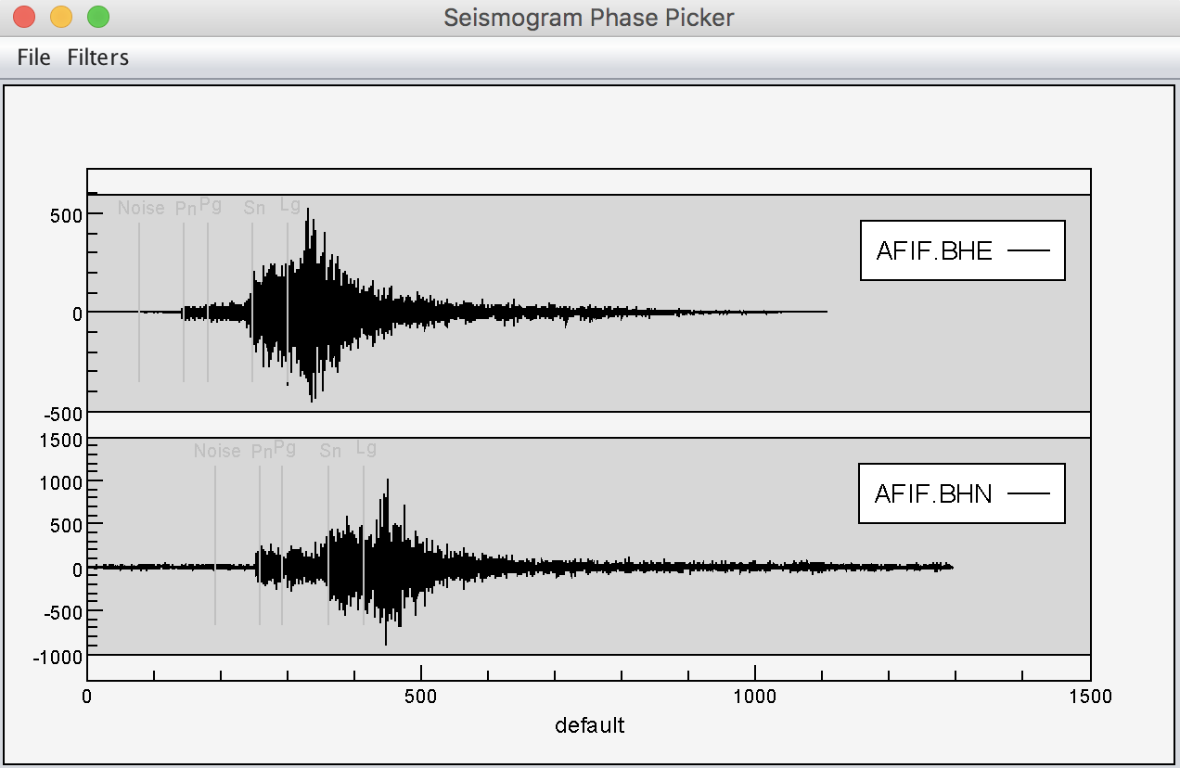
Figure 2-3. Measuring amplitudes based on the input group velocities. After unchecking “Require Defined Picks”, click on “Measure Amplitudes” (i.e., lower red box) to calculate amplitudes (left). Note gray lines indicate phase picks based on the input group velocities (right).

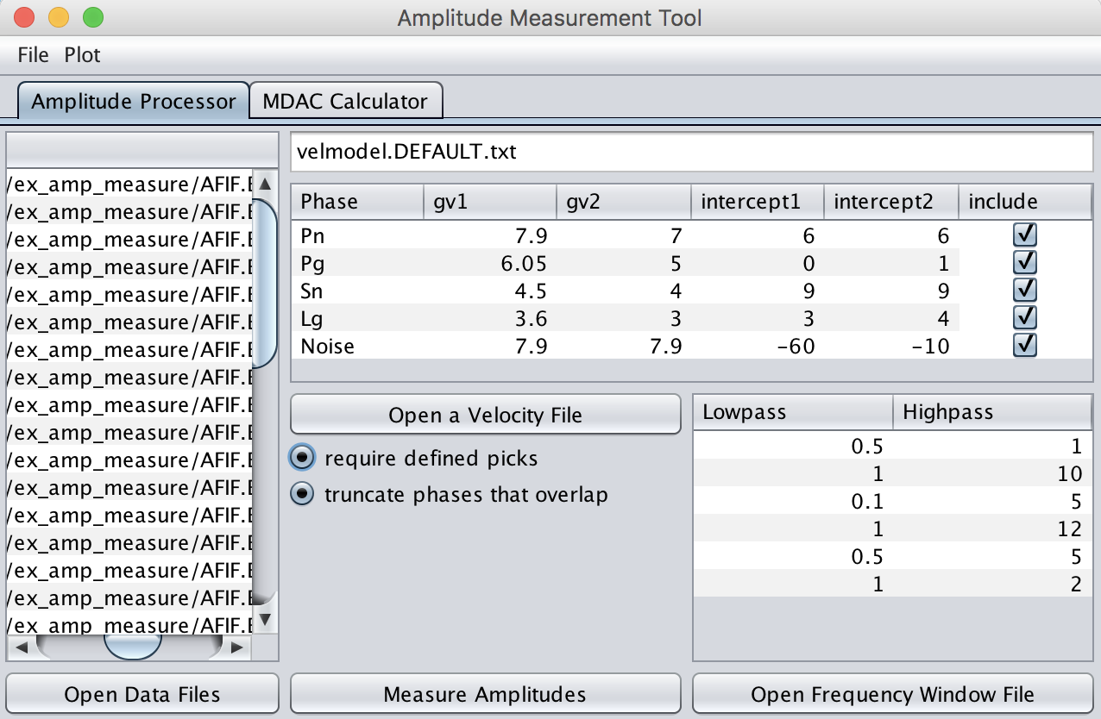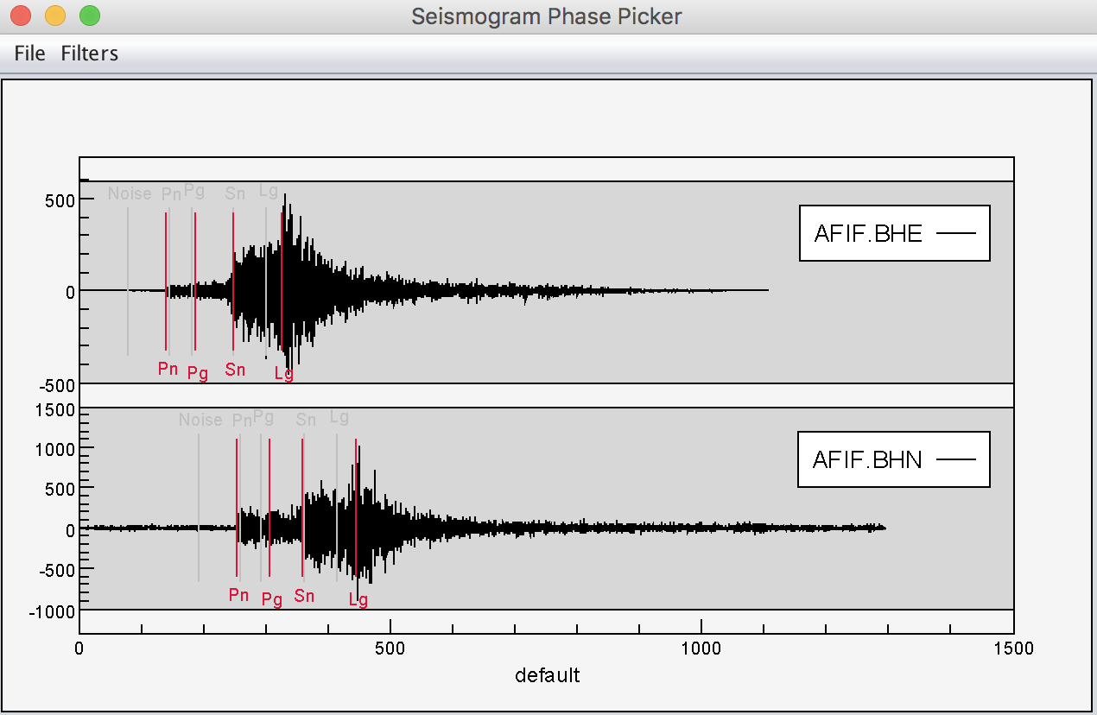
Figure 2-4. Measuring amplitudes based on the user’s phase-picks made. After checking “Require Defined Picks”, click on “Measure Amplitudes” (i.e., lower red box) to calculate amplitudes (left). Note red lines indicate manual picks made by the user (right).

The result of the measure Amplitudes will be saved under “Measured.amplitude” under the current working directory. Figure 2-5 shows an example of output file:

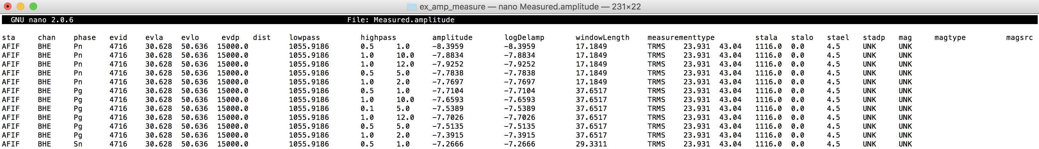
Figure 2-5. An example of output file using the SWFT Amplitude Measurement module.

Phase picker

EXAMPLE

ch ref o %set the reference time = origin time
align o %align the time axis with respect to the origin time
picks o %plot picks made over the seismograms
rmean %remove mean
rtrend %detrend seismogram
profile 3 %plot in profile mode in order of seismogram read and scaled
bp 0.5 5 %apply a bandpass filter of 0.5 – 5Hz
taper 0.05 %apply a consine taper of 0.05%
cut 0 150 %cut the seismogram between 0 and 150 seconds relative to origin

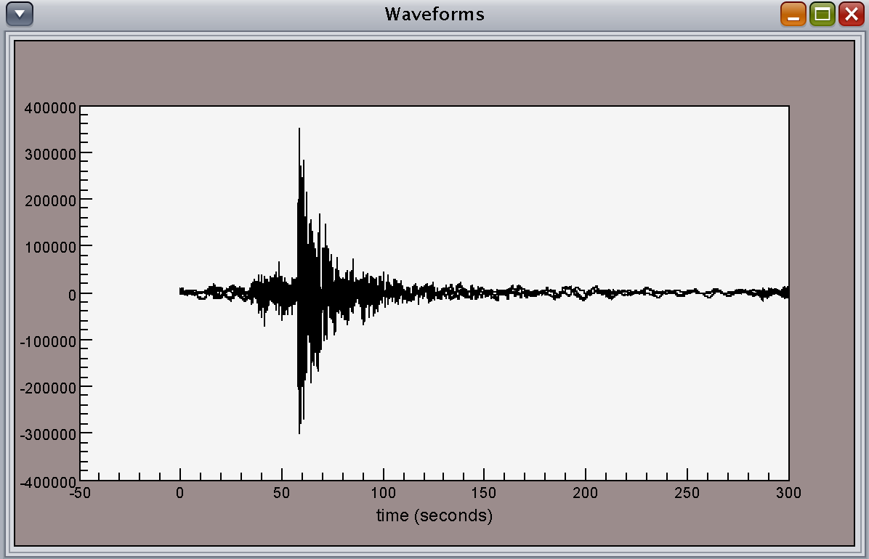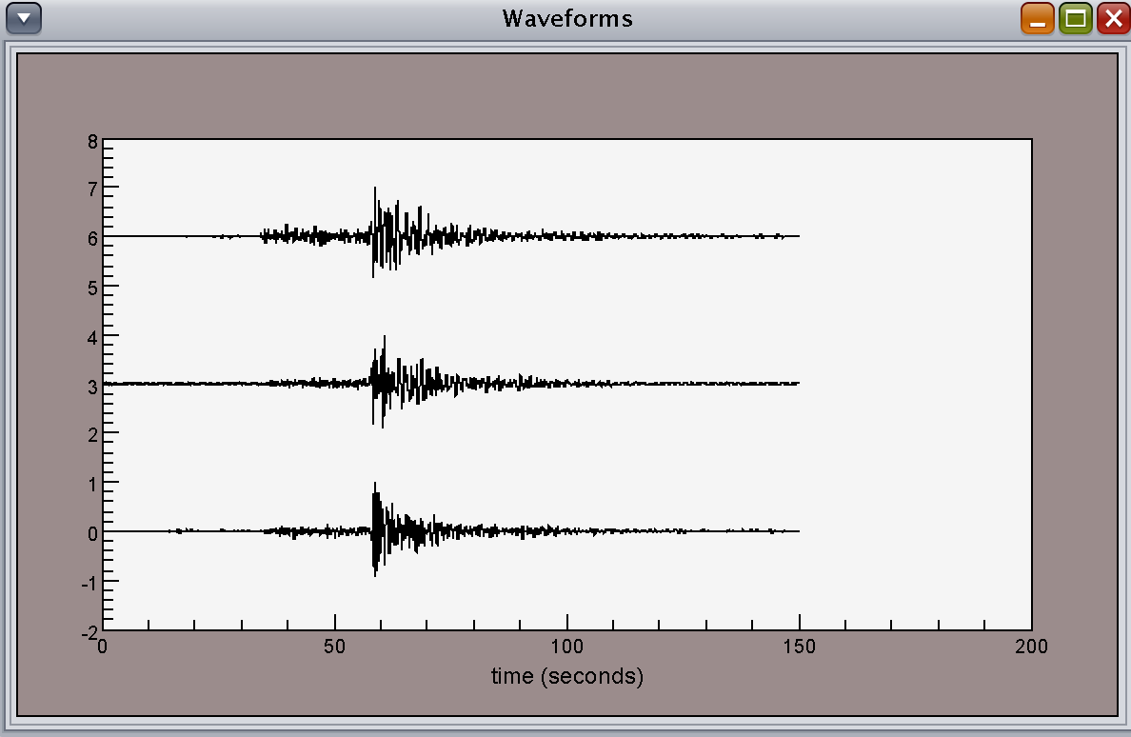
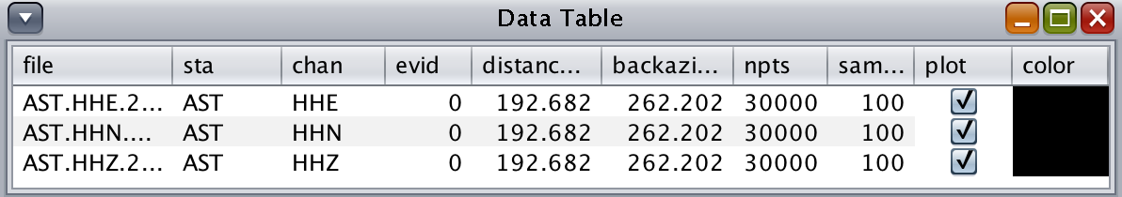
Figure 3-1. Before (left) and after (right) of using the list of commands in Console window.
Note the list of commands used in this example is optional.
Console> ch ref o ↵
Console> align o ↵
Console> picks on↵
Console> rmean↵
Console> rtrend ↵
Console> bp 0.5 5 ↵
Console> profile 3 ↵
Console> taper 0.05 ↵

Seismogram Phase Picker (see Tools>Phase Picker)

Phase picker allows the user to manually set phase arrival times. On selecting Phase Picker from the Tools list a new window appears titled "Seismogram Phase Picker" (left, Figure 6-1). With the mouse, a user can zoom in or out.

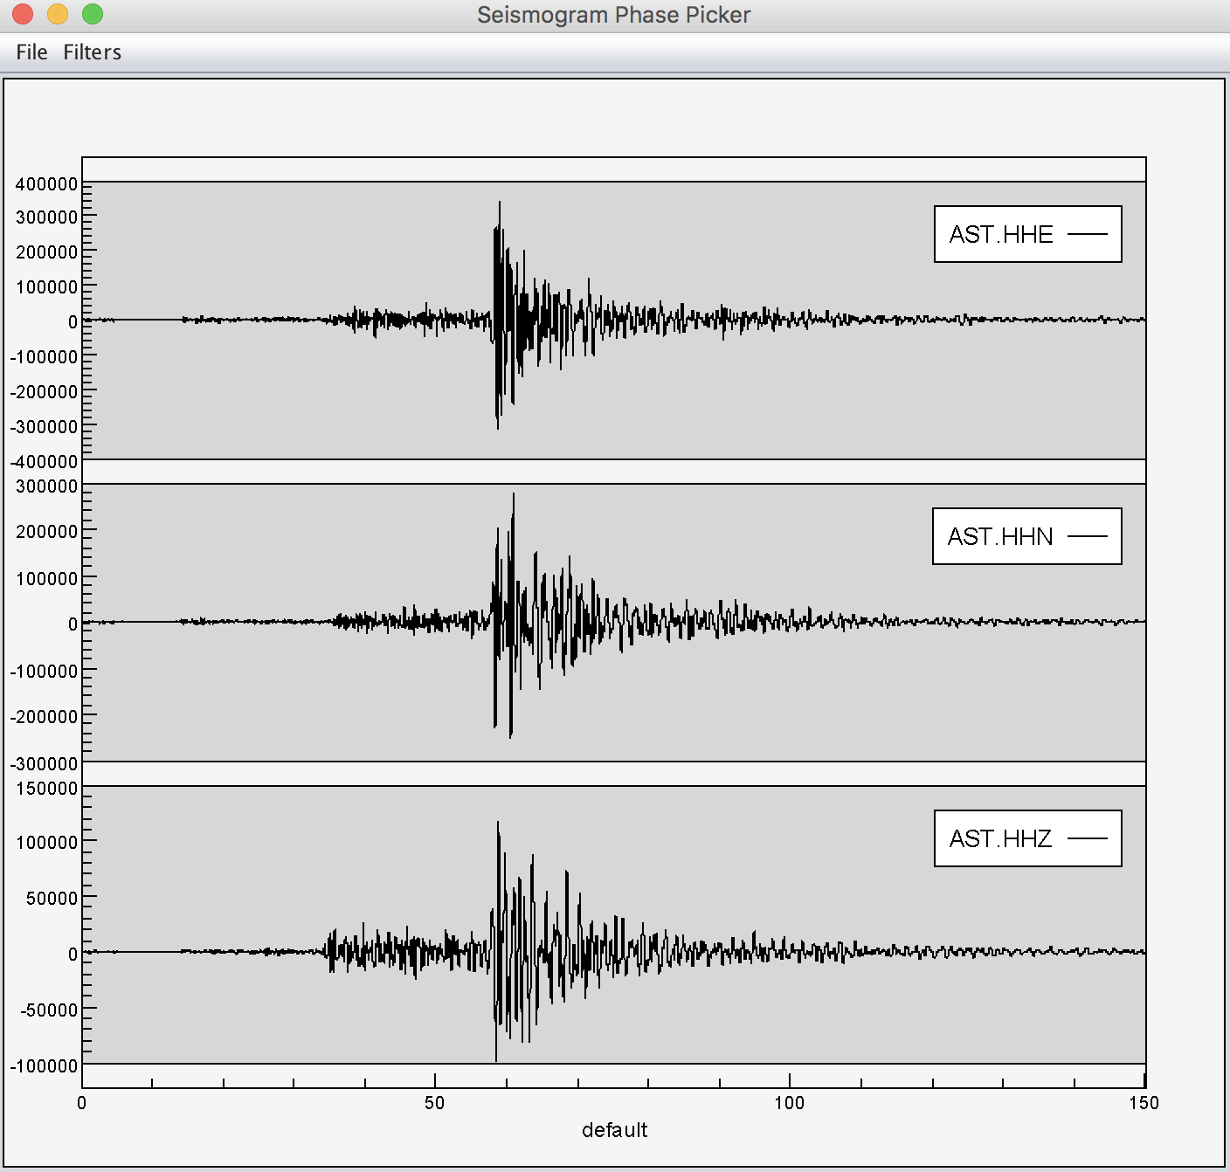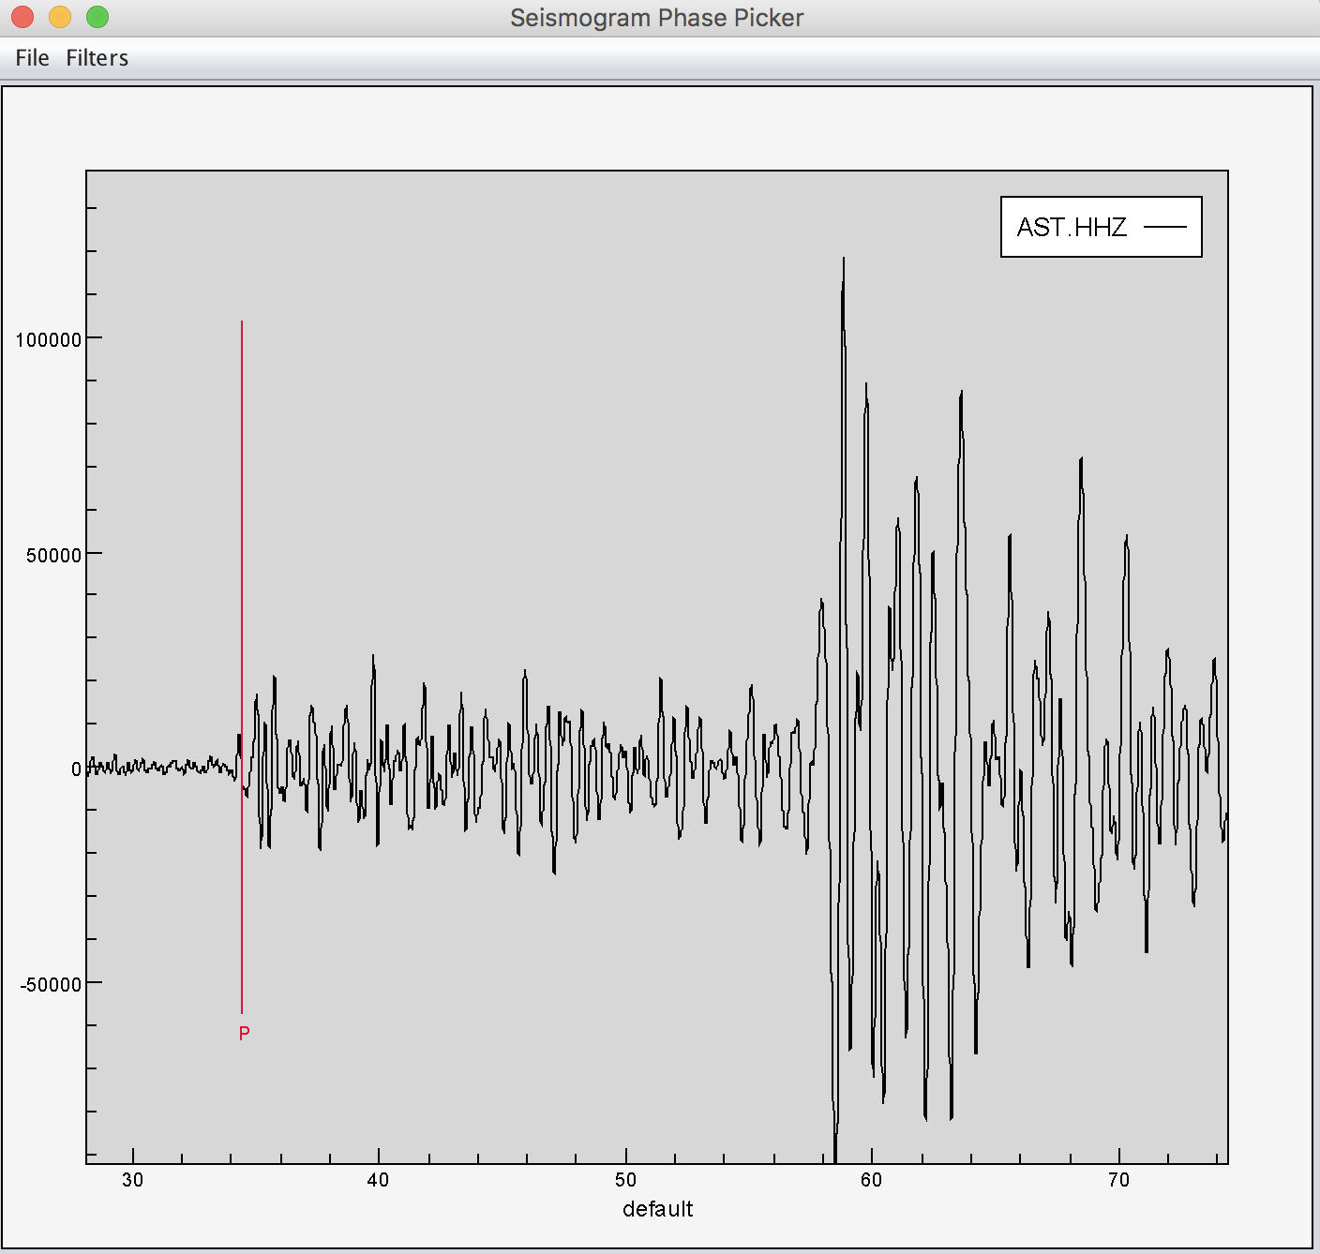
Figure 3.1-1. The Seismogram Phase Picker popup window (left) and a P wave pick (type “P” in keyboard and left click on the mouse) made in the zoom-in of z-component seismogram window (right).

In order to make a pick in the Seismogram Phase Picker, typing the following commands will switch out of zoom mode into picking mode:
Input | Picks
P: | P
S: | S
1: | Pn
2: | Pg
3: | Sn
4: | Lg
F:  A:  ESC or Z: | F  A  Escape picking and return to zoom

Picks are made by placing the mouse on the trace and left-clicking. A red marker line will appear with the phase name label included. Picks can be moved by left-click-dragging the marker.

picking phase: P
P 34.28782
:
kt0: P %each picked phase will appear in the header “kt#” (e.g. kt0 – kt5)
:
t0: 34.28782 %the pick time for “kt#” will appear in the header “t#” (e.g. t0 – t5)

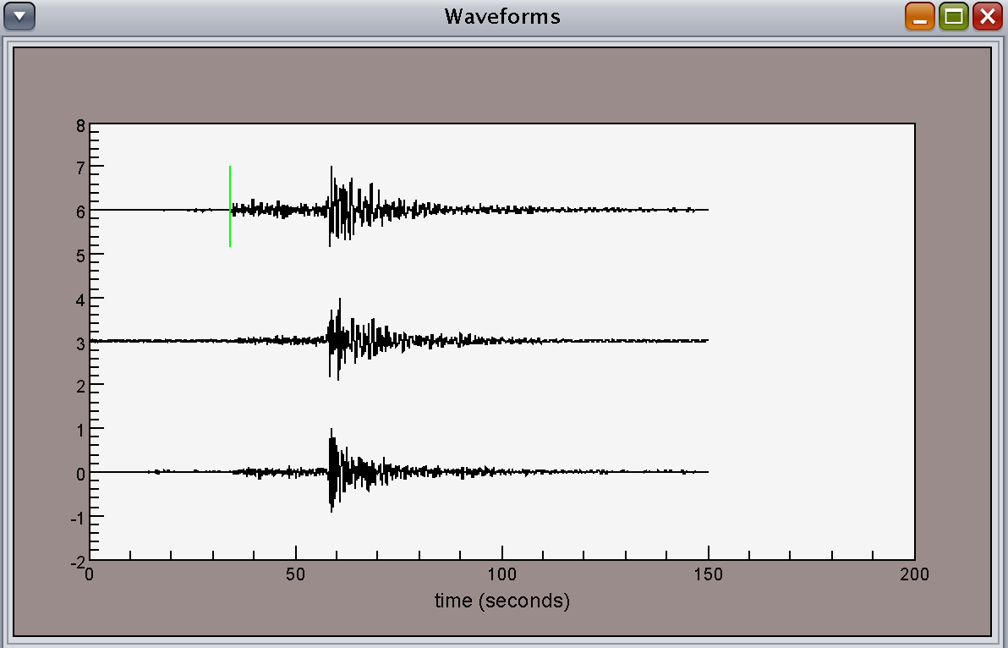
Figure 3.1-2. The data display in the Waveforms window after a P wave pick made by the Seismogram Phase Picker in Figure 2. Note a green line indicates the pick made.
Console> lh ↵

Phase Picker also supports bandpass filter panels. To use “Filters” in the menu bar, a separate text file that contains desired bandpass frequencies is required as an input file. An example of input text file for filters is the following:

bpFilters.txt:
0.5 | 1.0
1.0 | 10.0
0.1 | 5.0
1.0 | 12.0
0.5 | 5.0
1.0 | 2.0

To input the filter list, choose “Open file list” under “File” in the menu bar (Figure 4).

File> Open Filter List will open a popup window for a filter parameters file selection.

Once an input list is loaded into the Seismogram Phase Picker Filters option can be accessed and the user can simply select each bandpass filter from the drop-down list (Figure 4).

edit bpFilters.txt % modify the filter text file using preferred text editor

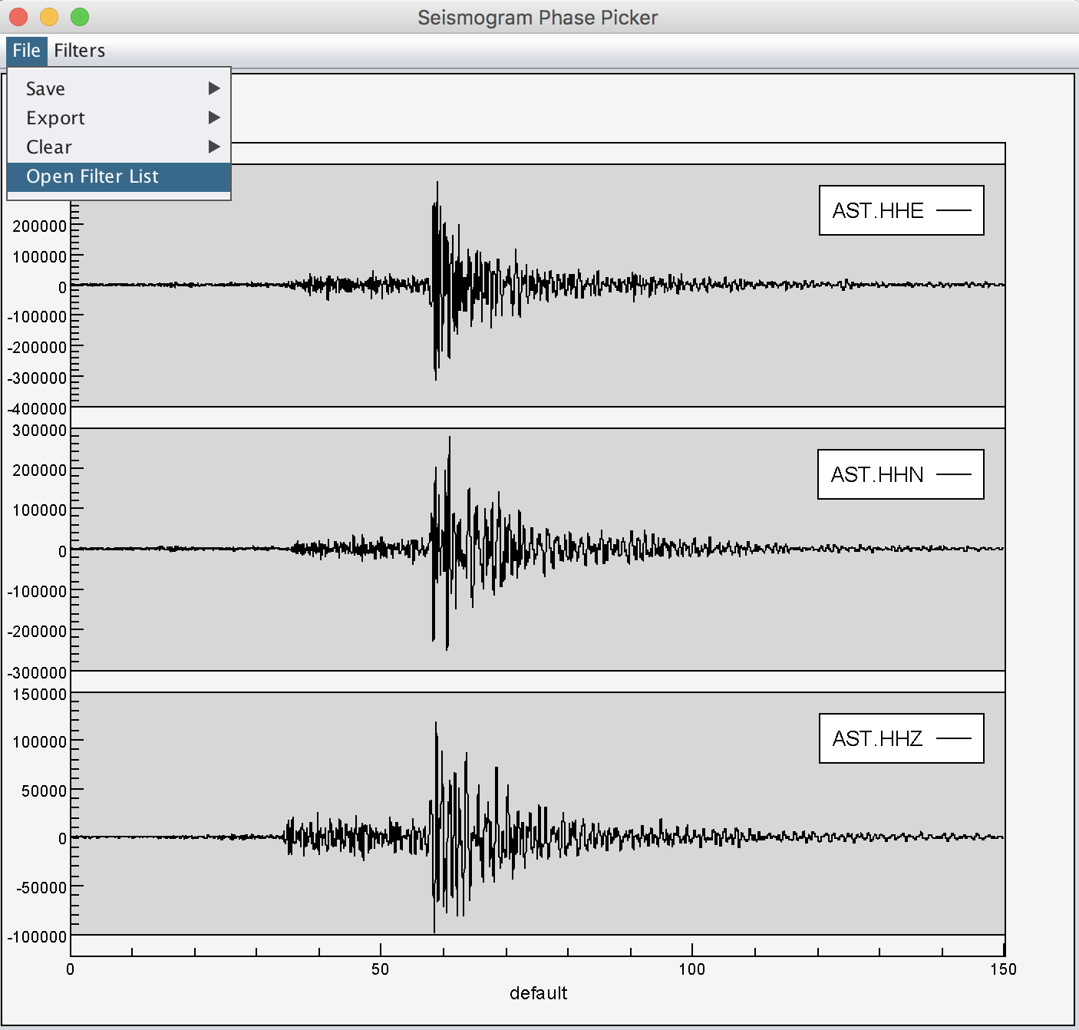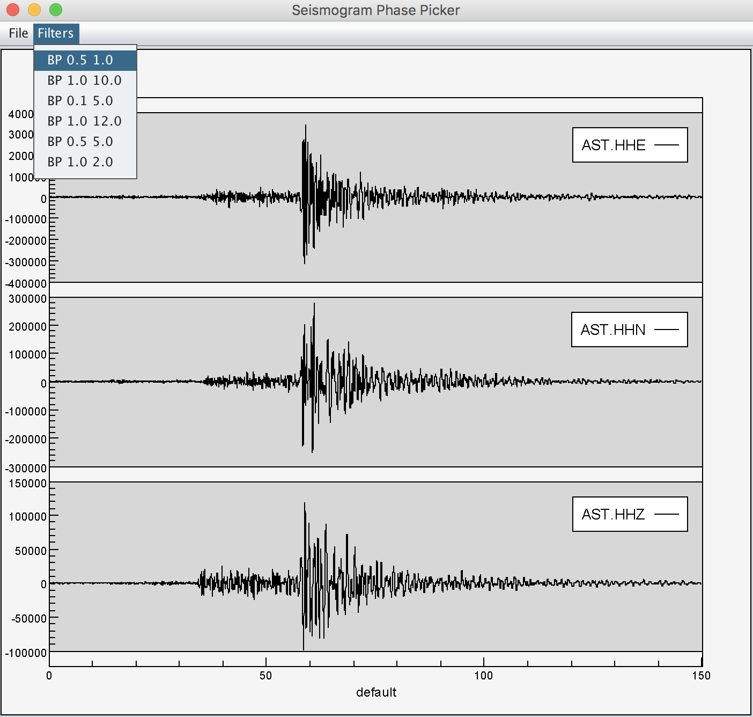
Figure 3.1-3. An example of using a filter from the drop-down list.
Console> edit bpFilters.txt ↵

To clear all the picks made use the picker menu bar (Figure 3.1-4).

File> Clear> Picks: will clear all of the previous picks made

Note that clearing picks will also clear the picks in the headers.

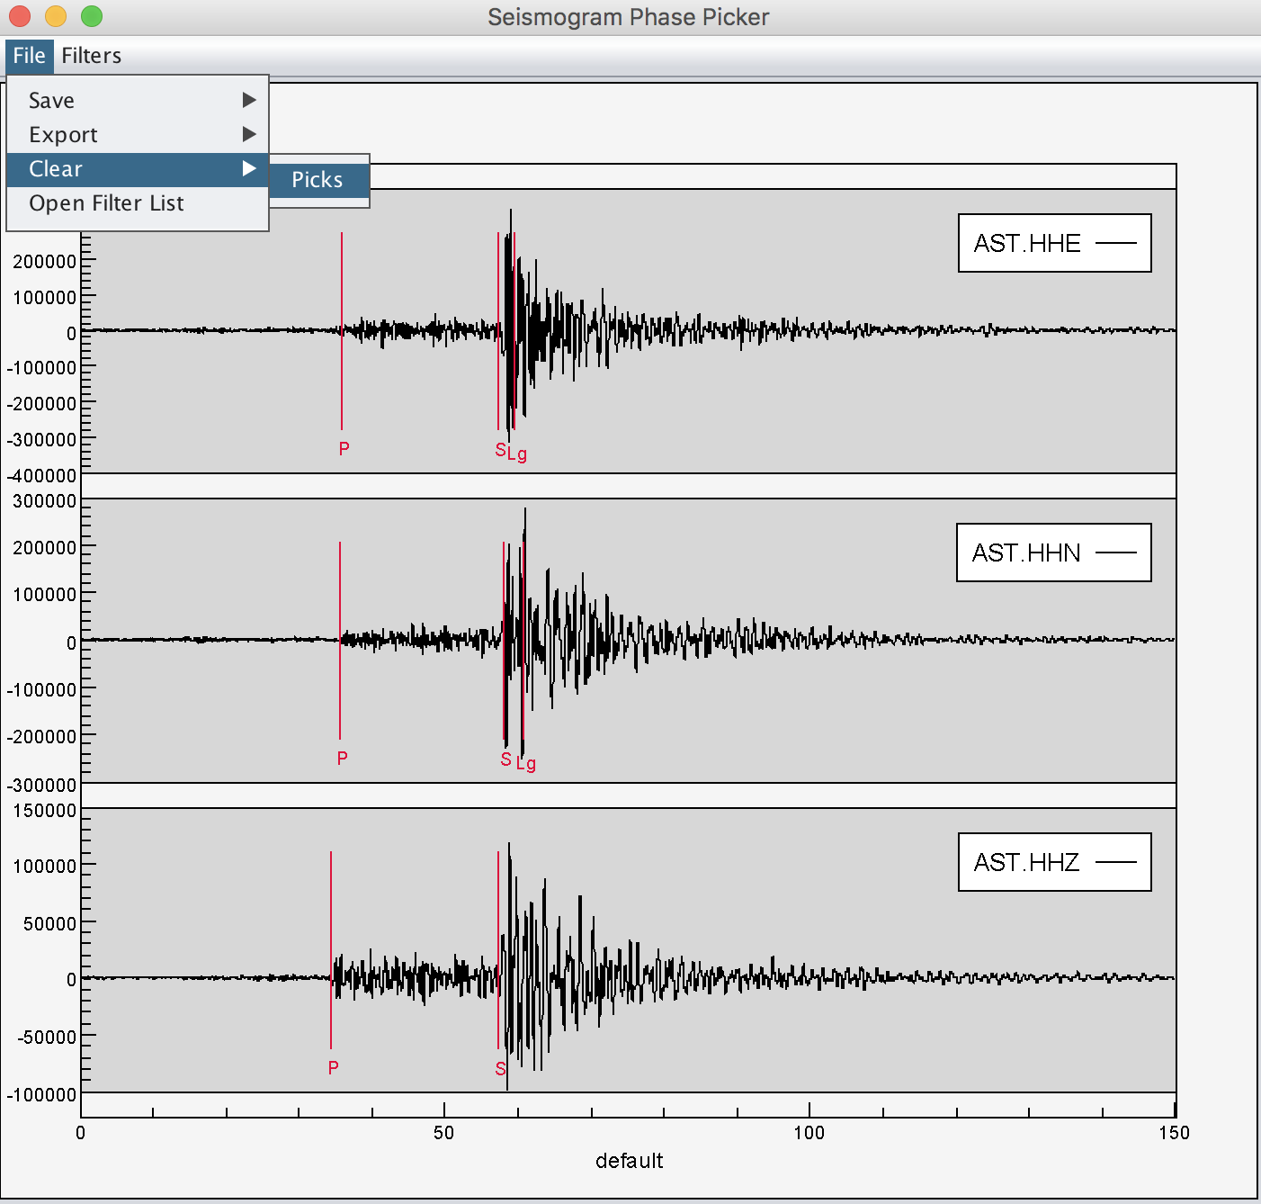Figure 3.1-4. Multiple picks made in Seismogram Phase Picker (left) and the usage of clearing picks (right).

To save the picks to the header, go to picker menu bar.

File> Save> Selected Picks: will save only those picks for traces currently plotted
File> Save> All Picks: will save the picks made for the data in the data table.

Saving from the picker window will only place the picks in the header. It will not change the original waveform.

The user can also use the “save” command in the console window after picks are made; however any modifications to the trace will also be saved.

To export the picks to a text file, use the picker menu bar.

File> Export> Selected Picks: will write only picks for selected traces.
File> Export> All Picks: will write all the picks made for the data in the data table.

The user will be prompted to create a file to write the picks into.

Coda Tool-Moment Magnitude Calculation Using Coda Waves

SWFT supports an empirical coda measurement module (Coda Tool) for obtaining stable seismic source moment-rate spectra derived from local and regional coda envelopes. Empirically derived coda source spectra provide unbiased, absolute magnitude estimates for events that are normally too small for accurate long-period waveform modeling.

Note: It is preferable to use the horizontal components of seismic data for high signal-to-noise ratio of S-waves. The fundamental procedure for coda amplitude measurement is described in more detail in Mayeda et al., (2003). The following are the measurement steps:

- Preprocess the data (i.e., remove instrument response, remove bad seismograms)
- Calculate narrow band seismic envelopes
- Stack (or average) the two horizontal components
- Measure spectral amplitudes
- Calculate average Mw
- Display spectra on the map

In coda method, empirical synthetic envelopes are calculated based on a simple analytic expression that is used to fit the observed narrowband envelopes. The coda amplitude at time t with a given distance r and a frequency band f is represented by the following:

$A_{coda}{(t,r)}_{f}=W_{f}S_{f}T_{f}{P\left(r\right)}_{f}H(t-\frac{r}{v\left(r\right)}){\left(t-\frac{r}{v\left(r\right)}\right)}^{-\left(r\right)}exp\left[b(r)(t-\frac{r}{v\left(r\right)})\right]$ (1)

$W_{f}=$ S-wave source function
$S_{f}=$ Site response
$T_{f}=$ S-to-coda transfer function resulting from scattering conversion
${P\left(r\right)}_{f}=$ geometrical spreading and attenuation
$H=$ Heaviside step function
$t=$ time from the origin
$v\left(r\right)=$ velocity of the envelope’s peak
$\left(r\right)$ and $b\left(r\right)=$ coda shape parameters

Step 1 Preprocessing

The first step is to remove the instrument response from the two horizontal component waveforms.

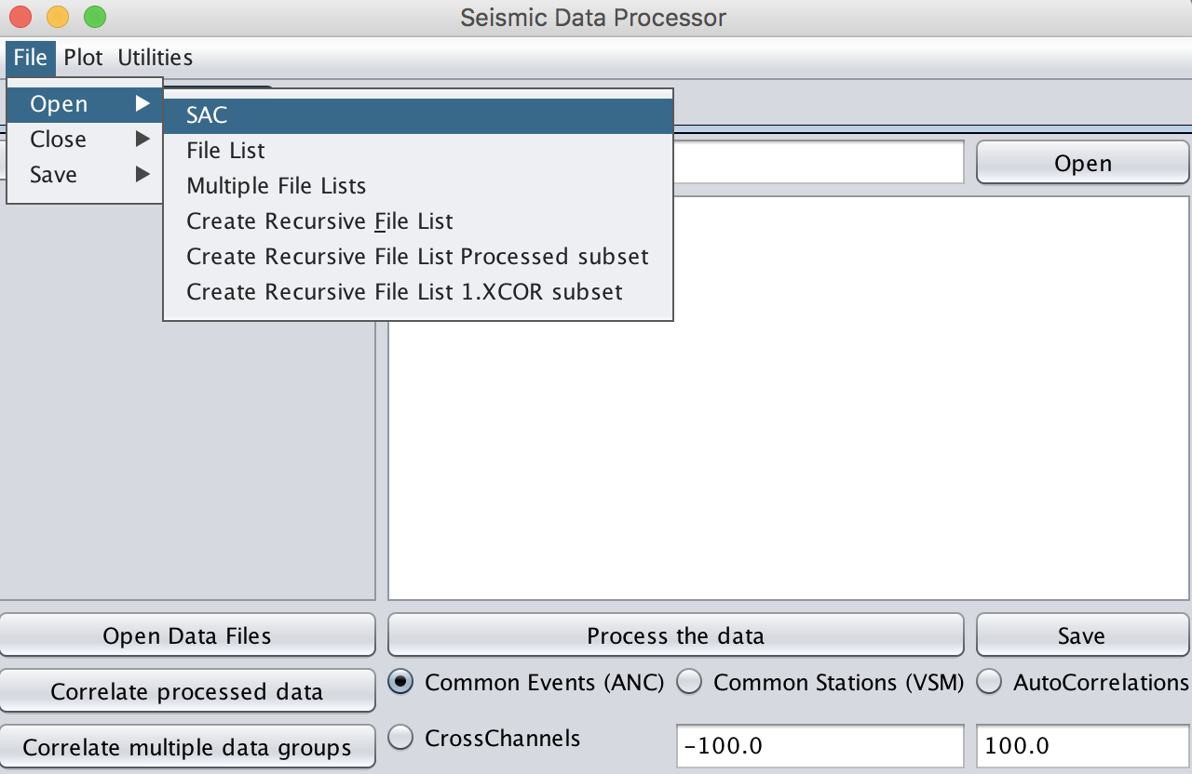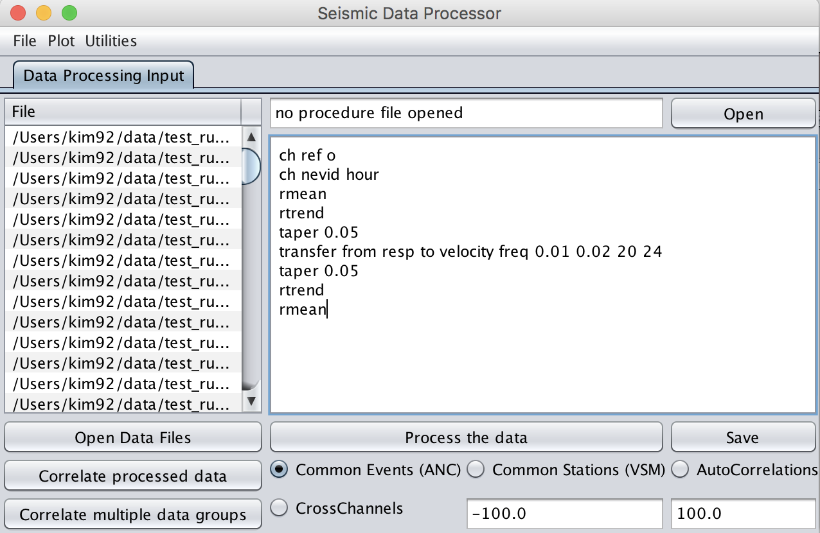
Figure 4-1. Load data (e.g., horizontal components) and use SWFT commands in Seismic Data Processor for preprocessing (click on Process the data, i.e. red box to batch process each data). Here resp file is used for deconvolving instrument response. Note the raw seismic signals are bandpass filtered for stable deconvolution for low frequencies.

IMPORTANT:
1) Set “plot off” (red box) before loading a large dataset in the main Waveforms window to prevent becoming memory intensive. Once all the data is loaded in the Data Table window, the user can “deselect all” then manually check a subset of events for quality checking.
2) The “nevid” and “knetwk” headears are required for coda amplitude measurement.
e.g.,“ch nevid hour” under Seismic Data Processor will create an event ID for each seismogram based on the origin or the reference time with format YYDDDHHMM (Year, Julian day, Hour, Minute).

Step 2 Calculate narrow band seismic envelopes

For each component, the narrow band envelopes are calculated by performing a Hilbert transform at each frequency band. For example, the seismic envelope for a given frequency bandwidth, 0.1 – 0.2 Hz, is of the following form:

${E(t)}_{f=0.1-0.2Hz}=\sqrt{{v[t]}^{2}+{h[t]}^{2}}$ (2)

A text file that contains specific frequency bands of interest is required to run this process in SWFT. After computing ${E(t)}_{f}$ for all of the frequency bands listed in the text file, SWFT takes the base 10 logarithm of the data and then smoothing is applied.

To start, open Coda tool window under Tools> Coda Processor

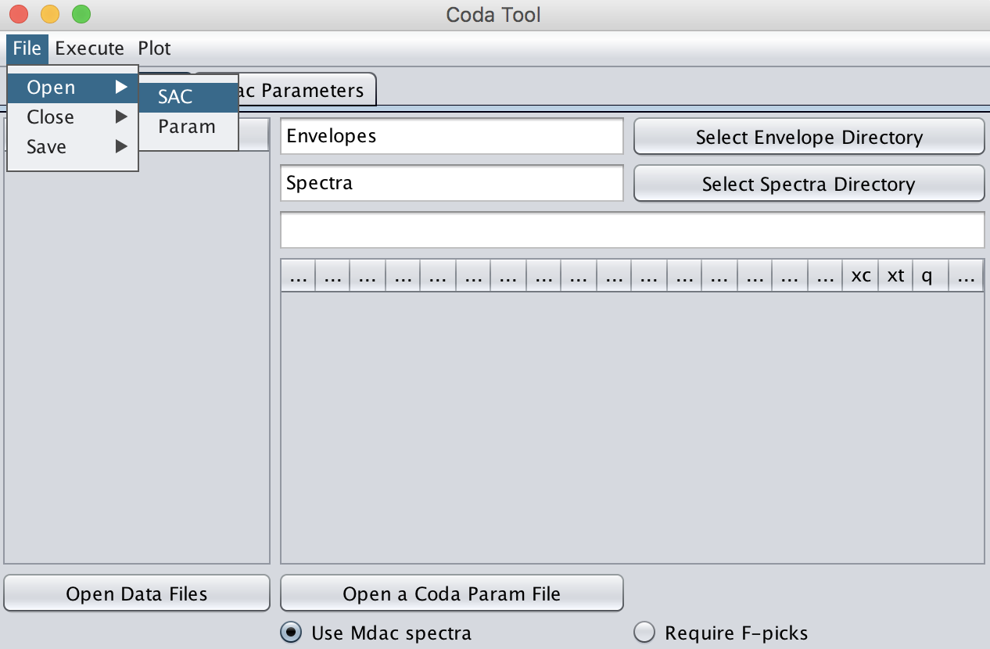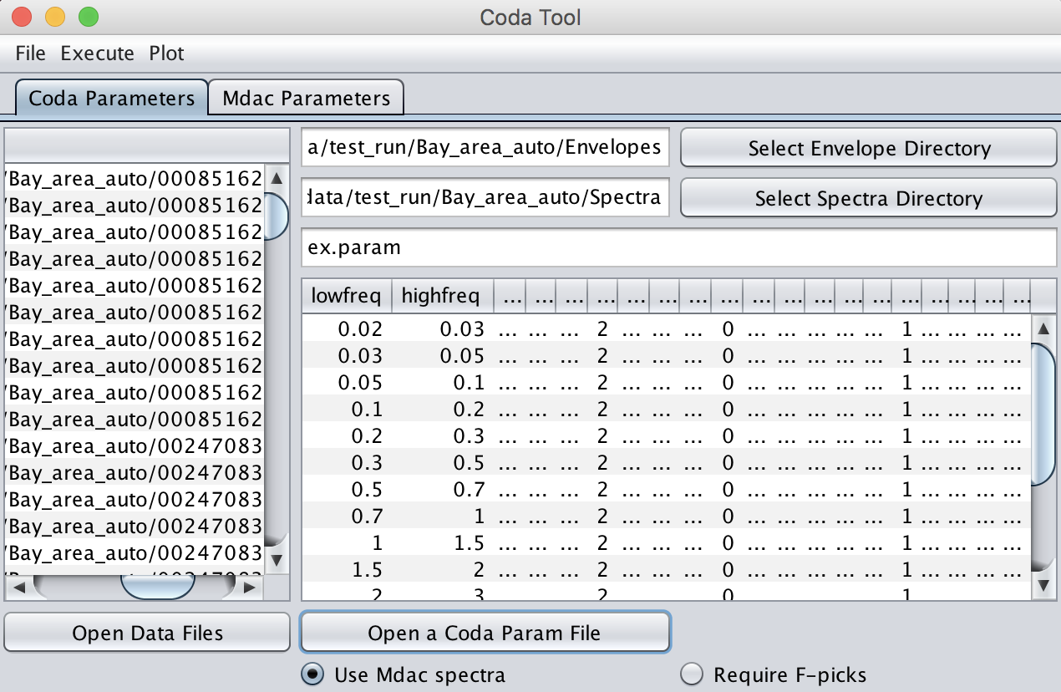

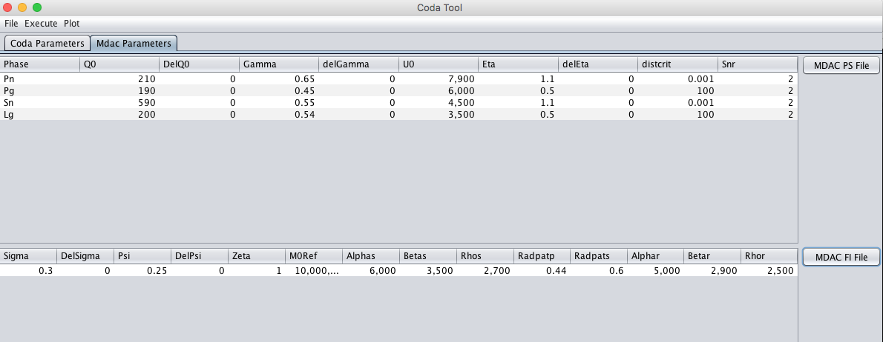
Figure 4-2. Load data in Coda Tool and a coda parameter file (click on Open a Coda Param File in red box) and in “Mdac Parameters” tab open MDAC PS File (mdac_ps_params.txt) and MDAC FI File (mdac_fi_params.txt). They are provided with SWFT package. MDAC files are used to create theoretical source spectra to fit to calculate Mw and stress drop. If MDAC is not selected lowest two frequency bands will be used to estimate the average Mw.

In total, the coda parameter file includes 11 parameter (there is no limit in the number of frequency bands, user is flexible to use preferred range and pass-band) fields for each frequency band (see the first row in Figure 4-2). This file can be used for any frequency range and the band-with. First and second column of the coda parameter file are the low and high frequency limits of the narrow bands of interest, respectively. With the coda parameter file completed, the user can calculate the envelopes by selecting Execute> Calculate Data Envelopes in the menu bar.

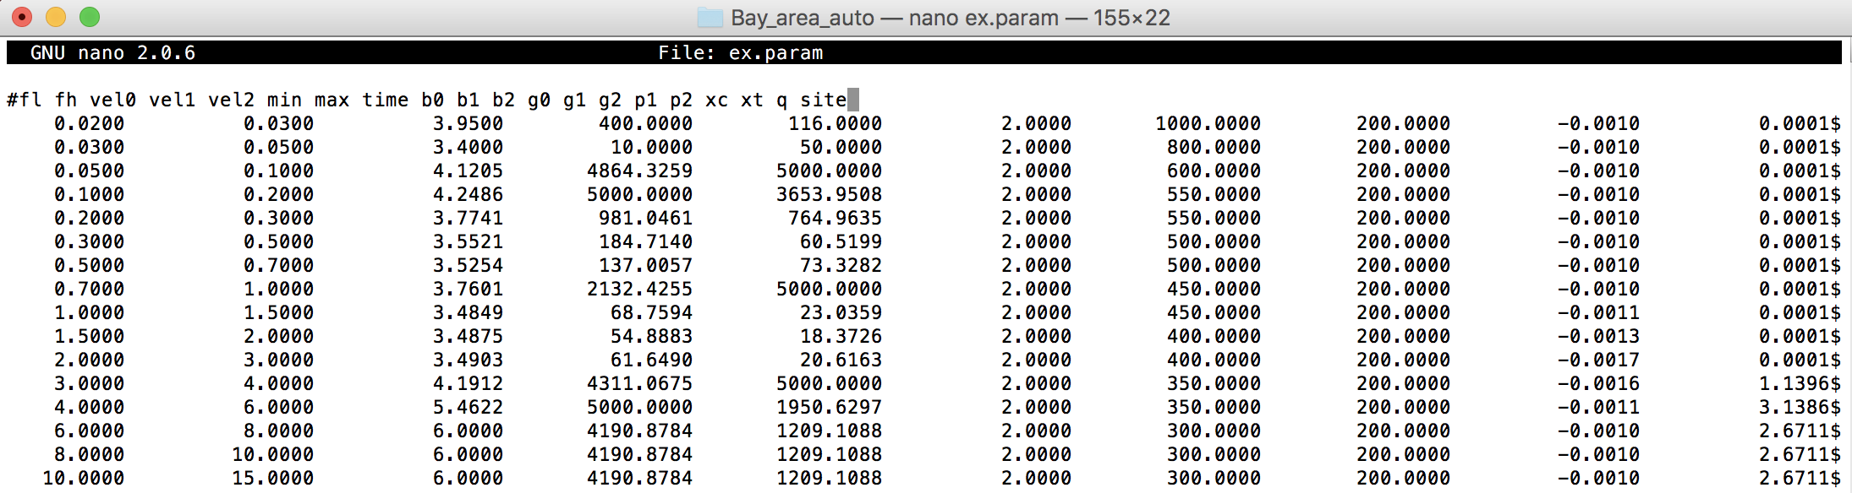
Figure 4-3. An example of the coda parameter file. Note red box has low and high frequency limits for the coda envelope calculation.

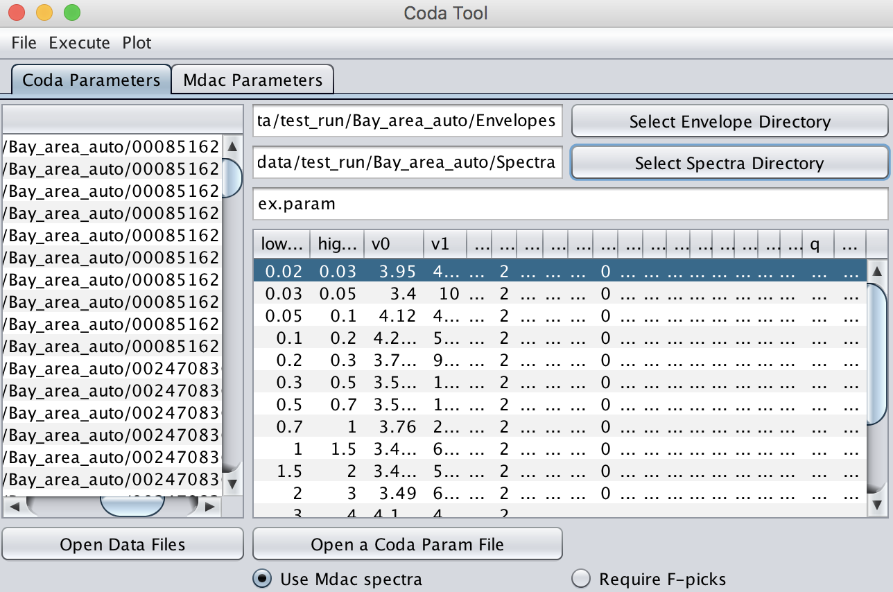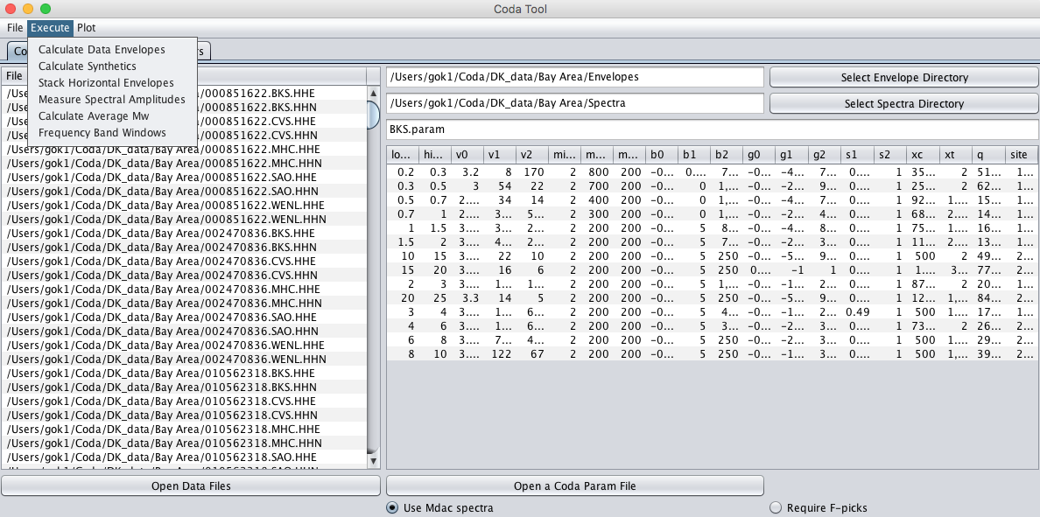
Figure 4-4. Select the desired directory for the envelopes (left) and spectra calculation (right)

Step 3. Stack two horizontal envelopes (S-waves)

In this step, if magnitude is going to be calculated from S-waves two horizontal envelopes (N-S and E-W) will be stacked then smoothed. Note that SWFT will check headers of SAC files and parse the envelope file (e.g. kcmpnm, kstnm, nevid)

To stack and smooth the envelopes select Execute> Stack Horizontal Envelopes from the Coda Tool menu bar.

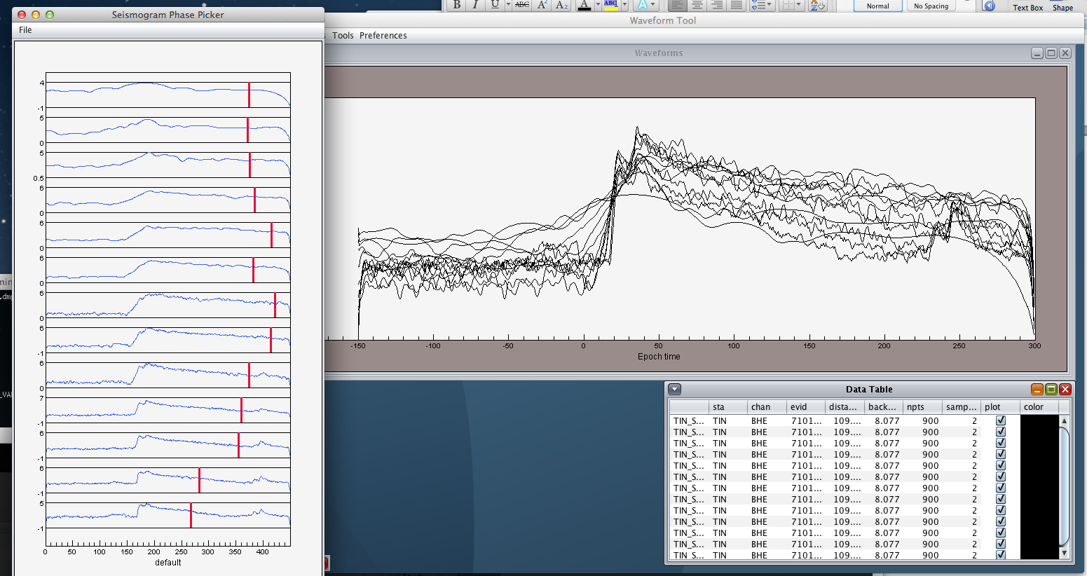
Figure 4-5. Stacked coda envelopes for each narrow-frequency band.

Prior to proceeding any further, it is recommended to check the window length of each of the frequency bands. SWFT has a default length for each narrow band however this may need to change depending on the dataset you are processing. The min and max lengths in Figure 4-6 define a coda window that will be used in case the user wishes to perform automatic picks in step 4.

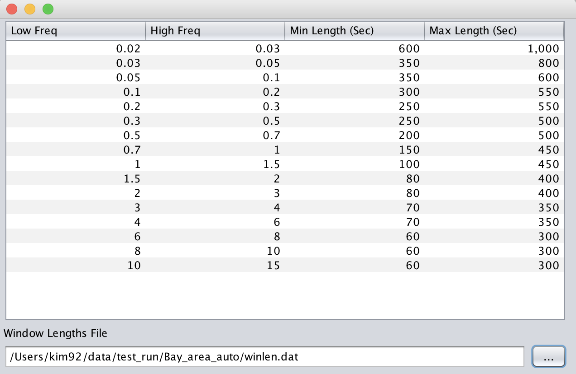
Figure 4-6. Check the Frequency Band Windows under Execute. When the frequency band window is selected the user will be prompted with a default window length table. Note any text file can replace the default table.

After stacking envelopes there are two options:
- Automatically identify the end of the envelope (Unselect “Require F-Picks” Figure 4-6)
- Use the picker tool to identify the “F” picks (Select Require F-Picks Figure 4-6)
It is also possible to provide the list of a file with name of the envelope files and SWFT will open it (e.g. BKS.list). This list is automatically created.

Step 4. generate synthetic shape files using the STA.param files.

Execute>Calculate Synthetics
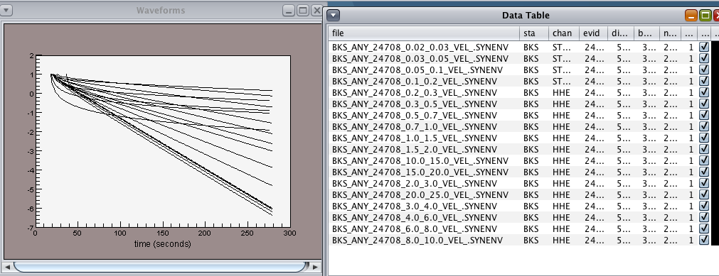

Figure 4-7. List and plot of synthetic envelopes in main window.

Step 5. generate the spectral amplitudes and the average Mw.

Execute>Measure Spectral Amplitudes
Execute>Calculate average Mw

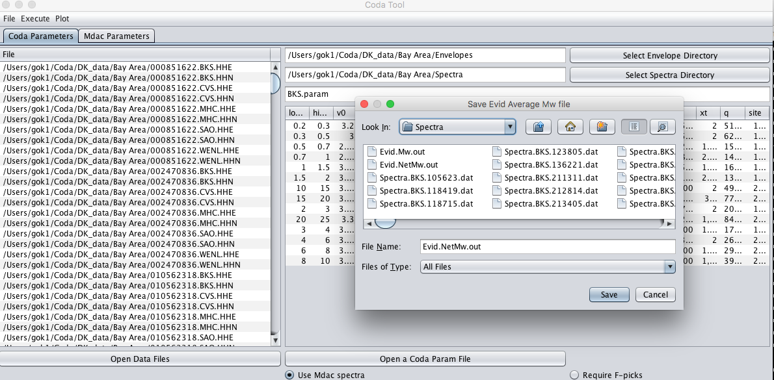
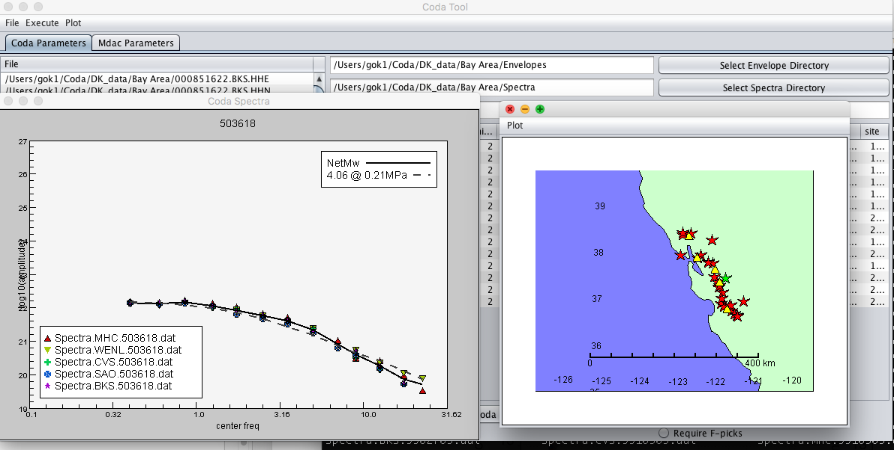

Figure 4-8. This snapshot shows the spectral amplitudes and final list of average and individual Mw’s. The lower panel displays all events (red starts) and stations (yellow triangles) used in this particular project. Selected event (green star) is displayed on the left. Note that five station spectral values look very close to each other.

Output Files

Spectral Amplitude (individual spectral amplitudes per event-station)

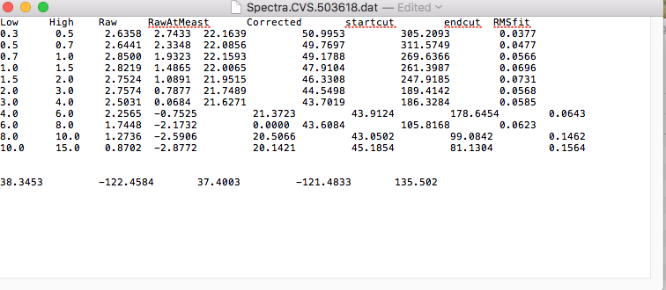

Evid.Mw.out (list of all Mo and Mw)

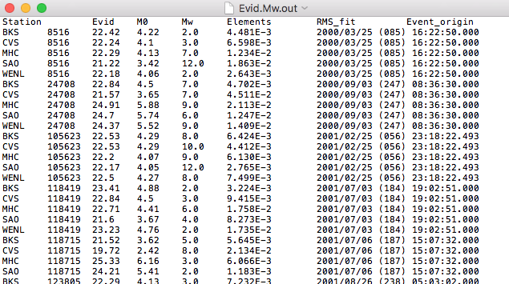

Evid.NetMw.out (list of network averaged Mw’s)

SWFT Command Manual

Application Support Commands

dir
Return to working directory

USAGE
dir
pwd

EXAMPLE

dir
/Users/Downloads/Coda_SWFT/Example_data
Console> dir ↵

cd

Change directory

USAGE
cd [directory]

EXAMPLE
• How to change the current working directory to its parent directory.
• How to change the current working directory to a specific directory
cd ..
/Users/Downloads/Coda_SWFT
cd /Users/Downloads/Coda_SWFT/Example_data
/Users/Downloads/Coda_SWFT/Example_data
Console> cd .. ↵
Console> cd /Users/Downloads/Coda_SWFT/Example_data ↵

ls

List directory contents

USAGE
ls

EXAMPLE
• How to see all of data in the current directory
ls
AFIF.BHE.1995352034511
AFIF.BHE.1995362182332
:
Console> ls ↵

find

Find file

USAGE
find [filestring]
• This command is used to find files matching the [filestring] search criteria in or below the working directory.
• SWFT does not support wildcard characters (e.g. find AFIF.BH?.*).

EXAMPLE
• Find file with the filename AFIF.BHE.1995342034511
find AFIF.BHE.1995342034511
/Users/Downloads/Coda_SWFT/Example_data/AFIF.BHE.1995352034511
Console> find AFIF.BHE.1995342034511 ↵

edit

Open a text editor with the desired file.

USAGE
edit [filename]

EXAMPLE
• Edit list of bandpass filters
cd ..
/Users/Downloads/Coda_SWFT
edit bpFilters.txt
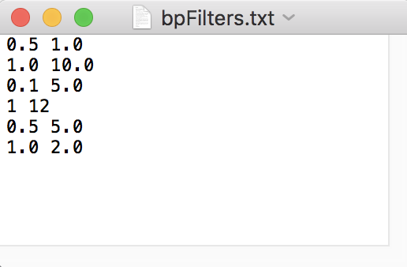
Note: a text editor will be opened.
Console> cd .. ↵
Console> edit bpFilters.txt ↵

help

List SWFT commands with descriptions.

USAGE
help
• SWFT does not support individual help sub-commands (e.g. help [command] or [command] help).

EXAMPLE
help

These commands get general information about the selected seismograms:

b usage: b get the begin time in seconds relative to the SAC reference time
ch usage: ch (variable) (value) change the sac header variables
date usage: date get the date of the origin time
:
Console> help ↵

save

Save seismogram

USAGE
save | save all | save selected
• This command is used to save changes made to seismogram and overwrites to the original file.
• SWFT does not support save command with unselected data (e.g. save unselected).

EXAMPLE
• Save seismogram after several processing commands
• The resulting seismogram will be permanently detrended, band-passed, cosine tapered, and saved to the original file.
rtrend
bp 0.5 5
taper 0.05
save
Console> rtrend ↵
Console> bp 0.5 5 ↵
Console> save ↵

writeascii

Write seismograms into an ascii file

USAGE
writeascii [filename]
• This command is used to write all traces to a designated ascii file.
• The resulting ascii file will be saved under current directory.
• SWFT does not support “writeascii” command with selected or unselected data (e.g., plot checkbox does not work with this command).

EXAMPLE
writeascii example_data.txt
/Users/Downloads/Coda_SWFT/Example_data/../example_data.txt written
Console> writeascii example_data.txt ↵

clear

Remove seismogram

USAGE
clear | clear all | clear selected | clear unselected
• This command is used to remove all or selected/unselected seismograms.

EXAMPLE
• Remove the selected seismogram from the group
• Unselected seismograms will be no longer in the Data Table window
clear unselected
Console> clear unselected ↵

color

Change color display of seismogram

USAGE
color [color] | color [R] [G] [B]
• This command changes the color display of a seismogram in the Waveform window.
• Available color built-in options are:
green, blue, black, cyan, dark, gray, light, magenta, orange, pink, white, yellow, lime, silver, maroon, purple, teal, navy, brown, crimson, coral, gold, khaki, indigo, midnight, seagreen, palegreen, beige, tan, sienna, sandybrown.

EXAMPLE
• How to change selected seismograms to red color display
• Same result can be achieved by typing “color red”
color 255 0 0
Console> color 255 0 0 ↵

select

Select data

USAGE
select [all] | select [variable statement] | deselect [all] | deselect [variable statement]
• This command is used to select seismograms from the data list.
• Once selection is made the plot check box will be checked.

EXAMPLE
• How to select seismograms with red color display
• How to select seismograms that have larger offset than 300 km
select color red
select distance > 300
Console> select color red ↵
Console> select distance > 300 ↵

Plotting Support Commands

autoplot

Switch automatic plotting of seismograms “on” or “off”

USAGE
autoplot on | autoplot off
• Note set “autoplot off” before loading a large data set to prevent memory intensive redrawing.

EXAMPLE
• Any changes made to seismogram will in Waveforms window
autoplot off
Console> autoplot off ↵

plot

Redraw the seismograms. Used when autoplot is switched to “off”

USAGE
plot

picks

Display picks

USAGE
picks on | pick off
• This command is used to turn the pick display on or off to seismogram in Waveforms window.
• Default in SWFT is picks “off”.
• See “Seismogram Phase Picker” under “Tools” to make picks to seismogram.

EXAMPLE
• How to plot the picks already made to seismogram
picks

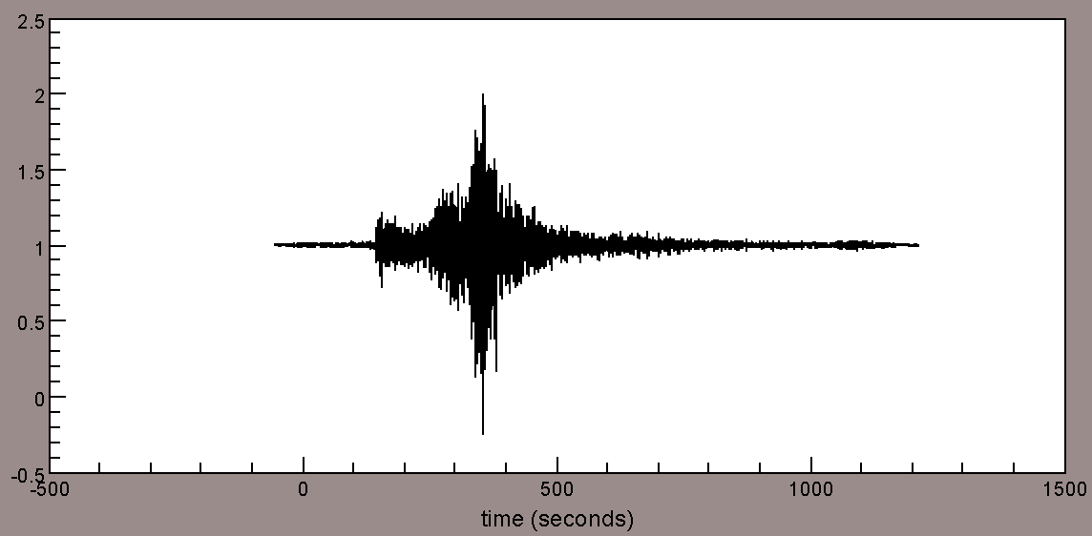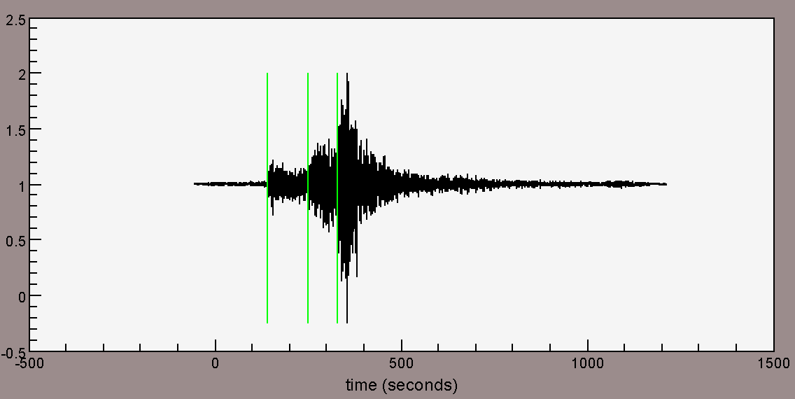
Note: before and after of using picks command in Waveforms window
Console> picks on ↵

align

Align seismogram

USAGE
align | align off | align [type]
• This command is used to align the time axis for plots.
• Available [type]s:
b, e, o, ref, 0 or SAC defined header values related to pick times (e.g., t0, t1, … t9).
• Note the default for this command is to put origin at zero sec, equivalent to “align o”. If origin time is undefined the header lddate values are plotted at zero.

EXAMPLE
• How to align seismogram with respect to the origin time
• Commands below will set SWFT reference time = event origin time
ch ref o
align
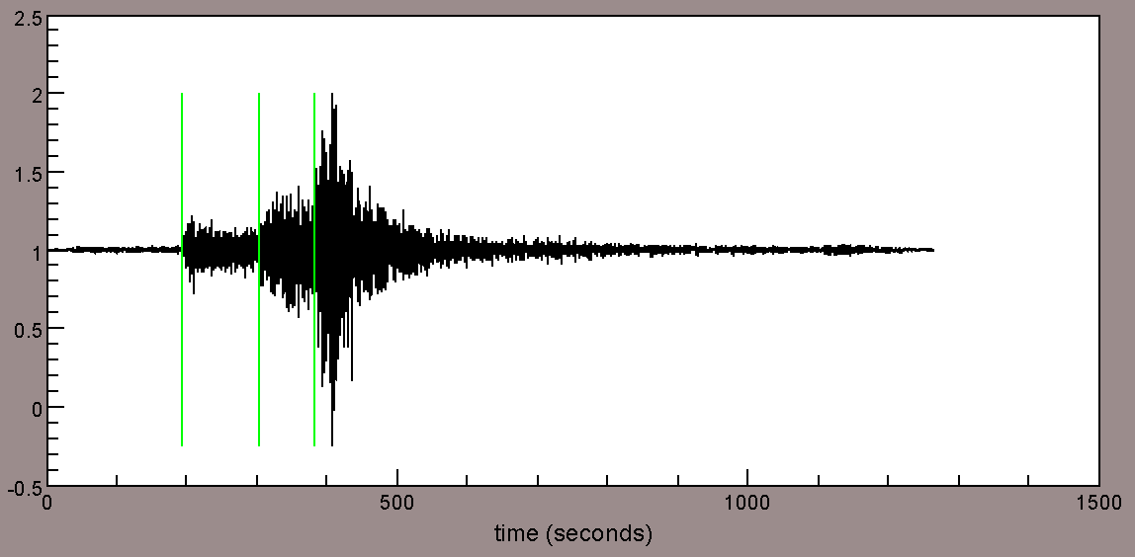
Note: before and after of using align command in Waveforms window
Console> ch ref o ↵
Console> align o ↵

profile

Plot seismograms in profile mode

USAGE
profile [value] | profile off | profile distance
• This command is used to plot multiple seismogram in profile mode.
• Note using this command with [value] will scale each trace -1 to 1 and plot [value] units above previous trace.
• The y-axis in Waveforms windows will change to distance ([value] unit) after using the command.

EXAMPLE
• How to plot multiple traces by source-receiver offset

ch ref o
rmean
rtrend
bp 0.5 5
align o
taper 0.05
scale 10
profile distance

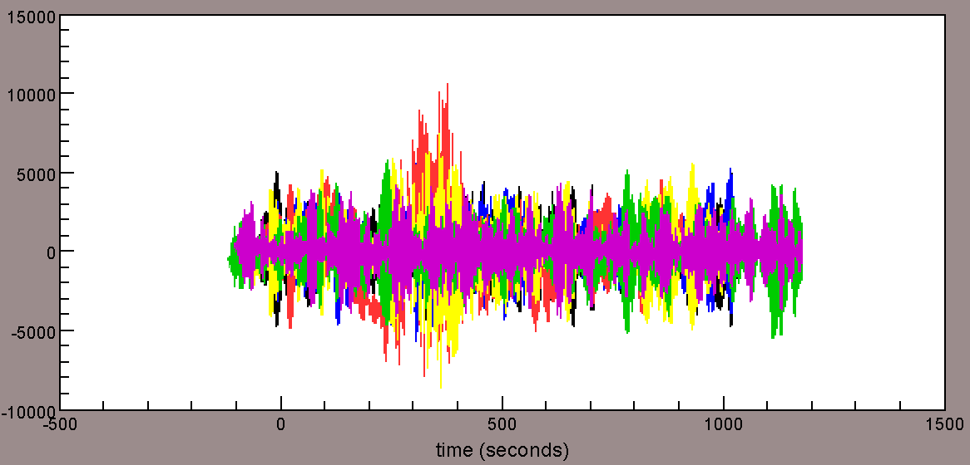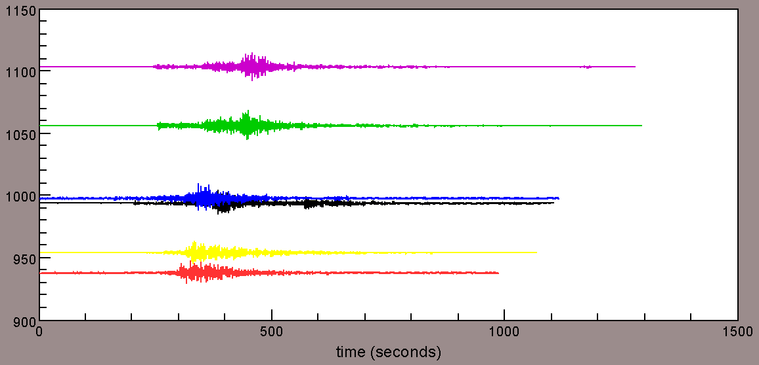
Note: before and after of using profile command in Waveforms window
Console> ch ref o ↵
Console> rmean ↵
Console> rtrend ↵
Console> bp 0.5 5 ↵
Console> align o ↵
Console> taper 0.05 ↵
Console> scale 10 ↵
Console> profile distance ↵

Header Information Commands

lh

List headers

USAGE
lh | lh [variable]
• This command is used to list the key header variables or a specific variable.

EXAMPLE
• How to return information on event longitude in the header
lh evlo

waveform:AFIF.BHE.1996076201833
---------
evlo: 50.985
Console> lh evlo ↵

ch

Change header

USAGE
ch [variable] [variable or value]
• This command is used to change the SAC header variables.
• Use “lh” command to see the precise header names.

EXAMPLE
• 1) How to set SWFT referencetime = origintime
IMPORTANT: Most of time-related commands in SWFT are subjected to the SAC reference time
ch ref o
Console> ch ref o ↵
• 2) How to set nevid
ch nevid 12345 %will change event ID to the number 12345
ch nevid day %will create event ID for each seismogram based on the origin or the reference time with
%format YYYYDDD (year, jdate)
ch nevid hour %will create event ID for each seismogram based on the origin or the reference time with
%format YYDDDHH (year, jdate, hour)
Console> ch nevid 12345 ↵
Console> ch nevid day ↵
Console> ch nevid hour ↵

b

Return begin time of seismogram

USAGE
b
• This command is used to get the begin time in seconds relative to the SWFT reference time.

EXAMPLE
• How to return begin time of seismogram
b
-75.778999
Console> b ↵

e

Return end time of seismogram

USAGE
e
• This command is used to get the end time in seconds relative to the SWFT reference time.

EXAMPLE
• How to return end time of seismogram
e
1031.371001
Console> e ↵

o

Return origin time of an event

USAGE
o
• This command is used to get the origin time of an event in seconds relative to the SWFT reference time.

EXAMPLE
• How to return origin time of an event from seismogram
ch ref o
o
0.0

Note “ch ref o” sets origintime=referencetime
Console> ch ref o ↵
Console> o ↵

date

Return date of origin time

USAGE
date

EXAMPLE
• How to return date of origin time
date
1996 76 20:18:33:90 0.0
Console> date o ↵

gv

Save group velocity picks

USAGE
gv (time-pick variable) (group velocity) | gv (time pick variable) (group velocity) (intercept)
• This command is used to make a time-pick based on a given group velocity and save the pick under a given time-pick variable.
• Note previous picks made and its corresponding time-pick variable before using.
• Variable = distance / group velocity or Variable = distance / group velocity + intercept.

EXAMPLE
• How to make a pick group velocity of 3.5km/s
gv t0 3.5
lh t0

waveform:AFIF.BHN.1995365115639
---------
t0: 315.19534

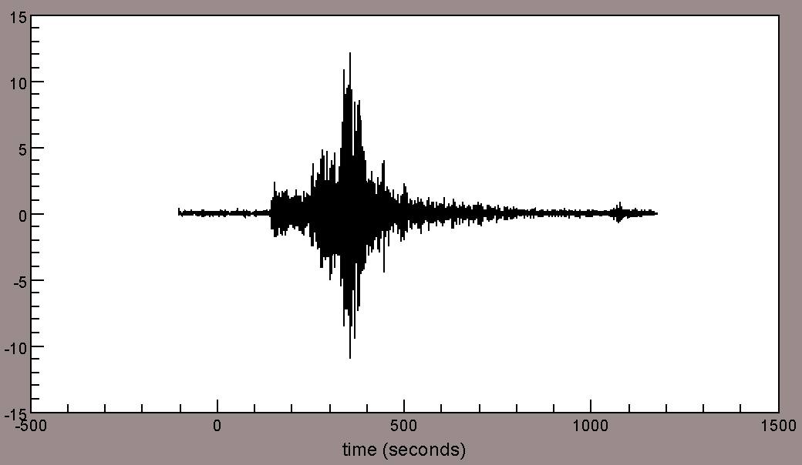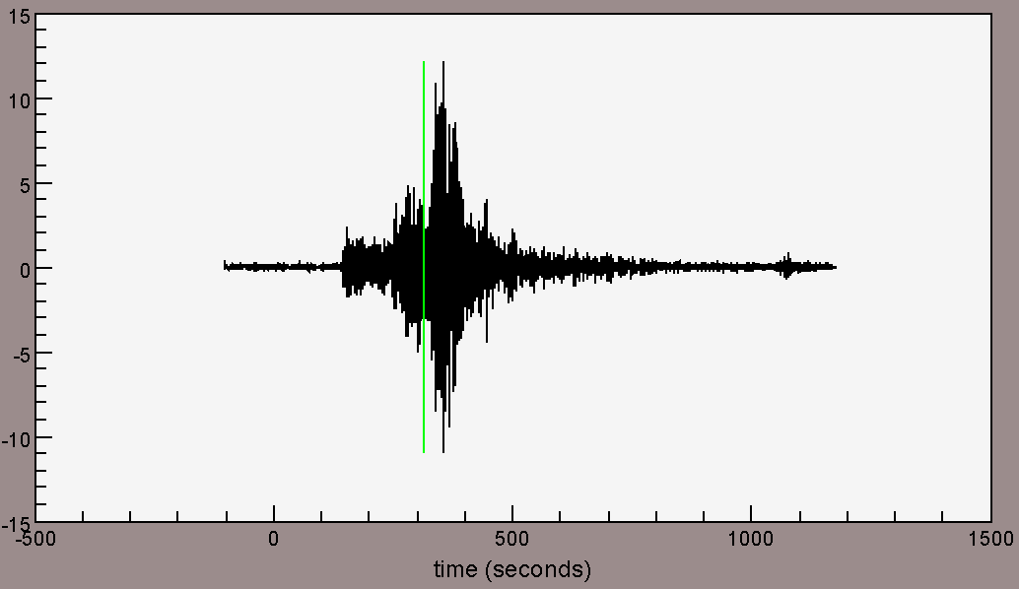
Note: before and after of using gv command in Waveforms window
Here the pick time will be saved under header “t0”

Console> gv t0 3.5 ↵
Console>lh t0 ↵

dt

Return sampling rate of seismogram

USAGE
dt

EXAMPLE
• How to return the sampling rate of seismogram
dt
0.025
Console> dt ↵

clearpicks

Remove all picks

USAGE
clearpicks
• All of the pick-time variables will be removed.
• Note this command works in both the Waveform and Phase Picker windows.

EXAMPLE
• How to return the sampling rate of seismogram
clearpicks
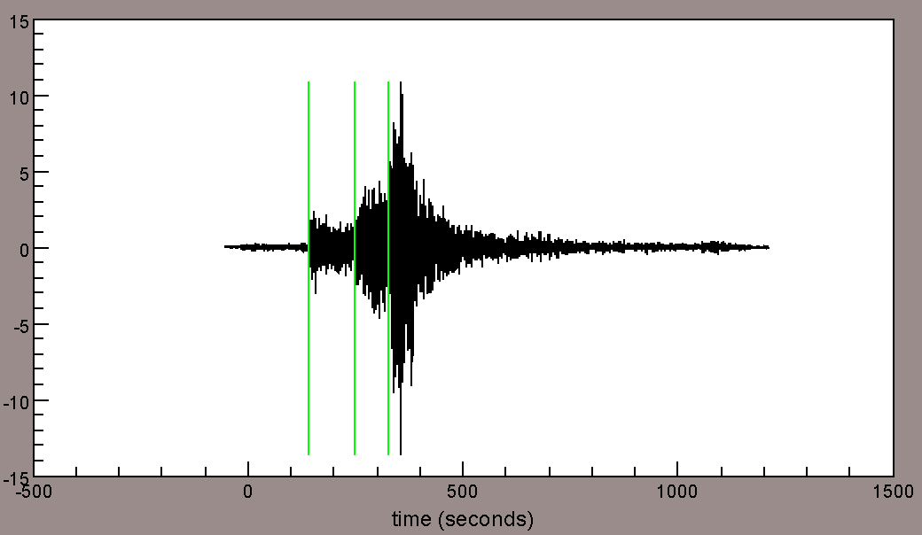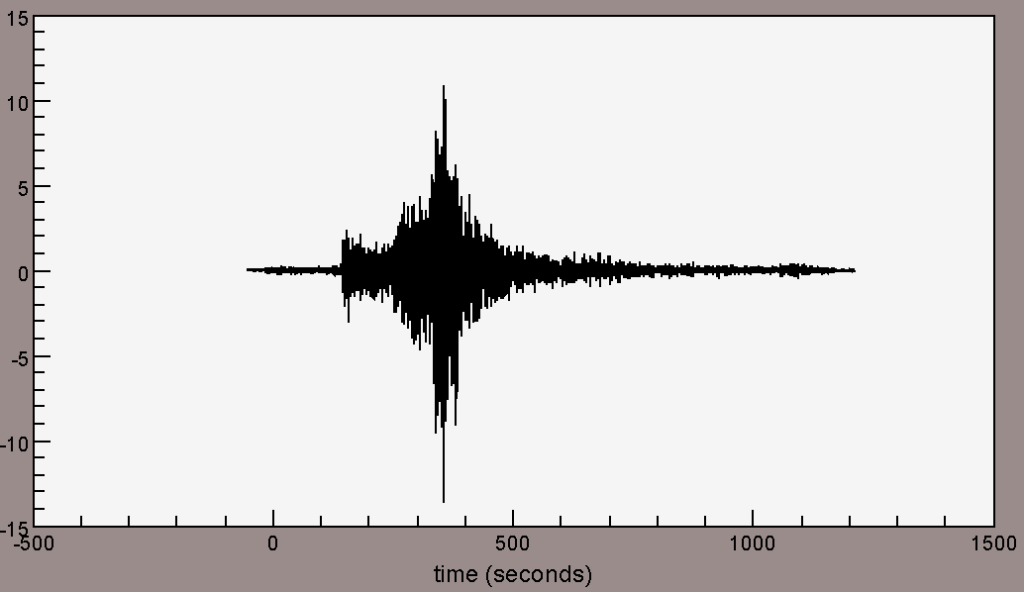
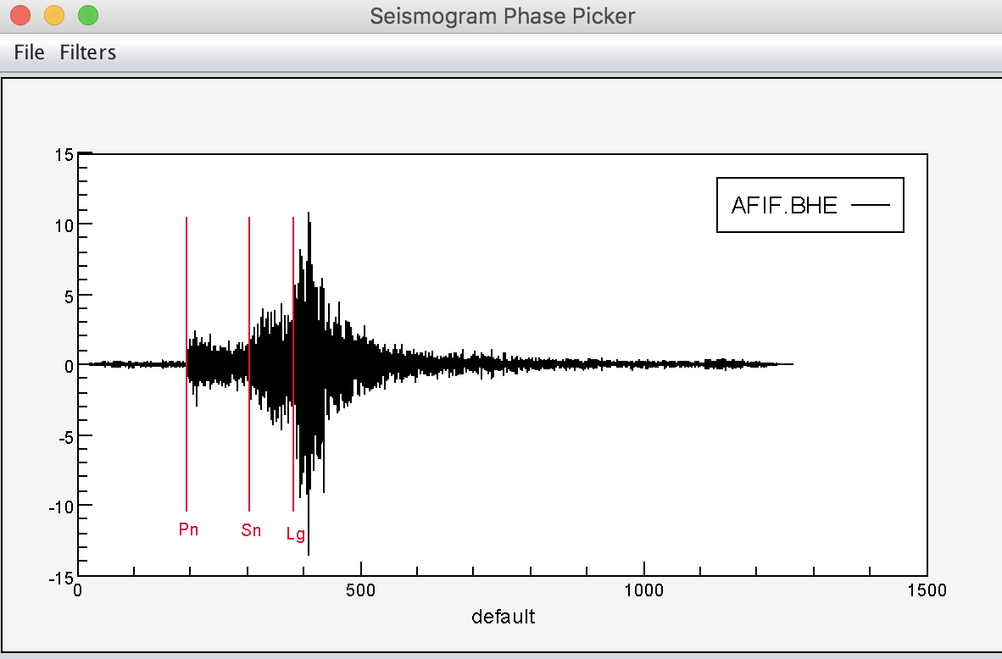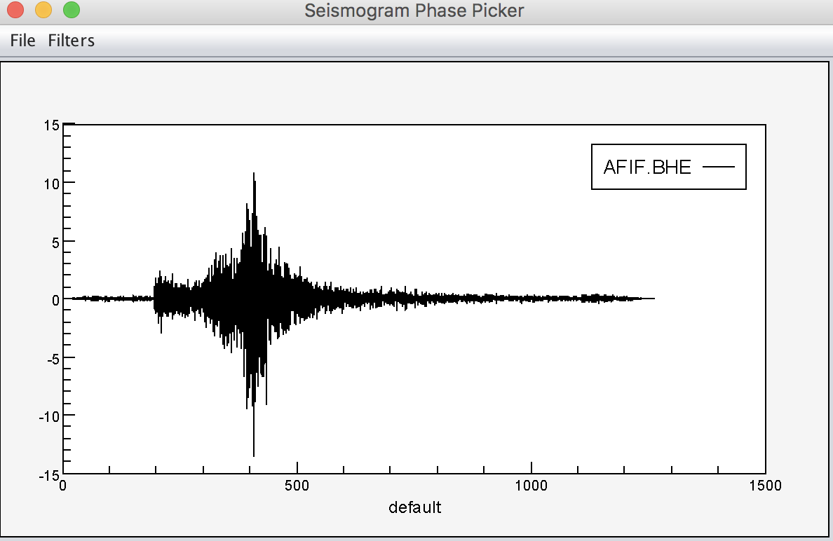
Note: before and after of using clearpicks command in Waveforms and Seismogram Phase Picker window (see under Tools> Phase Picker)
Console> clearpicks ↵

reckon

Calculate the point located a certain distance and azimuth from a reference lat, lon

USAGE
reckon [lat] [lon] [distance (km)] [azimuth (deg)]
• This command requires [lat] [lon] for an input location and degrees for distance.

EXAMPLE
• How to return lat/lon of a location in SW Montana from LLNL
reckon 37.7 -121.7 10 40
45.0308073076689 -112.61277508635521
Console> reckon 37.7 -121.7 10 40 ↵

distaz

Return distance and backazimuth

USAGE
distaz | distaz [lat1] [lon1] [lat2] [lon2]
• “distaz” return the distance and azimuth for each seismogram when event and station latitudes and longitudes are defined.
• “distaz [lat1] [lon1] [lat2] [lon2]” calculates the distance and azimuth between two input points.

EXAMPLE
• How to return the distance and backazimuth of an event from seismogram
• How to calculate the distance and azimuth of LLNL and SW Montana
distaz
distance: 1103.1837 (km) azimuth: 239.38202 baz: 55.19277
distaz 37.7 -121.7 45 -112.6
distance: 1110.9195366032247 (km) azimuth: 40.27188713541412
Console> distaz ↵
Console> distaz 37.7 -121.7 45 -112.6 ↵

refdistaz

Return distance from reference point

USAGE
refdistaz
• Note a reference point location should be already saved under correct SAC header variables.

EXAMPLE

ch reflat 22.931
ch relon 42.04
ch refdepth 0
refdistaz
null AFIF 4759 -12345.0 -12345.0 -12345.0 -12345.0 511.281999 0.017863101544382996

Note the last two numeric values are distances from the source and the receiver to the reference point, respectively.
Console> ch reflat 22.931 ↵
Console> ch reflon 42.04 ↵
Console> ch refdepth 0 ↵
Console> refdistaz ↵

track

Return distance and backazimuth

USAGE
track [lat1] [lon1] [lat2] [lon2] [npt]
• This command is used to list [npt]-1 points along a path connecting two input locations ((lat1, lon1) to (lat2, lon2)).
• This command results in equidistant locations along the path.
• Note the last return point is the 2nd input location.

EXAMPLE
• How to return three locations between LLNL and SW Montana
rack 37.7 -121.7 45 -112.6 4
point latitude longitude
0 37.7 -121.7
1 39.590599345741964 -119.61026132469735
2 41.44092935374513 -117.40501600217493
3 43.24595577763569 -115.07244395973075
4 44.99999999999999 -112.6

Note the last return point = (lat2, lon2).
Console> track 37.7 -121.7 45 -112.6 4 ↵

Statistical Information Commands

min

Return minimum value of all selected traces

USAGE
min

EXAMPLE
• How to return the minimum counts value from seismogram
min
trace(0): -1470.0771

Note SWFT trace index starts from 0.
Console> min ↵

max

Return maximum value of all selected traces

USAGE
max

EXAMPLE
• How to return the maximum counts value from seismogram
max
trace(0): 1172.9663

Note SWFT trace index starts from 0.
Console> max ↵

extremum

Return extremum value of all selected traces

USAGE
extremum
• Returns max if abs(max)>abs(min) else min.

EXAMPLE
• How to return the extremum from seismogram
min
trace(0): -1470.0771
max
trace(0): 1172.9663
extremum
trace(0): AFIF null BHE -1470.0771

Note abs(max) > abs(min) above case.
Console> min ↵
Console> max ↵
Console> extremum ↵

maxtime

Return time (sec) at max value

USAGE
maxtime

EXAMPLE
• How to return the time in seconds at the maximum counts for seismogram.
maxtime
trace(0): AFIF null BHE 355.331999
Console> maxtime ↵

mean

Return mean value for each seismogram

USAGE
mean

EXAMPLE
• How to return the mean counts value of seismogram
mean
trace(0): -6.926715797958528E-6

Note the seismogram here is detrended.
Console> mean ↵

median

Return median value for each seismogram

USAGE
median

EXAMPLE
• How to return the median counts value of seismogram
median
trace(0): 2.6190170319750905E-4
Console> median ↵

variance

Return variance value for each seismogram

USAGE
variance

EXAMPLE
• How to return the variance counts value of seismogram
variance
trace(0): 11663.52981048696
Console> variance ↵

rms

Return rms value for each seismogram

USAGE
rms
• This command is used to calculate Root Mean Square (RMS) for each seismogram.

EXAMPLE
rms
trace(0): 107.99782317476107
Console> rms ↵

rmsfit

Return rmsfit value for each seismogram

USAGE
rmsfit
• RMS fit =

EXAMPLE
rms
trace(0): 107.99782317476107
trace(1): 49.1000277133784
rmsfit
rmsfit trace(0).trace(1): 2.5217784938807757
Console> rms ↵
Console> rms fit ↵

p2p

Return maximum-to-minimum difference

USAGE
p2p [period]
• This command is used to calculate the peak to peak amplitude for each seismogram.
• This command requires an input period for peak to peak calculation.

EXAMPLE
• How to calculate maximum-to-minimum difference of T=500 sec signal for seismogram
p2p 500
seislist: 1P2P amplitude: 0 8376.283203125
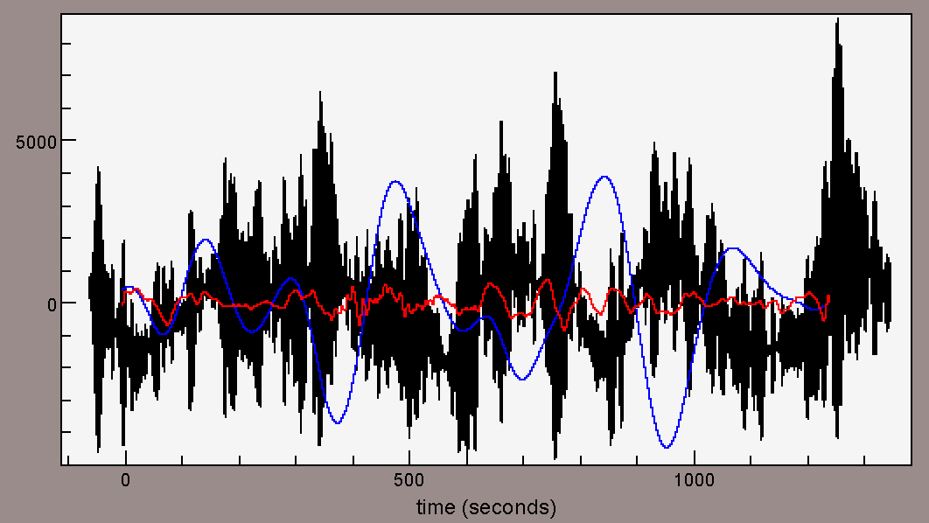
Note the black, blue, and red traces indicate raw, bp 0.001 0.01, and bp 0.01 0.1 of the same seismogram, respectively. “p2p” command was applied to the blue trace.
Console> p2p 500 ↵
Console> rms fit ↵

skewness

Return skewness

USAGE
skewness
• This command is used to calculate the skewness for each data point to the mean amplitude (e.g., y-axis) for each seismogram.
• Skewness is one way to measure of the asymmetry of the probability distribution of time series about its mean.
• Skewness =
• If (skewness > 0) then mean > median > mode, else mean < median < mode.

EXAMPLE
• How to calculate skewness of seismogram to its mean amplitude
skewness
trace(0): -0.6233743575451767
Console> skewness ↵

skewness’

Return skewness’

USAGE
skewness’
• This command is used to calculate the skewness for each data point to the reference time (e.g., x-axis) for each seismogram.

EXAMPLE
• How to calculate skewness of seismogram to its reference time
skewness'
trace(0): -0.5556520965674702
Console> skewness’ ↵

kurtosis

Return the kurtosis for each seismogram

USAGE
kurtosis
• Kurtosis is one way to measure of the asymmetry of the probability distribution of time series about its mean.
• Kurtosis =
• Normal distribution of kurtosis is 3. In case of excess kurtosis, the distribution is leptokurtic (i.e., larger tails).

EXAMPLE
kurtosis
trace(0): 29.79323086192545
Console> statistics ↵

statistics

Return sample statistics for each seismogram

USAGE
statistics
• Includes mean, median, RMS, variance, skewness, and kurtosis.

EXAMPLE
statistics
trace(index): mean median rms variance skewness kurtosis
trace(0): -6.926715797958528E-6 2.6190170319750905E-4 107.99782317476107 11663.52981048696 -0.6233743575451767 29.79323086192545
Console> statistics ↵

statistics’

Return statistics’

USAGE
statistics’

DESCRIPTION
• This command is used to calculate the sample statistics for each data point to the reference time (e.g., x-axis) for each seismogram.

EXAMPLE
statistics’
trace(index): mean median rms variance skewness kurtosis
trace(0): 72875.70780073998 2.826308310758936E9 2.339711160139277E15 5.474248312880281E30 0.12686141936789128 14.413337510487963
Console> statistics’ ↵

sum

Return sum counts

USAGE
sum

EXAMPLE
sum
trace(0): -0.35045025886823566
Console> sum ↵

valueatindex

Return value at index

USAGE
valueatindex [int] [int] [int] …

EXAMPLE
• How to return first 3 count values in seismogram
valueatindex 0 1 2
trace sta kevnm chan 0 1 2
trace(0): AFIF null BHE 0.0 8.302611E-5 4.6355612E-4

Note SWFT trace index starts from 0.
Console> valueatindex 0 1 2 ↵

Waveform Modification Commands
Commands listed in this category are not permanent unless you issue a save command to write over the open files.

abs

Take absolute value of each data point

USAGE
abs
• data[i] = abs(data[i]).

EXAMPLE
• How to take absolute value of each data point in seismogram
abs

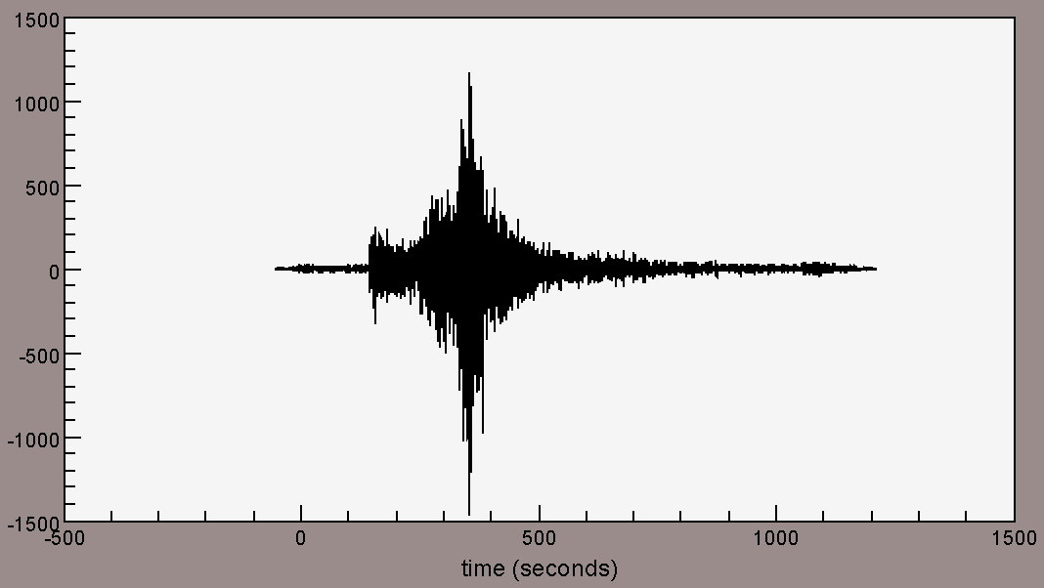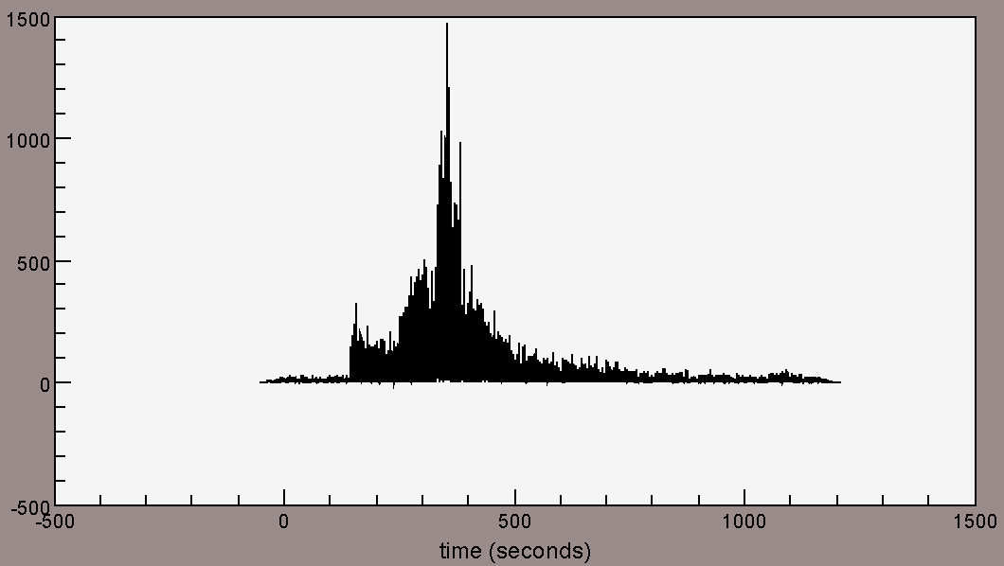
Before (left) and after (right) of applying “abs” command to the seismogram.
Console> abs ↵

add
Add a constant to each seismogram

USAGE
add [value]

EXAMPLE
• How to add a scalar value of 150 to seismogram
add 150

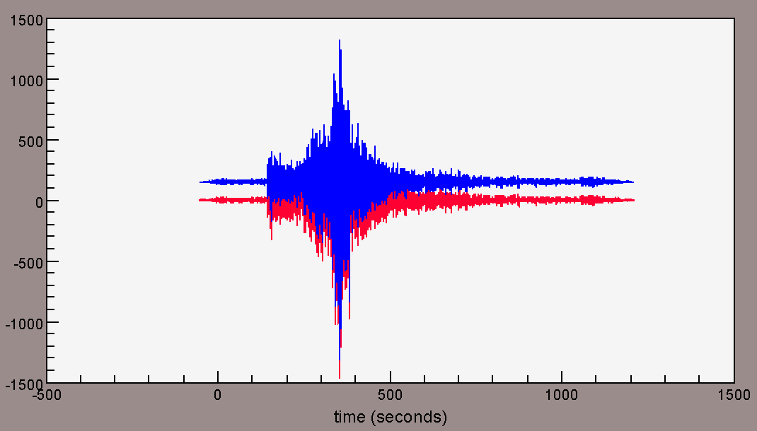
Before (red) and after (blue) of applying “add” command to the seismogram.
Console> add 150 ↵

differentiate

Differentiate seismogram

USAGE
differentiate

EXAMPLE
differentiate

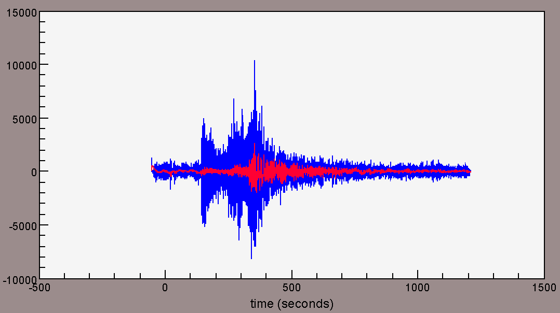
Before (red) and after (blue) of applying “differentiate” command to the seismogram.
Console> differentiate ↵

integrate

Integrate data

USAGE

integrate

EXAMPLE

integrate
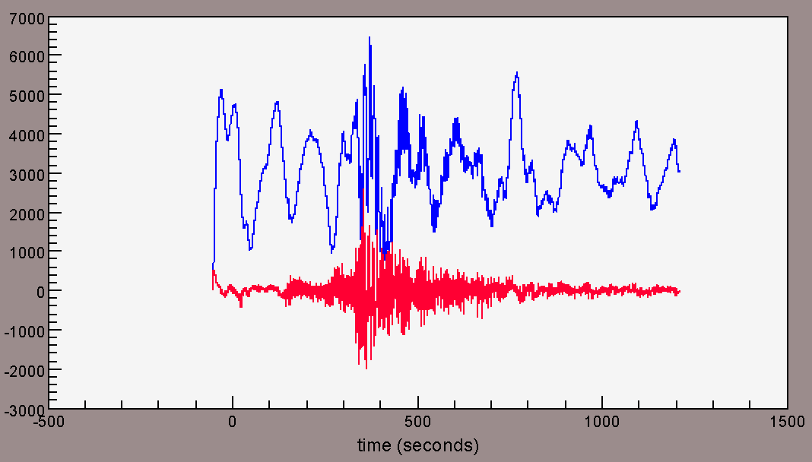
Before (red) and after (blue) of applying “integrate” command to the seismogram.
Console> integrate↵

dividetrace

Divide one trace by another

USAGE
dividetrace [index]
• This command is used to divide reference trace [index] into each seismogram

EXAMPLE
• How to divide 2nd with 1st t trace
dividetrace 0

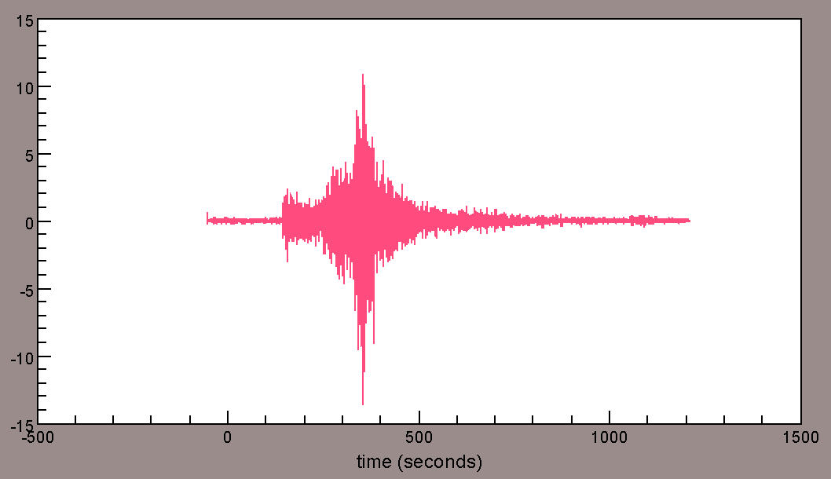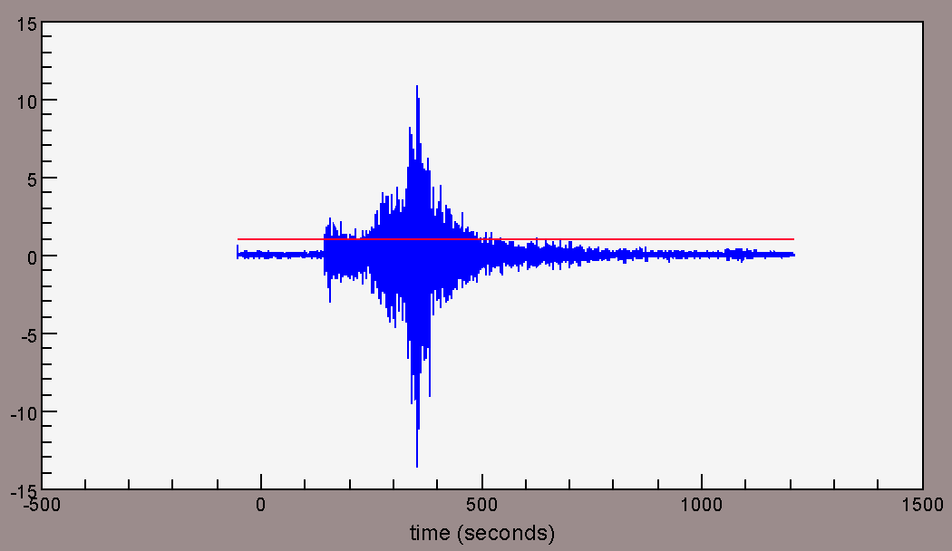
Before and after of applying “dividetrace” command to the seismogram (Note blue = trace[0], red = trace[1]).
Console> dividetrace 0 ↵

envelope

Compute envelope using Hilbert transform

USAGE
envelope
• This command is used to replace the seismogram with its envelope function.
• Envelope is calculated using Hilbert transform:
Envelope = where is the original signal and is its Hilbert transform.

EXAMPLE
• How to compute envelope of seismogram in frequency between 0.1 – 0.5Hz
bp 0.8 1
envelope
log10
smooth 50

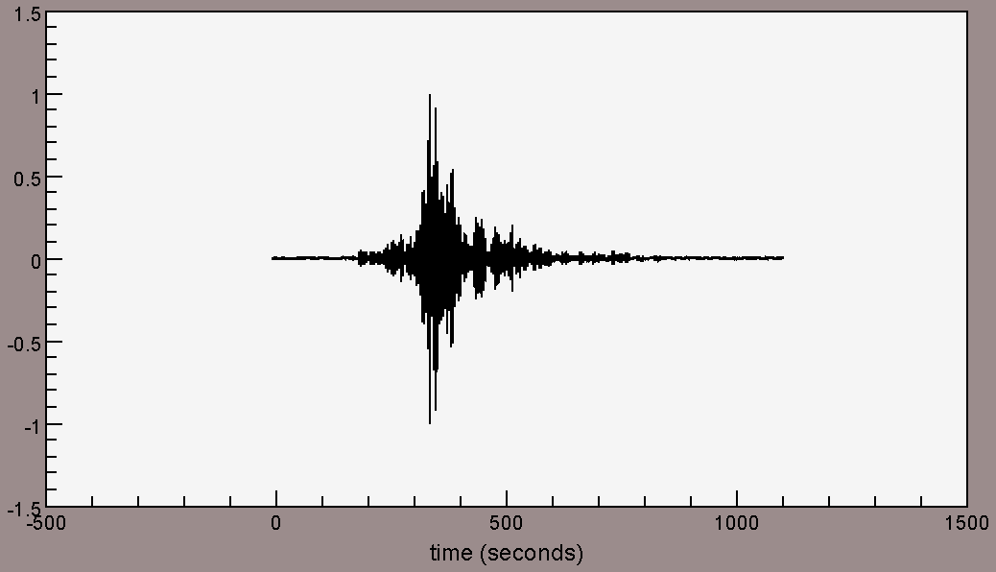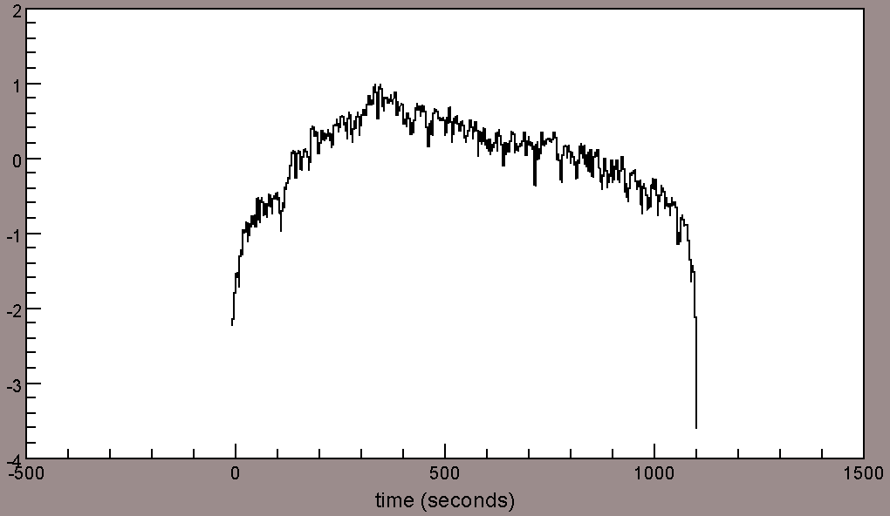
Before (left) and after(right) of applying “envelope” command to the seismogram.
Note the raw seismogram has been already normalized and filtered.
Console> bp 0.8 1 ↵
Console> envelope ↵
Console> log10 ↵
Console> smooth 50 ↵

fft

Performs a discrete Fourier transform on the trace

USAGE
fft

EXAMPLE
• How to plot amplitude spectra of seismogram
rmean
rtrend
normalize
bp 0.5 5
taper 0.05
fft
abs

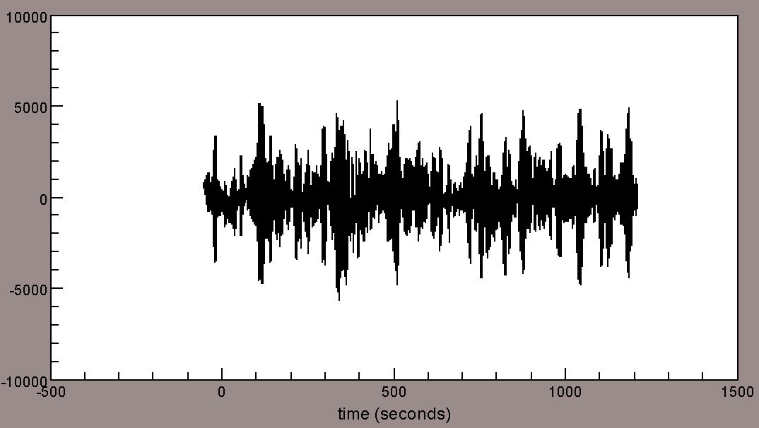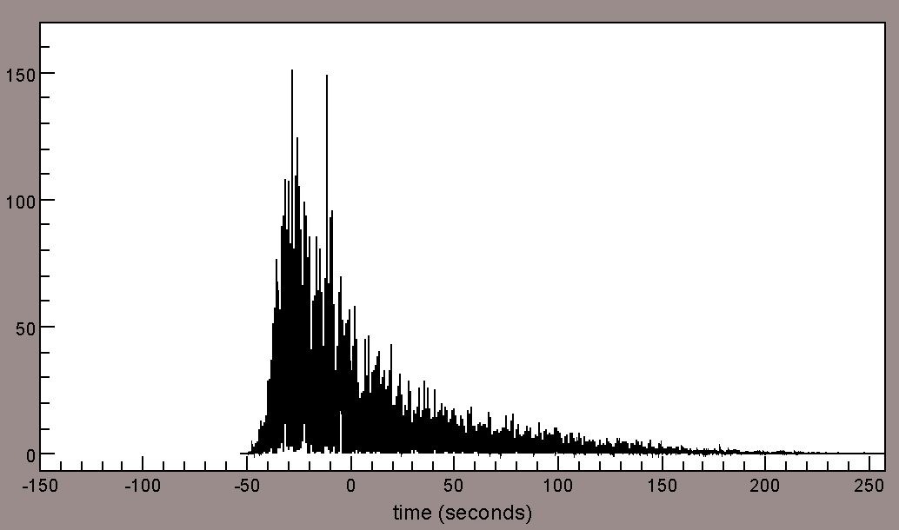
Comparison of raw seismogram (left) vs its amplitude spectra
Console> rmean ↵
Console> rtrend ↵
Console> normalize ↵
Console> bp 0.5 5 ↵
Console> taper 0.05 ↵
Console> fft ↵
Console> abs ↵

hilbert

Apply a Hilbert transform

USAGE
hilbert
• This command is used to replace the seismogram with its Hilbert transform.
• The Hilbert transform is a process which converts a real time series into its analytic signal.
• The Hilbert transform is related to the original data by 90° phase shift.

EXAMPLE

hilbert

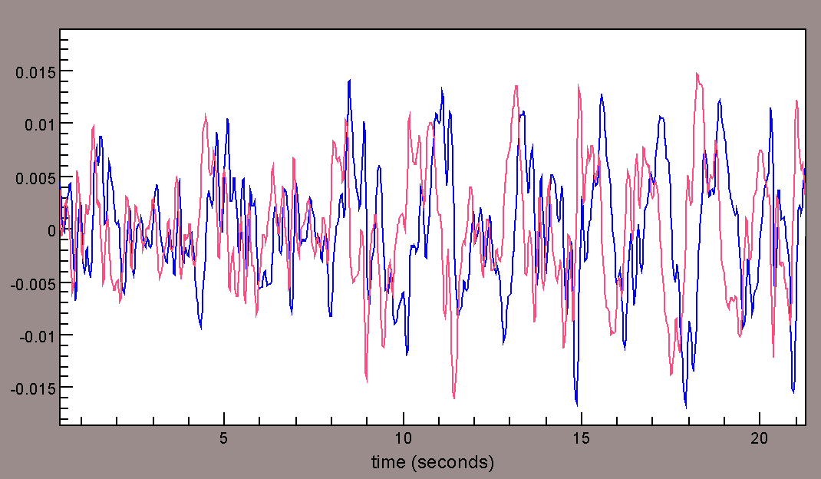
Before (red) and after (blue) of applying “hilbert” command to the seismogram;
notice the phase shift of the two signals.
Console> hilbert ↵

interpolate

Interpolate to a new sampling rate

USAGE
interpolate [new sampling rate]

EXAMPLE
• How to down-sample seismogram from 40 to 10 Hz
dt
0.025
interpolate 10
dt
0.1

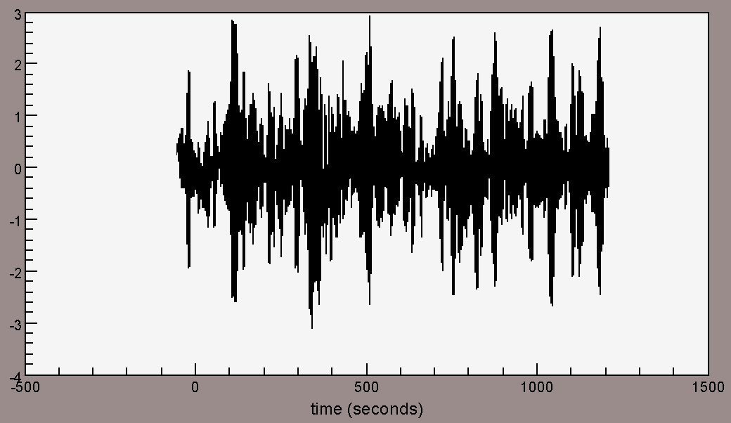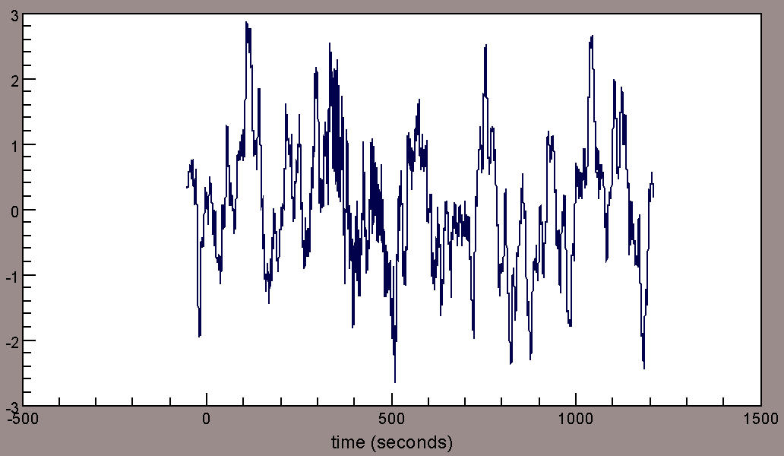
Before (left) and after (right) of applying “interpolate” command to the seismogram.
Console> dt ↵
Console> interpolate 10 ↵
Console> dt ↵

log

Take the natural logarithm of traces

USAGE
log
• data[i] = ln(data[i]).

EXAMPLE

log

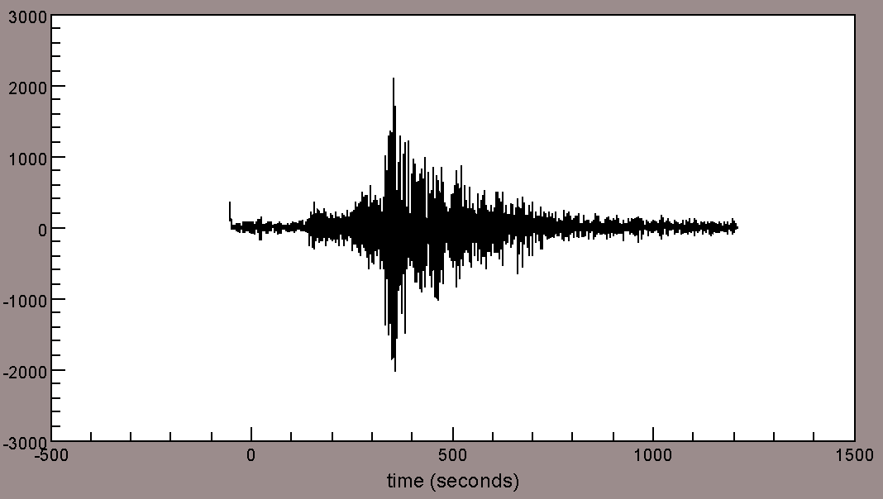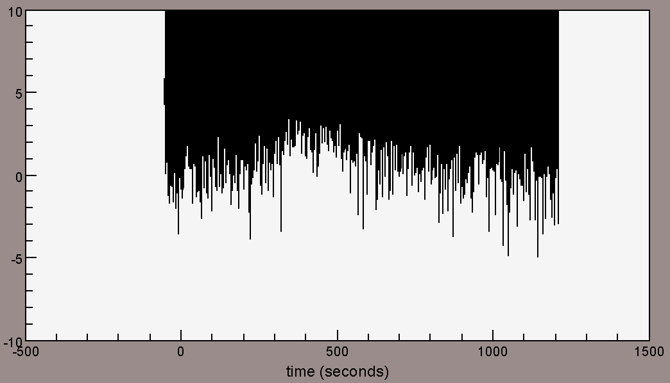
Before (left) and after (right) of applying “log” command to the seismogram.
Console> log ↵

log10

Take the base 10 logarithm of traces

USAGE
log
• data[i] = log10 (data[i]).

EXAMPLE

log10

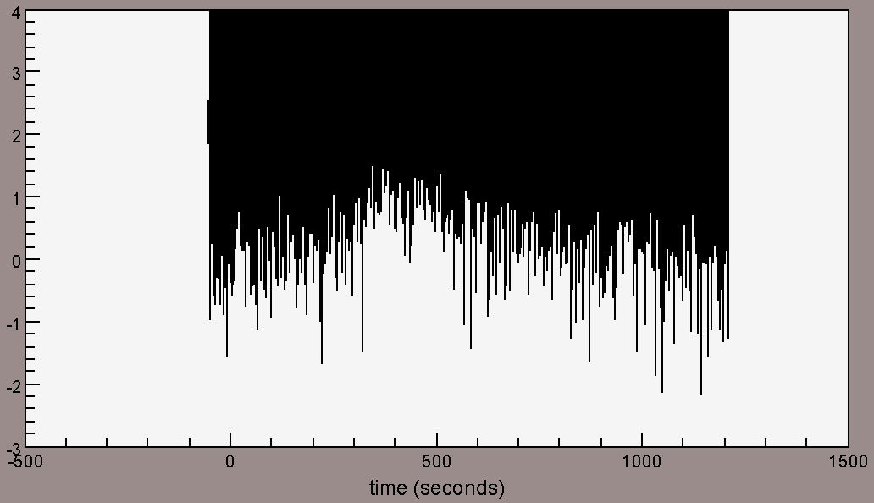
Before (left) and after (right) of applying “log” command to the seismogram.
Console> log10 ↵

multiply

Multiply traces by a constant

USAGE
multiply [value]

EXAMPLE
multiply 5

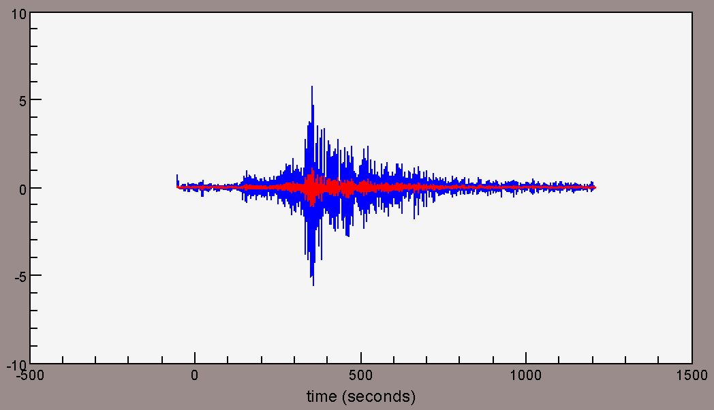
Before (red) and after (blue) of applying “multiply” command to the seismogram.
Console> multiply 5 ↵

raw

Remove all processing

USAGE
raw
• This command is used to re-read the input files from disk; any changes not saved will be replaced.

EXAMPLE

rmean
rtrend
normalize
bp 0.1 5
taper 0.05
align o
cut 0 1000
picks
raw

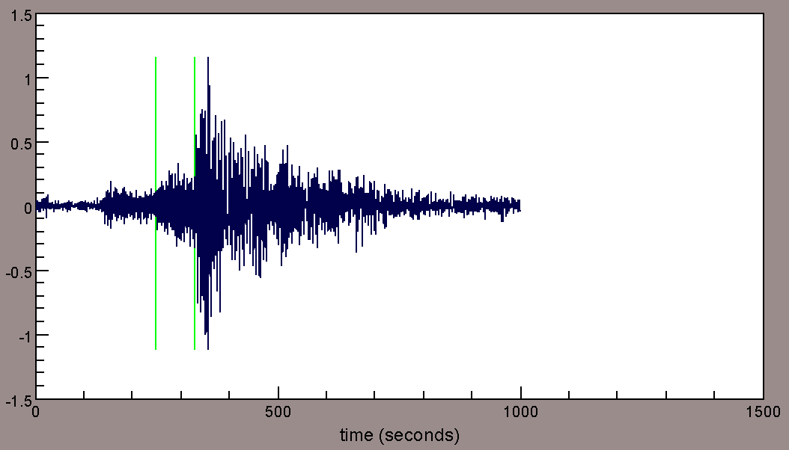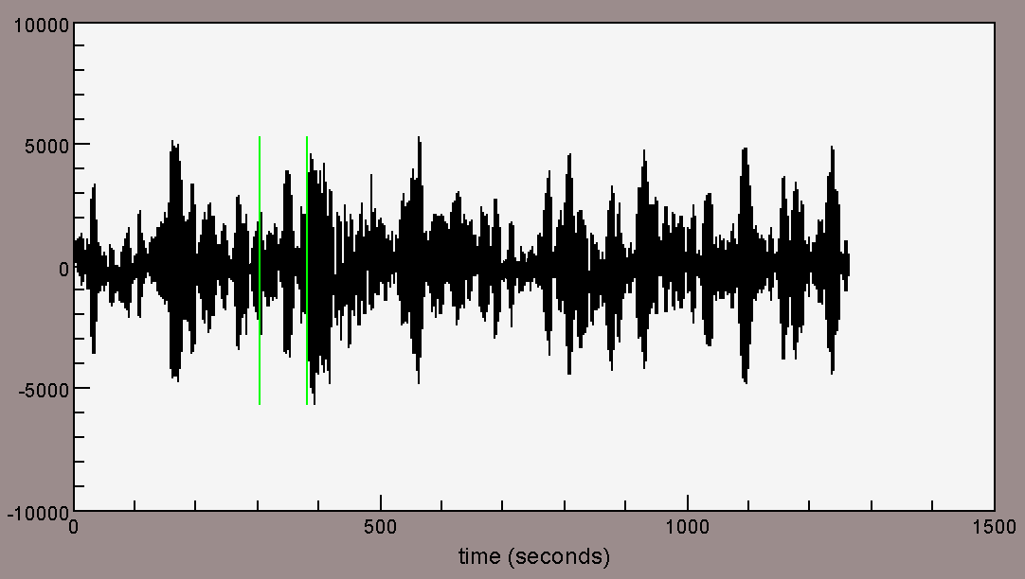
Before (left) and after (right) of applying “raw” command to the seismogram.
Note Plotting Support Commands used in this example (“align”, “cut”, and “picks”) are still applied after using raw command.

Console> rmean ↵
Console> rtrend ↵
Console> normalize ↵
Console> bp 0.1 5 ↵
Console> taper 0.05 ↵
Console> align o ↵
Console> cut 0 1000 ↵
Console> picks ↵
Console> raw ↵

normalize

Normalize data

USAGE
normalize | normalize [value] | normalize extremum | normalize mean | normalize max | normalize min
• This command is used to scale seismograms based on the extremum, mean, min, max or an input numeric value.
• The default for this command is extremum.

EXAMPLE
• How to normalize the seismogram based on its max
normalize max

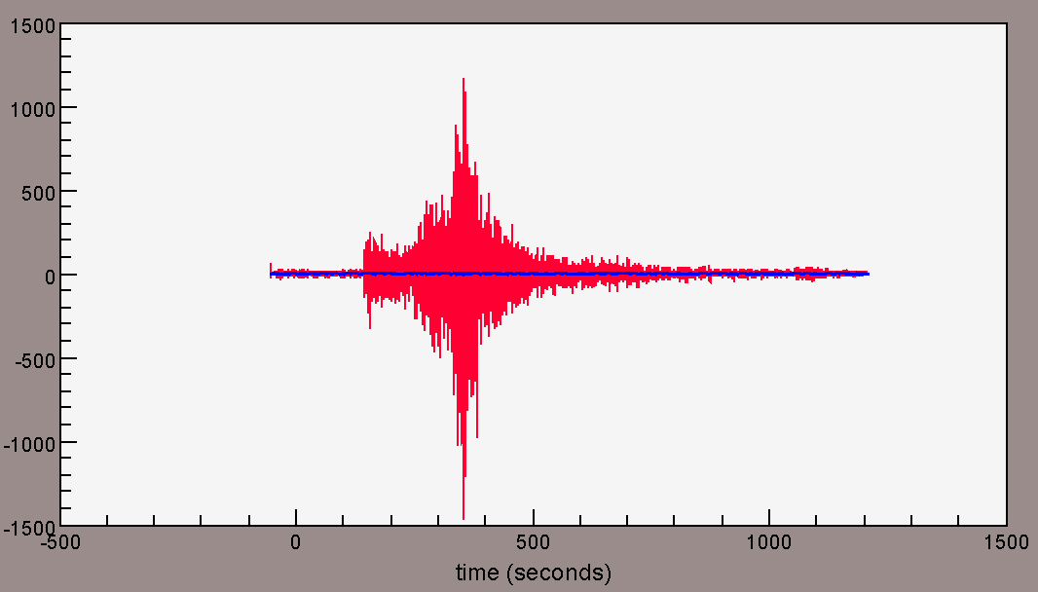
Before (red) and after (blue) of applying “normalize” command to the seismogram.
Console> normalize max ↵

scale

For profile plotting purposes – scale the data to a common reference size.

USAGE
scale [value]
• This command is used to scale seismograms in profile plots. It does not change the actual values in the traces.

power

Take a power of each data point

USAGE
power [value]
• data[i]=data[i]^[value].

EXAMPLE
• How to raise each data point of seismogram to 2
power 2

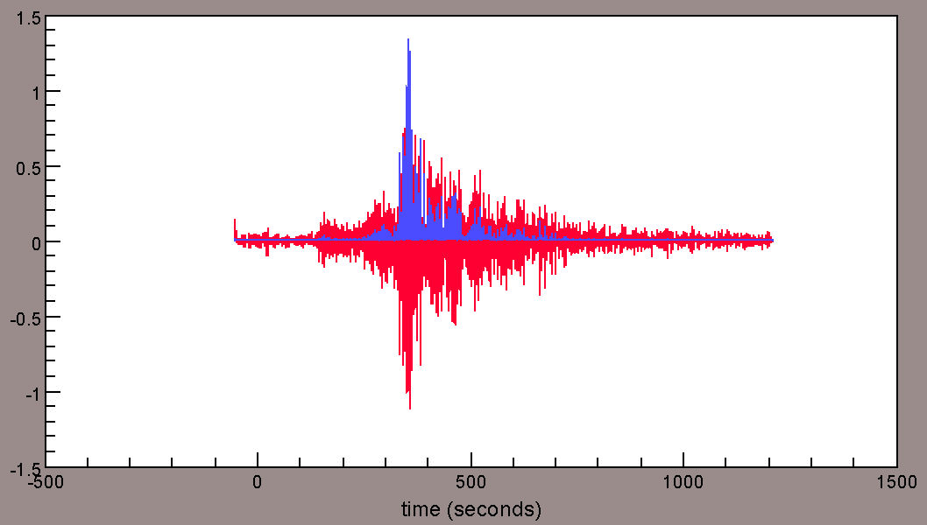
Before (red) and after (blue) of applying “power” command to the seismogram.
Console> power 2 ↵

spower

Take power of each data point and preserve original sign

USAGE
spower [value]
• This command preserves original sign of each data point as opposed to the “power” command.

EXAMPLE
• comparison of spower vs power
power 2
spower 2

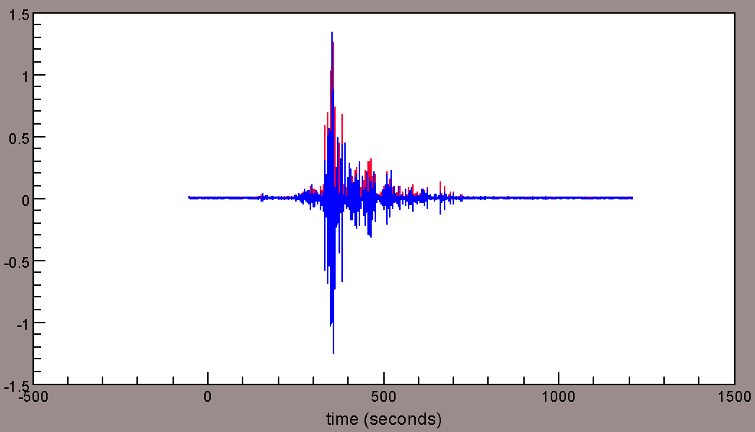
Note the sign preservation applying “spower” (blue) to the seismogram as opposed to “power” (power) command.
Console> power 2 ↵
Console> spower 2 ↵

mute

Mute data

USAGE
mute [gv1] [gv2] | mute [gv1] [inc1] [gv2] [inc2]
• This command is used to mute the data outside a designated window of group velocities [gv1] and [gv2] and optionally intercepts [inc1] and [inc2].
• A common convention of using group velocity inputs are [high group velocity] to [low group velocity].

EXAMPLE
• How to mute seismogram outside of a window of 3.5km/s to 8km/s
mute 8 3.5

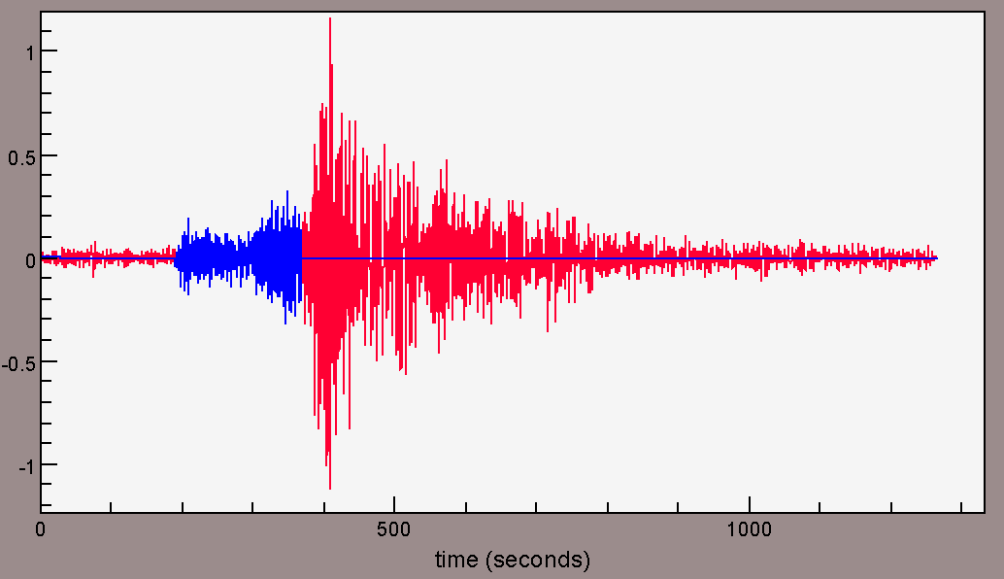
Before (red) and after (blue) of applying “mute” command to the seismogram.
Console> mute 8 3.5 ↵

rmean

Remove data mean

USAGE
rmean | removemean
• data = data – mean(data).

EXAMPLE
• How to remove data mean
raw
mean
trace(0): -6.023067215180917
rmean
mean
trace(0): -2.6967060756116722E-5

Note the mean of the trace is close to zero after applying “rmean” command to the seismogram.
Console> raw ↵
Console> mean ↵
Console> rmean ↵
Console> mean ↵

rmedian

Remove data median

USAGE
rmedian | removemedian
• data = data – median(data).

EXAMPLE
• How to remove data median
raw
median
trace(0): -48.699995040893555
rmedian
median
trace(0): 0.0
Console> raw ↵
Console> median ↵
Console> rmedian ↵
Console> median ↵

rtrend

Remove linear trend

USAGE
rtrend | removetrend
• A straight line with a least-square fit is computed then subtracted from seismogram.

EXAMPLE
• How to detrend the seismogram
raw
mean
trace(0): -6.023067215180917
rtrend
mean
trace(0): -8.284340039572914E-8
Console> raw ↵
Console> mean ↵
Console> rtrend ↵
Console> mean ↵

reverse

Reverse time series

USAGE
reverse [time variable]
• When using this command with [time variable], data reverses around defined SAC time header values (e.g., “reverse o”).

EXAMPLE
• How to reverse seismogram
valueatindex 0 1 2
trace sta kevnm chan 0 1 2
trace(0): AFIF null BHE 547.39325 787.0934 548.73816
reverse
valueatindex 50593 50592 50591
trace sta kevnm chan 50593 50592 50591
trace(0): AFIF null BHE 547.39325 787.0934 548.7381

Note the seismogram is a length of 50594 sample points in total.
Console> valueatindex 0 1 2 ↵
Console> reverse ↵
Console> valueatindex 50593 50592 50591 ↵

signum

Perform signbit conversion

USAGE
signum
• This command is used to perform 1-bit or signbit conversion to seismogram:
signum(data[i]) = (±1 or 0) to each seismogram.

EXAMPLE
• Converting a seismogram to signbit
cut 150 200
signum

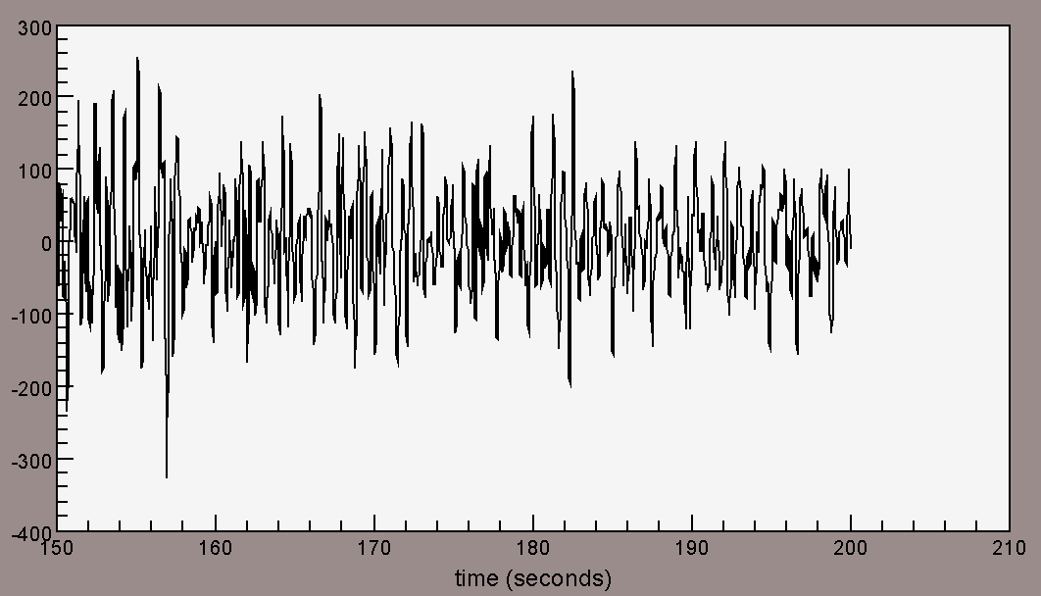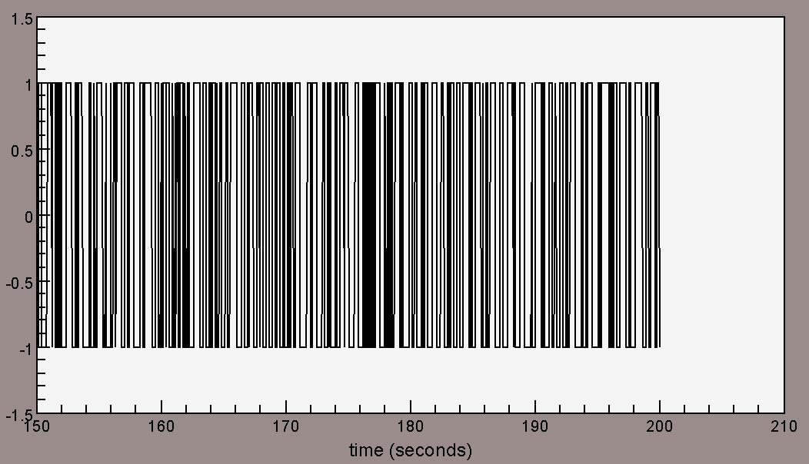
Before (left) and after (right) of applying “signum” command to the seismogram.
Console> cut 150 200 ↵
Console> signum ↵

sqr

Square each data point

USAGE
sqr
• data[i] = data[i]^2

EXAMPLE
• How to square each data point in seismogram
rtrend
normalize
sqr

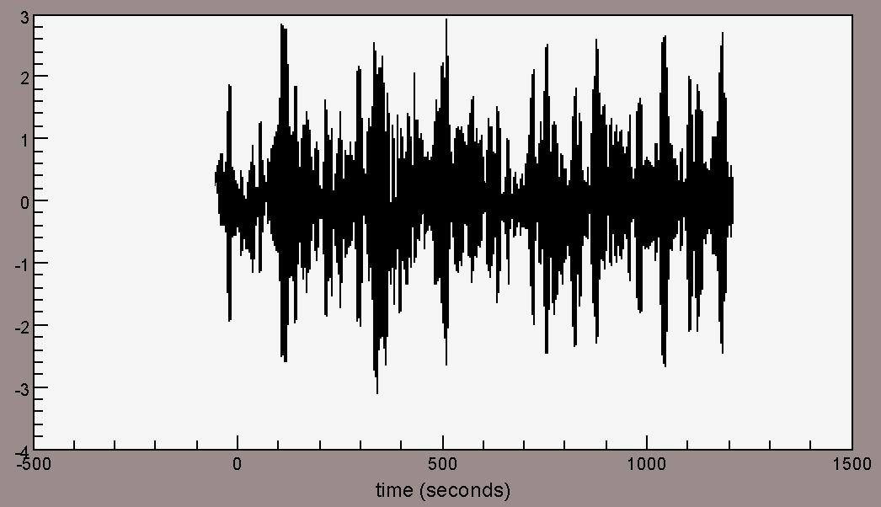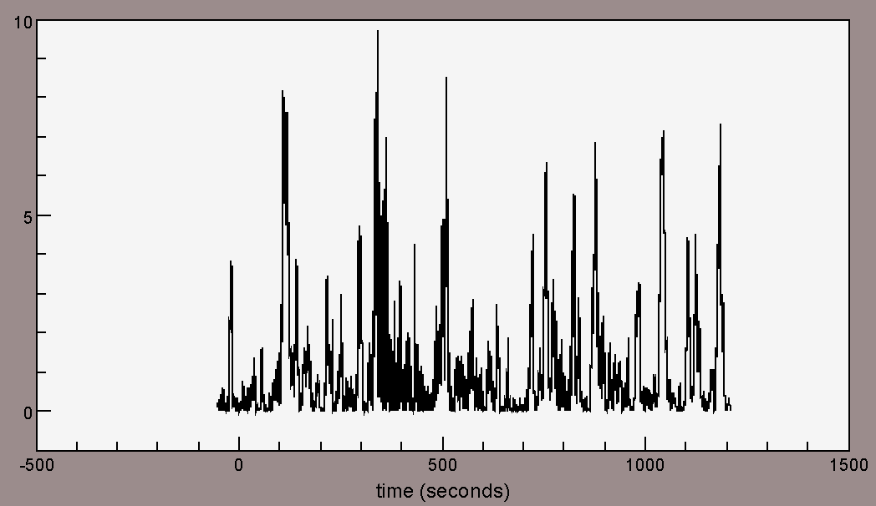
Before (left) and after (right) of applying “sqr” command to the seismogram.
Console> rtrend ↵
Console> normalize ↵
Console> sqr ↵

sqrt

Take the square root of each data point

USAGE
sqrt
• data[i] = sqrt(data[i])

EXAMPLE
• How to take square root of each data point in seismogram
rtrend
normalize
sqrt

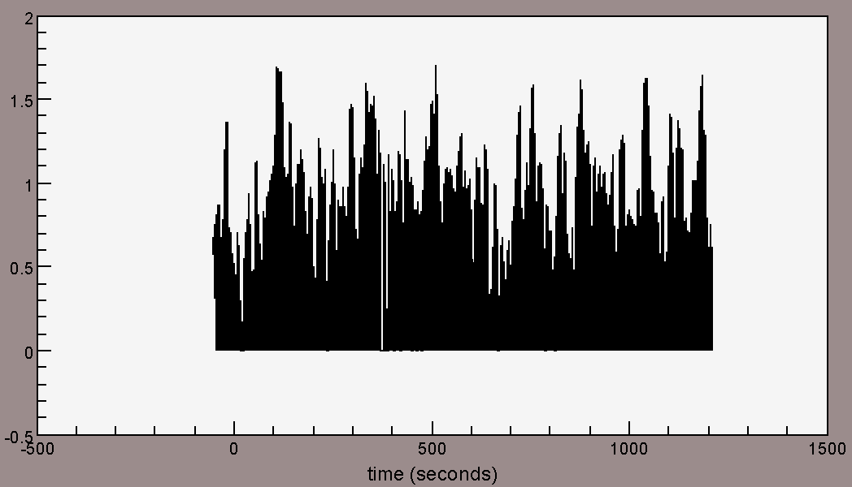
Before and after of applying “sqrt” command to the seismogram.
Console> rtrend ↵
Console> normalize ↵
Console> sqrt ↵

stack

Perform a linear stack

USAGE
stack
• Replace the first trace with a stack of all the selected traces.

EXAMPLE
• How to perform a brute stack to multiple seismograms
Stack

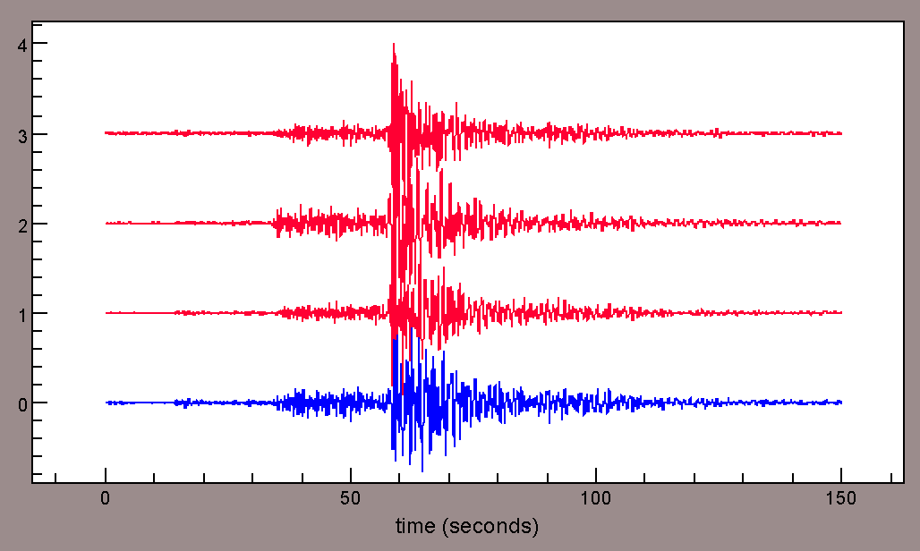
Before (red) and after (blue) of applying “stack” command to the seismogram.
Console> stack ↵

stretch

Stretch data in time

USAGE
stretch [factor]
• This command is used to stretch data by an input factor in time.
• This command is a different command from SAC “stretch” command (i.e., upsampling).

EXAMPLE
• How to stretch seismogram twice as along in time
rtrend
normalize
bp 0.5 5
taper 0.05
cut 0 500
stretch 2

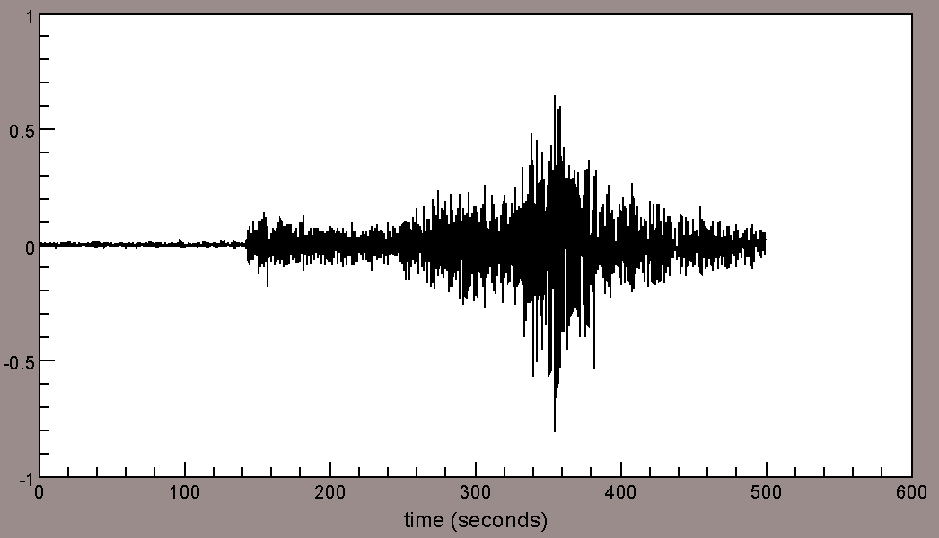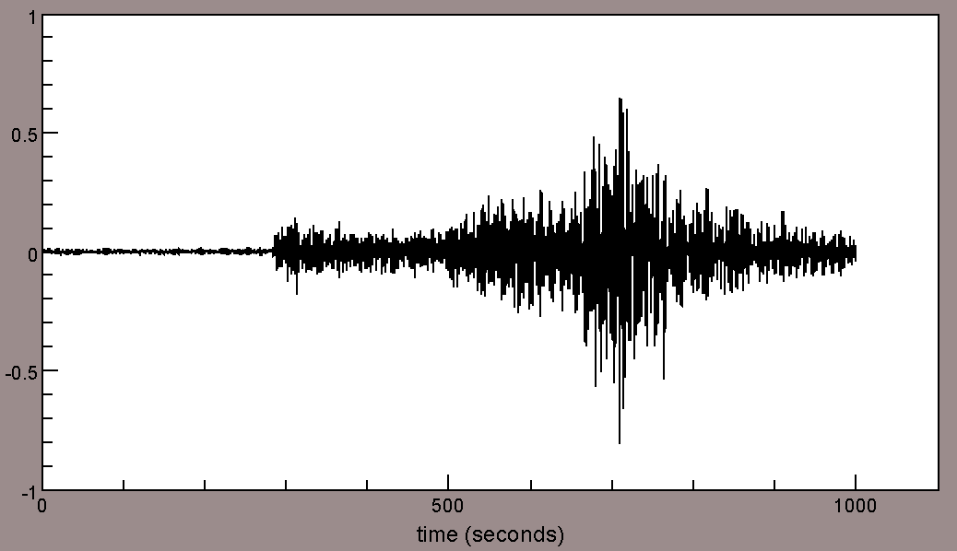
Before (left) and after (right) of applying “stretch” command to the seismogram.
Console> rtrend ↵
Console> normalize ↵
Console> bp 0.5 5 ↵
Console> taper 0.05 ↵
Console> cut 0 500 ↵
Console> stretch 2 ↵

Filtering and Basic Processing Commands

taper

Apply a symmetric taper

USAGE
taper [value]
• This command is used to apply a cosine taper of [value] % (0 – 50) to each end of seismogram.

EXAMPLE
• How to apply a cosine taper of 0.05% to each end of seismogram
rtrend
normalize
bp 0.5 5
taper 0.05

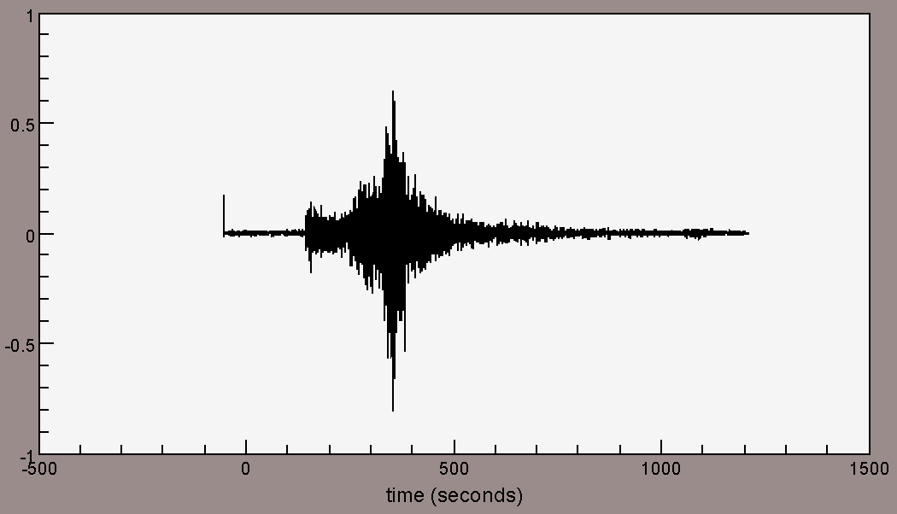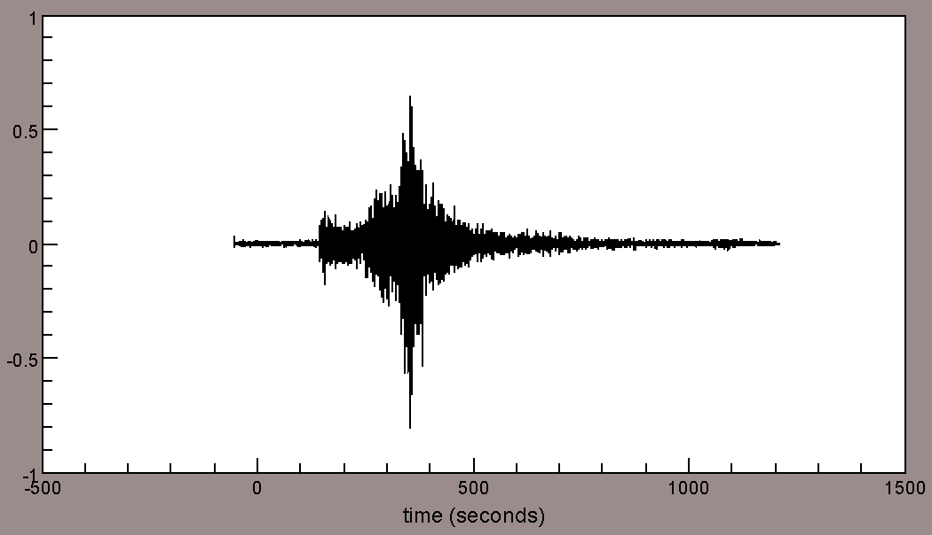
Before (left) and after (right) of applying “taper” command to the seismogram. Note a spike is removed after applying tapering the seismogram.
Console> rtrend ↵
Console> normalize ↵
Console> bp 0.5 5 ↵
Console> taper 0.05 ↵

bp

Apply an IIR bandpass filter

USAGE
bp [low] [high] | BP [low] [high]
• This command is used to apply a 2nd order bandpass filter to seismogram.

EXAMPLE
• How to apply a bandpass filter of 0.5 – 5Hz to seismogram
rtrend
normalize
bp 0.5 5

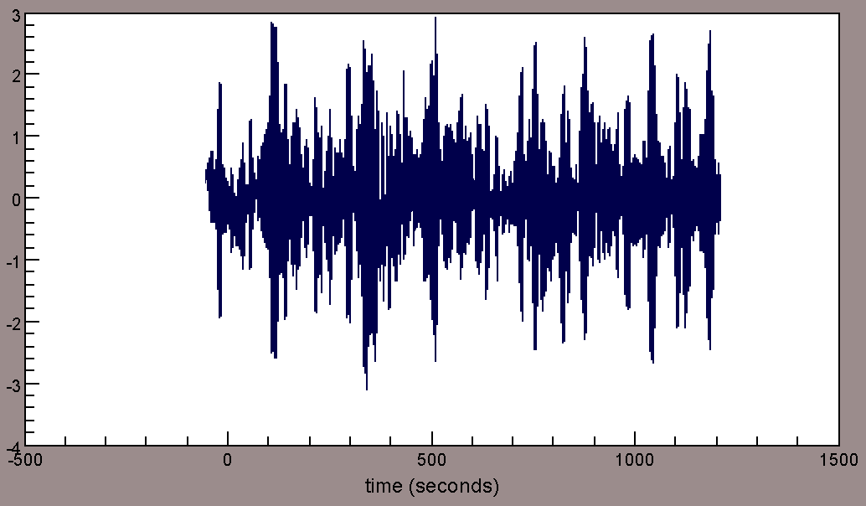
Before and after of applying “bp 0.5 5” (i.e., bandpass 0.5 – 5 Hz) command to the seismogram.
Console> rtrend ↵
Console> normalize ↵
Console> bp 0.5 5 ↵

lp

Apply an IIR lowpass filter

USAGE
lp [pass] [cut] | LP [pass] [cut]
• This command is used to apply a 2nd order low pass filter to seismogram.

EXAMPLE
• How to apply a 0.1 Hz lowpass filter to seismogram
rtrend
normalize
bp 0.01 0.1
raw
rtrend
normalize
lp 0.01 0.1

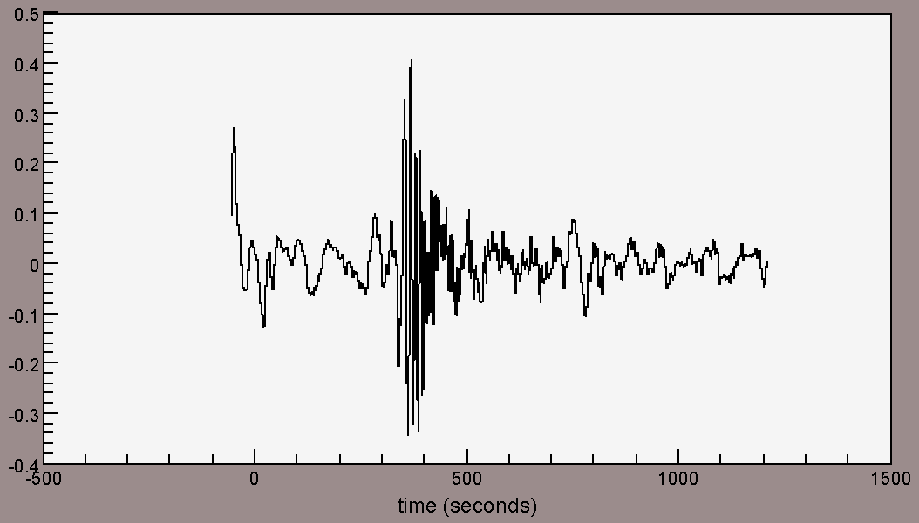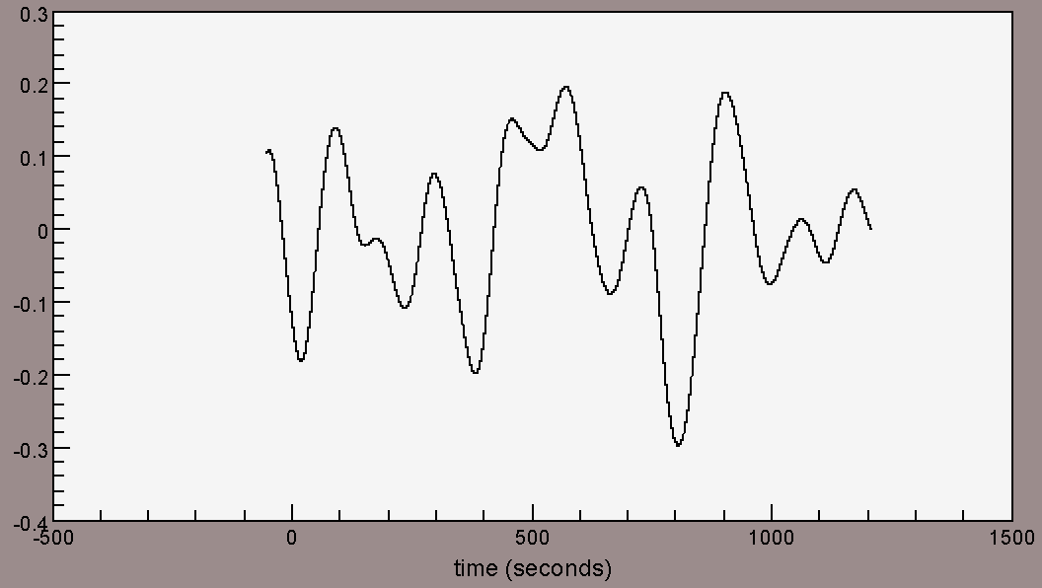
Note the difference between applying “bp” (left) and “lp” command (right) to the same seismogram.
Console> rtrend ↵
Console> normalize ↵
Console> bp 0.01 0.1 ↵
Console> raw ↵
Console> rtrend ↵
Console> normalize ↵
Console> lp 0.01 0.1 ↵

filter

Apply an IIR filter

USAGE
filter [order] [type] [low] [high]

EXAMPLE
• How to apply a 2nd order bandpass filter of 0.5 – 5Hz to seismogram
rtrend
normalize
filter 2 bp 0.5 5

Before (left) and after (right) of applying “filter” command to the seismogram.
Console> rtrend ↵
Console> normalize ↵
Console> filter 2 bp 0.5 5 ↵

acor

Compute autocorrelation function of energy

USAGE
acor
• Note the autocorrelation function of energy and the energy spectral density of seismogram are Fourier transform pairs.

EXAMPLE
• How to compute the autocorrelation function of energy of seismogram
rtrend
normalize
acor
trace(0) energy: 50593.000024166366

Note this command will only output the autocorrelation energy at zero-lag time.
Console> rtrend ↵
Console> normalize ↵
Console> acor ↵

xcor

Compute correlation coefficient

USAGE
xcor [start] [end]
• This command is used to compute the correlation coefficient between the first selected seismogram and each of the others.
• The computation will take place from [start] to [end] time in seconds.
• Correlation coefficient =

EXAMPLE
• How to compute the correlation coefficient of two seismograms
rtrend
normalize
bp 0.5 5
taper 0.05
align
xcor 0 1000
normalized cross correlation between trace(0) and trace(1): 0.12466966577256697 shift:-4.25 seconds

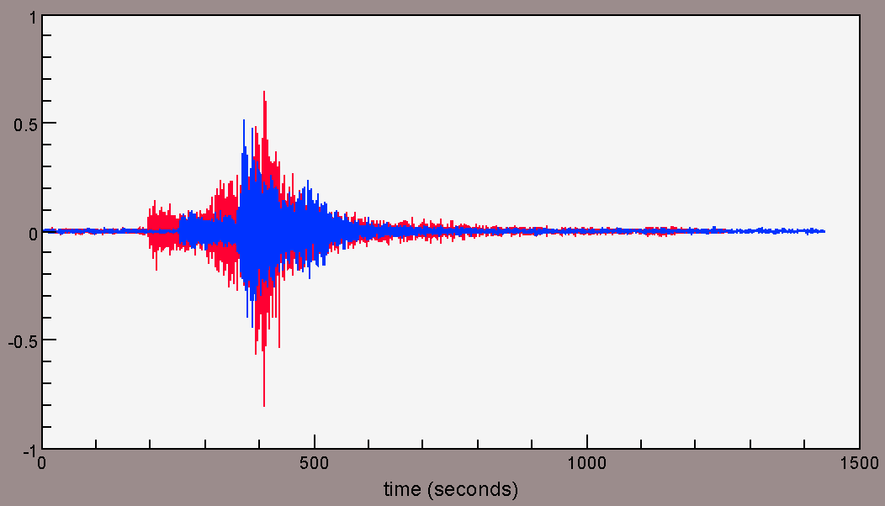
Note the resulting correlation coefficient may use for a measure of similarity between the two seismograms.
Console> rtrend ↵
Console> normalize ↵
Console> bp 0.5 5 ↵
Console> taper 0.05 ↵
Console> align ↵
Console> xcor 0 1000 ↵

correlate

Compute the auto and cross correlation functions

USAGE
correlate
• This command is used to correlate all selected seismograms against the 1st seismogram.
• If the two data have different lengths, this command appends zeros at the end of the shorter time series and commute cross correlation function for ± (n-1) time-lags.

EXAMPLE
• How to compute the auto and cross correlation functions for given seismograms
rtrend
normalize
bp 0.5 5
taper 0.05
correlate

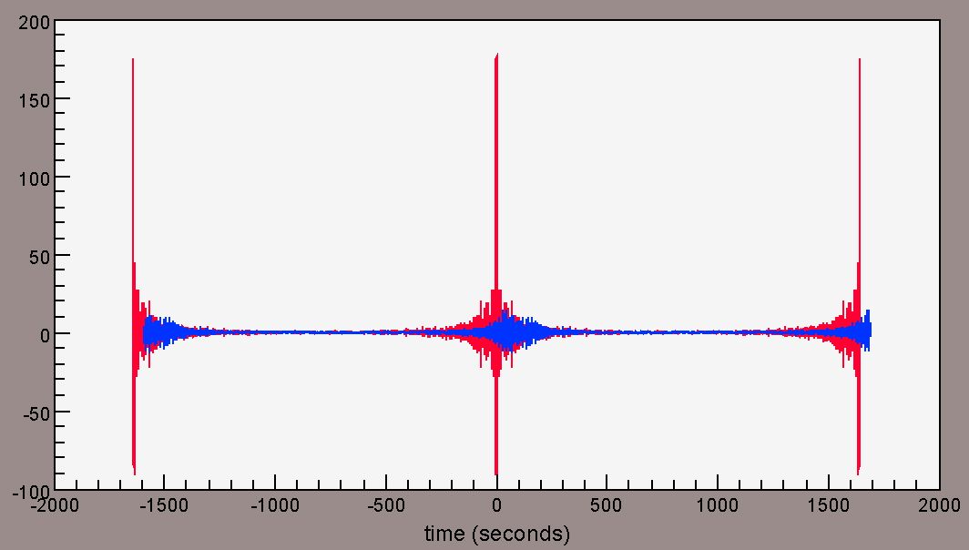
Before (left) and after (right) of applying “correlate” command to the seismograms.
Note the 1st and 2nd seismogram are indicated in red and blue, respectively. Thus the resulting traces of using correlate command will show the autocorrelation trace of the 1st seismogram and the cross correlation trace of 1st vs. 2nd seismograms.
Console> rtrend ↵
Console> normalize ↵
Console> filter 2 bp 0.5 5 ↵

cut

Cut the seismogram relative to the origin time to each seismogram.

USAGE
cut [start] [end]

EXAMPLE
• How to cut the seismogram between the origin time and 500 sec afterwards
ch ref o
rtrend
normalize
bp 0.5 5
taper 0.05
cut 0 500

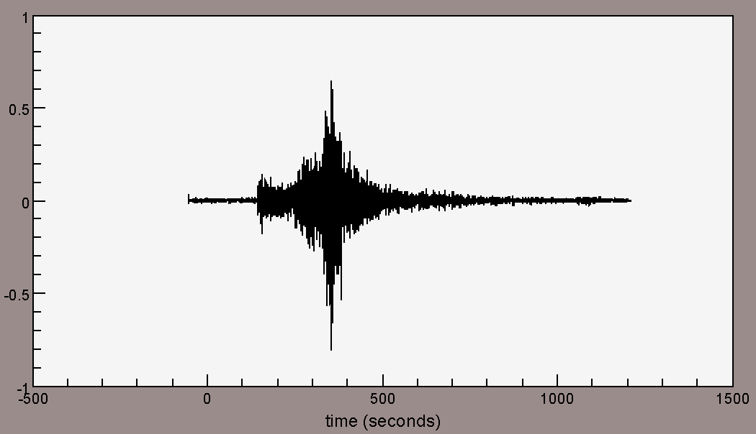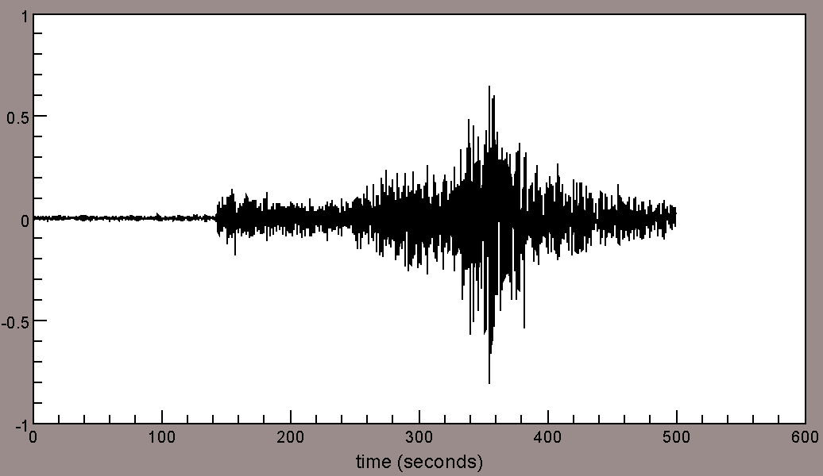
Before (left) and after (right) of applying “cut” command to the seismogram.
Console> ch ref o ↵
Console> rtrend ↵
Console> normalize ↵
Console> bp 0.5 5 ↵
Console> taper 0.05 ↵
Console> cut 0 500 ↵

despike

Despike data

USAGE
despike [threshold]
• This command is used to replace spikes and glitches in the data[i] with mean(data[i-n]).
If (data[i] – mean) > threshold × sqrt (variance), then replace with mean.

EXAMPLE
• How to despike the normalized amplitude above 2 of seismogram
normalize
despike 2
cut 50 250

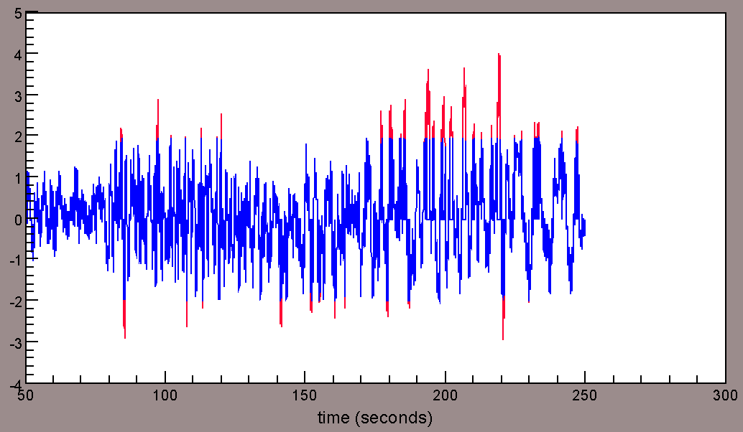
Before (red) and after (blue) of applying “despike” command to the seismogram.
Console> normalize ↵
Console> despike 2 ↵
Console> cut 50 250 ↵

smooth

Apply a mean smoothing to data

USAGE
smooth [n]
• This command is used to apply a [n] length of moving average window to seismogram:
data[i] = mean(data[i-n] : data[i+n]).

EXAMPLE
• How to smooth seismogram with 20 and 500 sample point moving average window
smooth 20
smooth 500

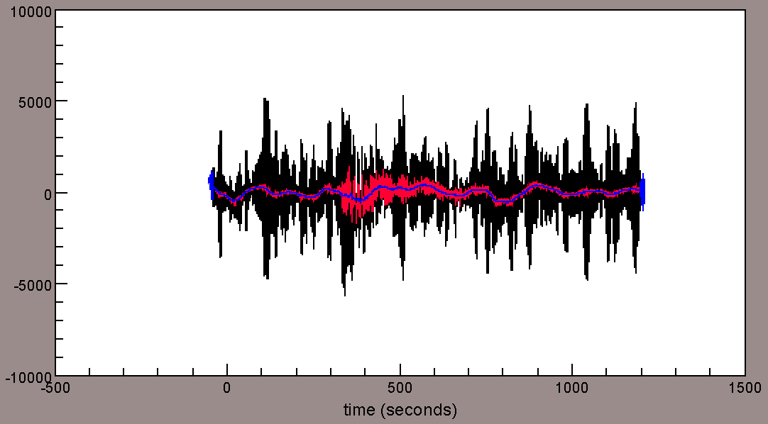
Before and after of applying “smooth” command to the seismogram.
Note the raw, smooth 20, smooth 500 data are indicated in black, red, and blue, respectively.
Console> smooth 20 ↵
Console> smooth 500 ↵

whiten

Perform spectral whitening on data

USAGE
whiten
• This command adds white noise to the data to flatten the spectra.

EXAMPLE
• How to perform spectral whitening on seismogram
rtrend
normalize
fft
abs
raw
rtrend
normalize
whiten
taper 0.05
fft
abs

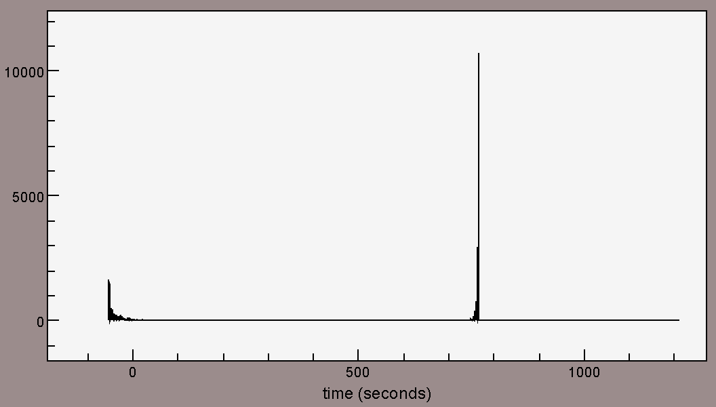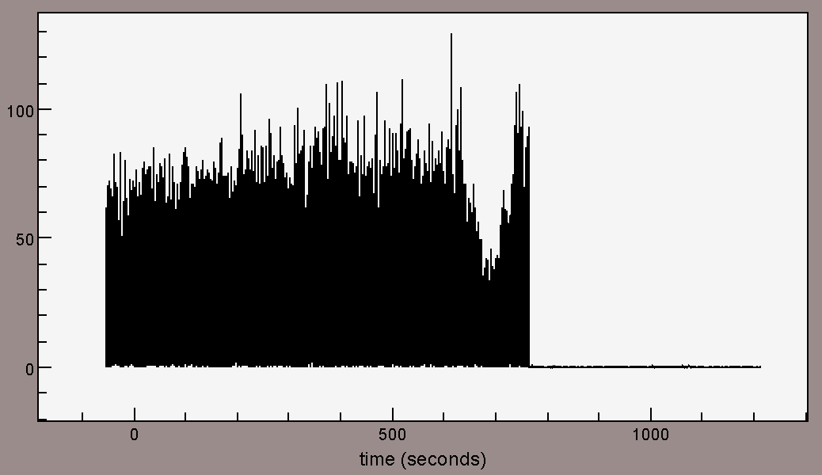
Before (left) and after (right) of applying “whiten” command to the seismogram.
Console> fft ↵
Console> abs ↵
Console> raw ↵
Console> whiten ↵
Console> taper 0.05 ↵
Console> fft ↵
Console> abs ↵

transfer

Apply transfer function

USAGE
transfer from [resp | polezero] to [displacement | velocity | acceleration] freq [lowcut] [lowpass] [highpass] [highcut]
• This command is used to remove instrument response from data by applying transfer function.
• This command requires either “resp” or “polezero” file; the user will be prompted to designate a directory where instrument response file lies.
IMPORTANT: SAC header variables (e.g. KNETWK, STA, CHN, etc.) should match with the “resp” or “polezero” filename

EXAMPLE
• 1) How to remove instrument response with a resp file and convert voltage count to velocity
rmean
rtrend
taper 0.05
transfer from resp to velocity freq 0.01 0.02 9.0 9.5
taper 0.05
rtrend
rmean

lh
:
depvariabletype: velocity
:
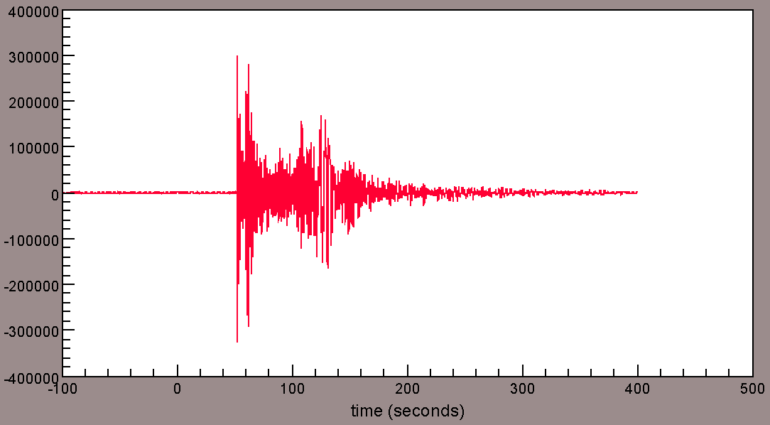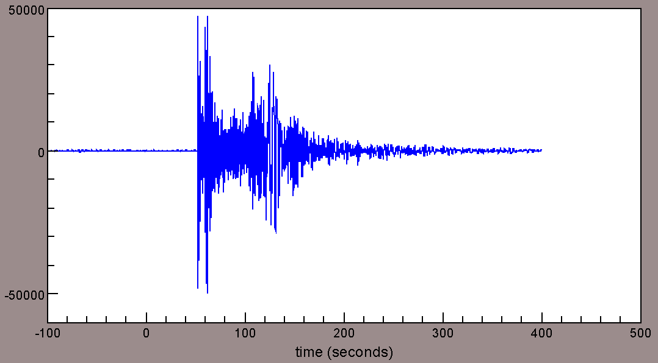
Before (red in voltage counts) and after (blue in velocity) of applying “transfer” command to the seismogram. Note user can check with “lh” command after applying transfer function for verification (e.g., header: “depvariabletype”).
Console> rmean ↵
Console> rtrend ↵
Console> taper 0.05 ↵
Console> transfer from resp to velocity freq 0.01 0.02 9.0 9.5 ↵
Console> taper 0.05 ↵
Console> rtrend ↵
Console> rmean ↵
Console> lh ↵
• 2) How to remove instrument response with a “polezero” file and convert voltage count to displacement
rmean
rtrend
taper 0.05
transfer from polezero to displacement freq 0.01 0.02 9.0 9.5
taper 0.05
rtrend
rmean

lh
:
depvariabletype: velocity
:
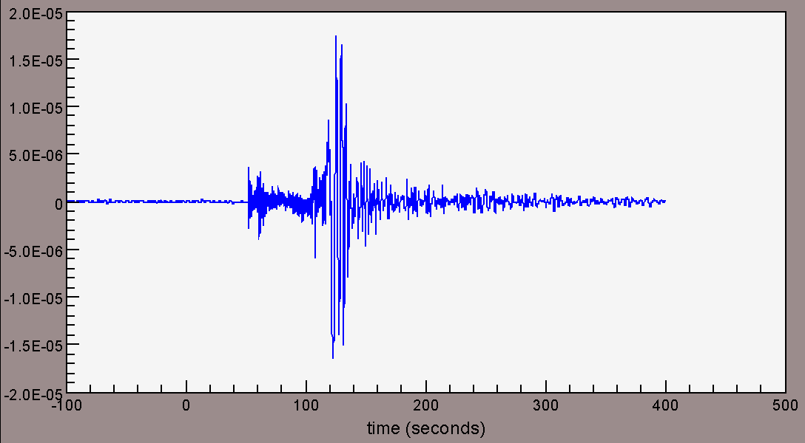
Before (red in voltage counts) and after (blue in displacement) of applying “transfer” command to the seismogram. Note user can check with “lh” command after applying transfer function for verification.
Console> rmean ↵
Console> rtrend ↵
Console> taper 0.05 ↵
Console> transfer from polezero to displacement freq 0.01 0.02 9.0 9.5 ↵
Console> taper 0.05 ↵
Console> rtrend ↵
Console> rmean ↵
Console> lh ↵

References

Brune, J. N. (1970). Tectonic stress and the spectra of seismic shear waves from earthquakes. Journal of Geophysical Research, 75(26), 4997-5009.

Mayeda, K. M., Hofstetter, A., O’Boyle, J. L., & Walter, W. R. (2003). Stable and transportable regional magnitudes based on coda-derived moment-rate spectra. Bulletin of the Seismological Society of America, 93(1), 224-239.

Mayeda, K. M., Malagnini, L. & Walter, W. R. (2007). A new spectral ratio method using narrow band coda envelopes: Evidence for non-self-similarity in the Hector Mine sequence, Geophysical Research Letters, 34, L11303.

Morasca, P., Mayeda, K., Gok, R., Phillips, W. S., & Malagnini, L. (2008). 2D coda and direct-wave attenuation tomography in northern Italy, Bulletin of the Seismological Society of America, 98(4), 1936-1946.

Phillips, W. S., Mayeda, K. M., & Malagnini, L. (2014). How to invert multi-band, regional phase amplitudes for 2-D attenuation and source parameters: Tests using the USArray. Pure and Applied Geophysics, 171(3-5), 469-484.

